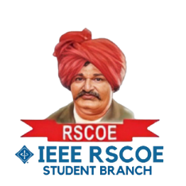

**Research Paper Writing**

Mode of Session: **Online**Session Name**:** **Research Paper Writing.**  
Date: **January 15, 2024**  
Number of Attendees**: 180**Speaker: **Mr. Swapnil Vyavahare**

**Introduction:**

Under the guidance of Branch Counsellor Dr. Swati Kale, the Research Paper Writing session was hosted on December 15, 2024, at 11:00 PM by IEEE RSCOE SB in collaboration with the E&TC Department. The event aimed to equip students and researchers with essential skills for crafting impactful research papers. Targeting engineering students and research aspirants, the session was conducted online.

**Event Details:**

Distinguished speaker Mr. Swapnil Vyavahare graced the occasion, sharing his expertise on Research Paper Writing. Mr. Vyavahare, currently holding the position of Associate Professor and Data Scientist, provided valuable insights into the nuances of research writing, including selecting relevant topics and structuring impactful papers.

Mr. Vyavahare, an alumnus of NIT Surat with extensive experience in academic research and data science, delved into identifying impactful research topics based on current industry and academic trends. He explained how to structure a research paper effectively, with detailed attention to each section. The session also focused on conducting a comprehensive literature review, analyzing gaps in existing research, and presenting data visually through charts and graphs to enhance paper quality. Additionally, Mr. Vyavahare provided guidance on navigating the publication process, highlighting common pitfalls and ethical considerations.

**Attendee Engagement & their Key Takeaways and Future Actions:**

The event witnessed 100 attendees, who actively engaged with the speaker during the Q&A segment. The participants gained practical knowledge on structuring research papers and presenting findings effectively. They also learned strategies for identifying research gaps, selecting innovative topics, and writing compelling abstracts and conclusions. Many attendees expressed enthusiasm for applying these learnings to their academic and professional projects, with several indicating their intent to submit research papers to upcoming conferences and journals.

**Support and Recognition & Conclusion:**

The event was made possible with the support of the E&TC Department and Faculty Coordinator Dr. P.M. Ghate, along with IEEE RSCOE SB. The collaborative efforts ensured accessibility and inclusivity, enabling active participation from all attendees.

The session received positive feedback for its relevance and practical application, empowering attendees to excel in research writing. Future sessions could incorporate hands-on activities, such as analyzing real research papers or engaging in peer-review exercises. 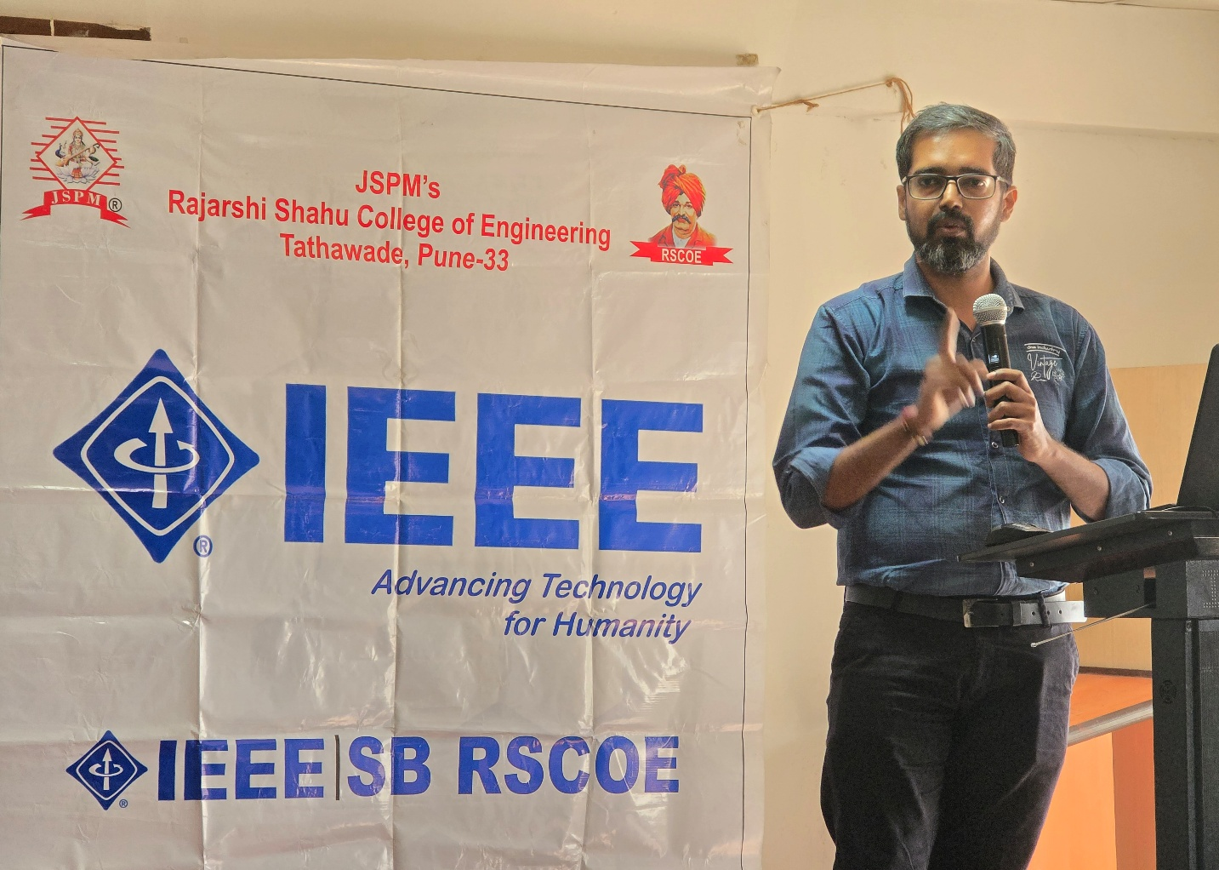

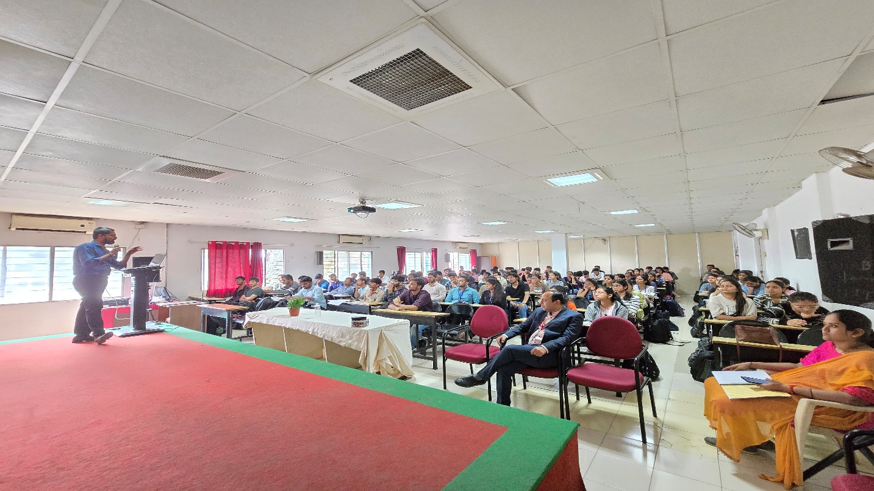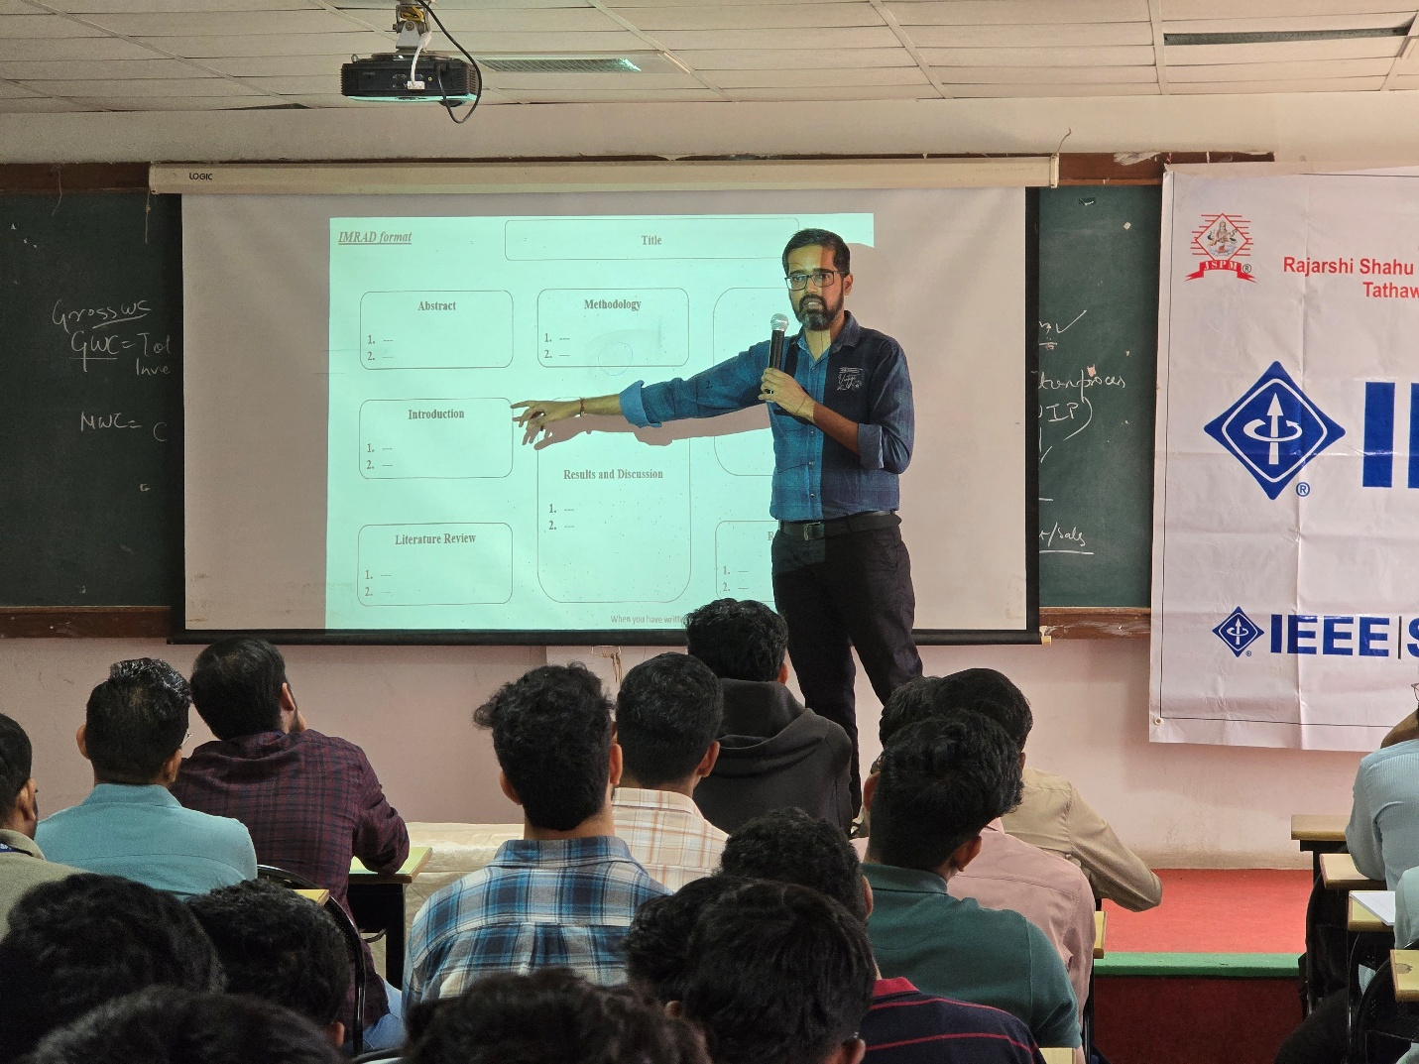Google drive- [Event photos](https://drive.google.com/drive/folders/1yVObTkHdq4UL3n_HYedWTCS-U7T6CzCR)