
IEEE COMPUTER SOCIETY SIT

AETHER CLASH-UNLEASH THE CODE

NAME OF THE ORGANIZING UNIT: IEEE COMPUTER SOCIETY SIT

DATE OF EVENT: 14Th February, Saturday

Topic: AETHER CLASH-UNLEASH THE CODE

MODE OF EVENT: Online

TARGET AUDIENCE: Student Members

ATTENDANCE: 30

On February 14th, 2025, the IEEE Computer Society organized AETHER CLASH, a thrilling coding challenge that required two-member teams to tackle a problem within a short time limit. The contestants showcased their solutions in front of the judges, who assessed both approach and code quality. The competition encouraged teamwork, problem-solving, and rapid thinking, and so, it was a thrilling experience for everyone involved.

TIMINGS: 7:30 pm – 9:30 pm

EVENT SUMMARY:

AETHER CLASH was a thrilling coding event organized by the IEEE Computer Society to test the problem-solving skills and programming capabilities of participants. There were 15 teams with two members each, competing in a fierce war of logic and programming skills.
To provide a diverse set of challenges, a set of two programming problems each, one of which was easier and the other harder, were given to each team. Problem sets were allotted randomly through a spin-the-wheel selection method to introduce an air of uncertainty and excitement. Teams were required to solve the given problems, think out efficient solutions within a finite time frame, and then defend their strategy to a panel of judges.
The competition created a culture of healthy competition, collaboration, and innovation, with an interactive platform for students to exhibit their technical skills. AETHER CLASH ended with an enlightening assessment process, giving participants better problem-solving abilities, worthwhile experience, and a deeper understanding of the art of coding.
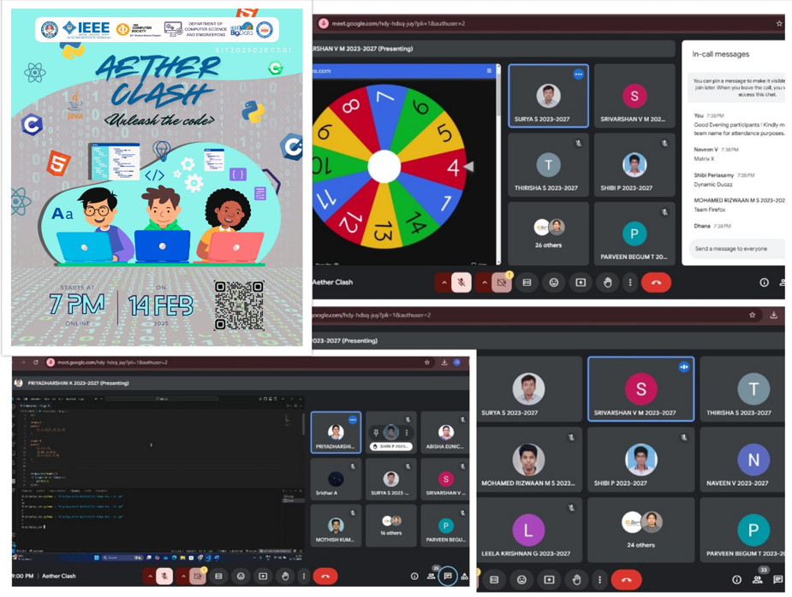

Reported By Suhail Ahmad T

