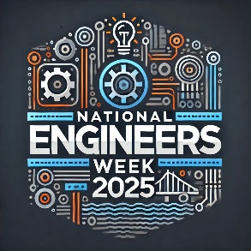

DeVry University Online Student Branch
Presents: ”Special Presentation for National Engineers Week”
Generative AI and Education
Dr. Mohamad Muqri and Dr. Gusteau Duclos

AI applications using Deep Seek
Dr. Simon Obeid

Thursday, February 20, 2025, 7:00 pm CDT
Meeting Information:
https://devry.engageli.com/devry/current/ids-3u9-uqr/?

Speakers
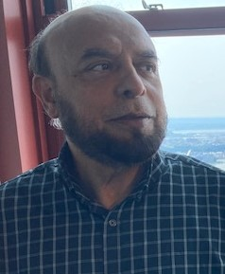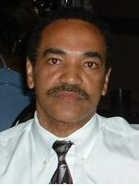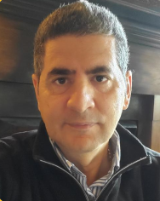
Dr. Duclos is a Senior Professor at DeVry university. He has MS and PhD in Electrical Engineering and BS in Mathematics.

Dr. Obeid is a Professor at DeVry university. He has MS and PhD in Electrical Engeering and MBA in Information Sequrity.

Dr. Muqri is a Professor at DeVry university. He has MD, , MSEE in Computer Engineering and MBA from Keller School of Management.

