**Event Report**

**On**

**Exploring key problems in robotics and control: key insights from real world applications**

**Organized by:** IEEE Student Branch PDEU

**In Association with**: IEEE CIS Gujarat Section and Department of Electrical Engineering  
**Date:** February 28, 2025  
**Venue:** F-102 PDEU Campus

The IEEE Student Branch, PDEU, kickstarted 2025 with an expert talk on “Exploring key problems in robotics and control: key insights from real world applications” in collaboration with IEEE CIS Gujarat Section and Department of Electrical Engineering, Pandit Deendayal Energy University (PDEU). Under the expert guidance of Dr. Parth S. Thakar the 15 participants embarked on a comprehensive learning journey which encompassed the fundamentals of robotics and control systems and dived deep into the applications and key problems existing in robotics and control systems.

IEEE Student Branch PDEU is grateful to Dr. Parth for sharing wonderful insights from his research experience on how control systems are employed in rockets, drones, and robotics, and how interdisciplinary and multidisciplinary problems were different.   
  
Dr. Parth also briefly talked about the design of a custom controller for a sloshing problem and open vs. closed loop control systems for audience new to the field. He also shared insights on how research problems are meant to be tackled i.e. one might benefit from a bottom up rather than top-down approach.  
  
The session was kept engaging by participants from various technical backgrounds.

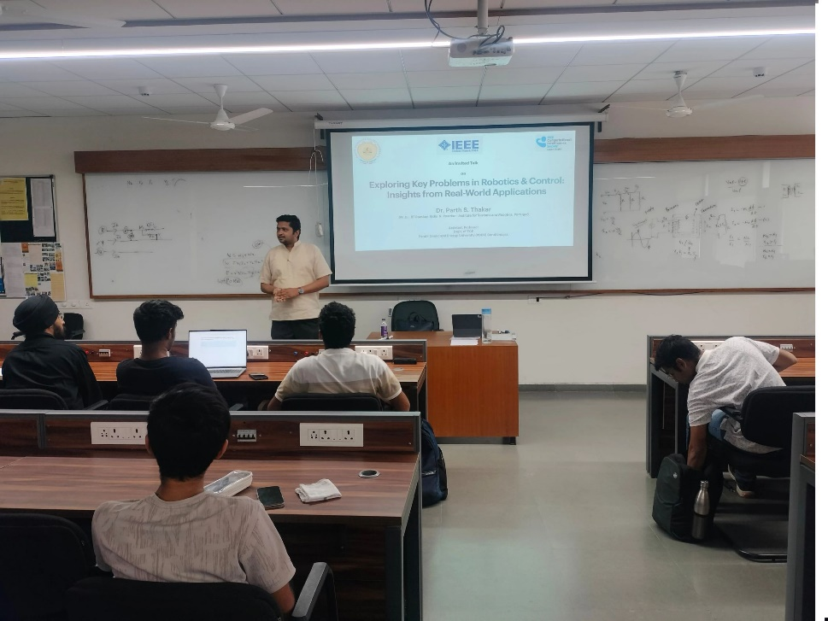

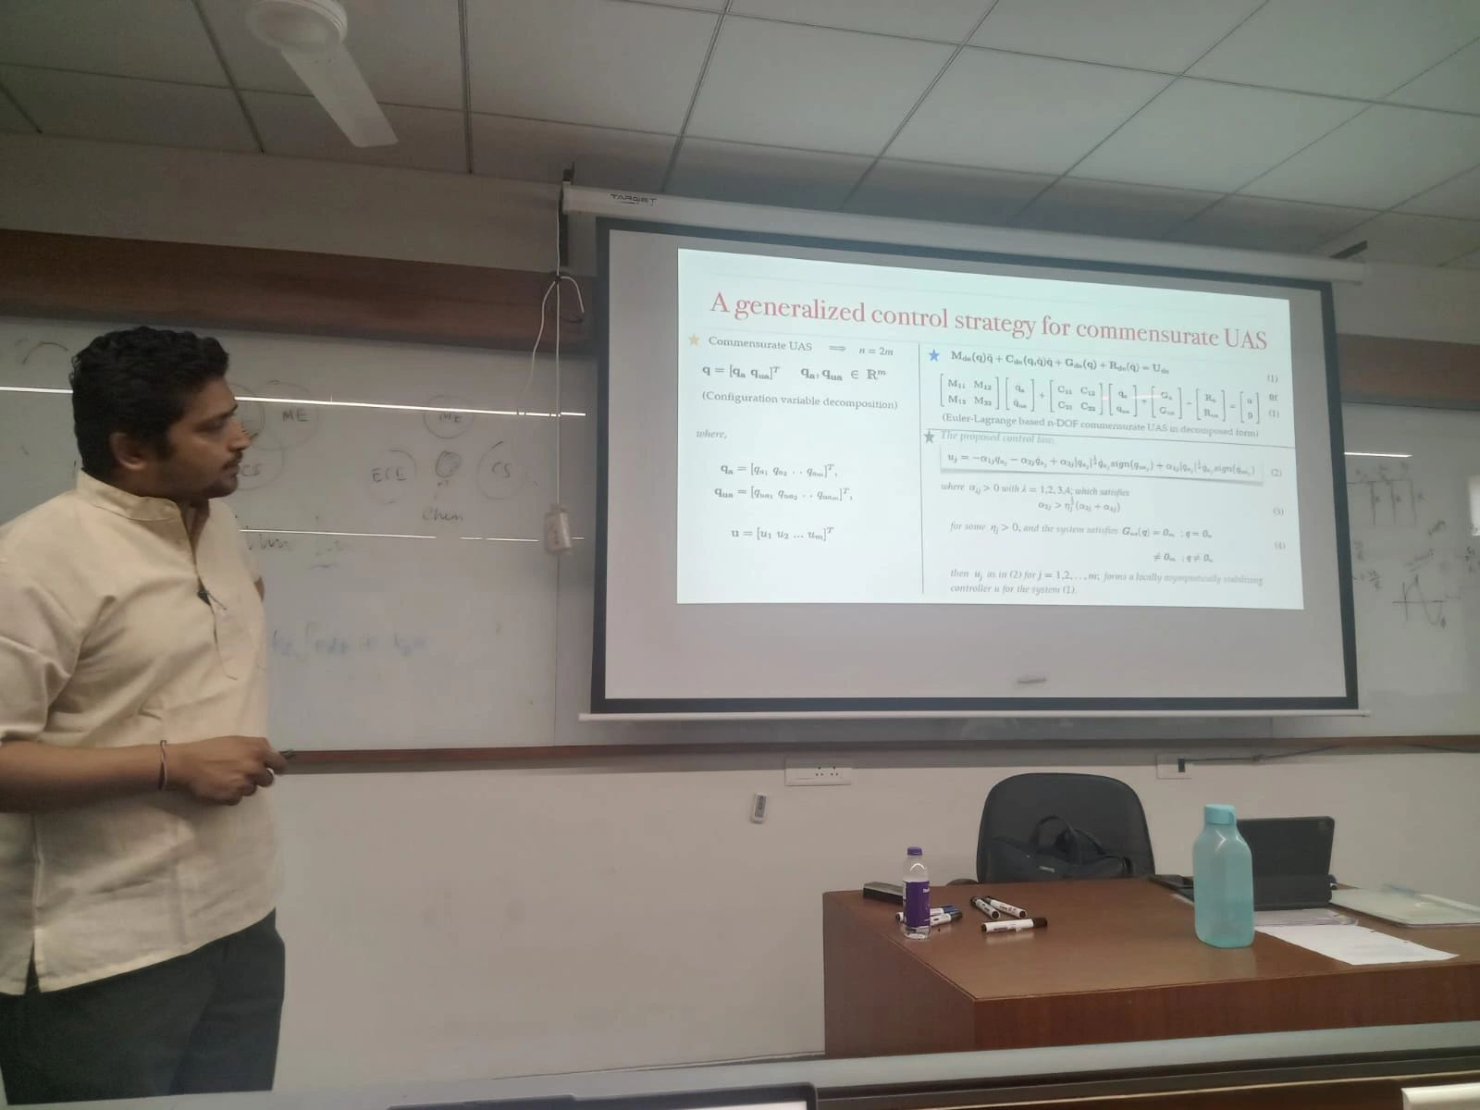

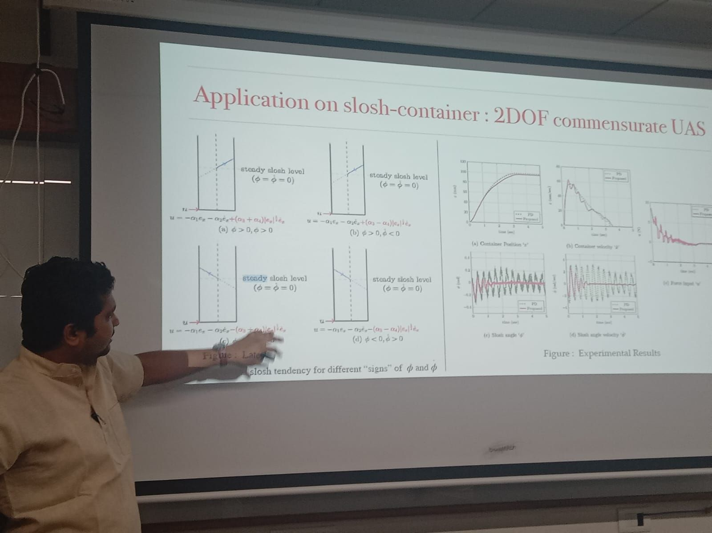

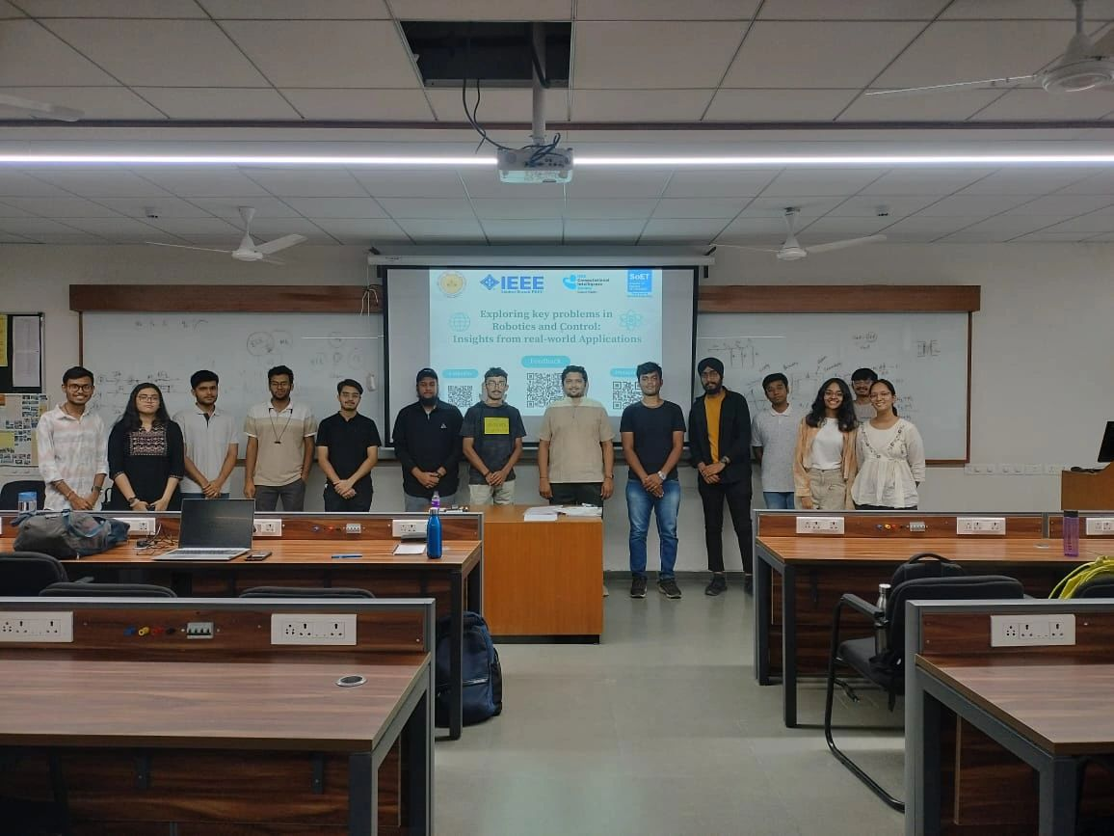

**Marketing material:**

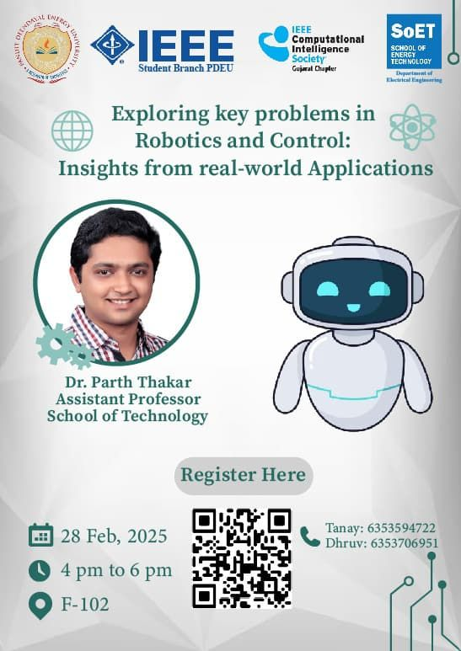

**Event coverage:**

LinkedIn: [Post](https://www.linkedin.com/posts/ieee-student-branch-pdeu_a-system-is-never-the-sum-of-its-parts-activity-7300007326114045952-uQp2?utm_source=share&utm_medium=member_desktop&rcm=ACoAAD2IYwYBx1kd3F5m3xhIYO5zFaU2bDRh64k)

**Fulfilled collaboration and sponsorship requirements:**

1. **IEEE CIS Gujarat Section**
   * *Requirements for Event Poster:* Include the IEEE CIS Gujarat Section logo and the title of the educational activity.
   * *Post-Event Requirements:* Submit the final report with pictures. Report the event under the Educational Activity category.
2. **Department of Electrical Engineering, PDEU**
   * *Requirements for Event Poster:* Include the Department of Electrical Engineering, PDEU logo and the title of the educational activity.
   * *Post-Event Requirements:* Submit the final report with pictures. Report the event under the Educational Activity category.

**Acknowledgments:** The event’s success was made possible through the collaborative efforts of IEEE CIS Gujarat Section, and Department of Electrical Engineering, PDEU, along with our esteemed expert Dr. Parth for sharing wonderful insights, and IEEE student branch counsellor Dr. Siddharth Joshi. The dedicated student coordinators team comprised of the IEEE student branch chair (Tanay Shah) and the general secretary (Dhruv Kalambe), ensured smooth and seamless learning environment for all.