**Name of the Event:** Two Days Workshop on "Patent Drafting and E-Filing in India"

**Date of the Event:** 7th – 8th March 2025

**Organized by:** Sanskriti University, Institution's Innovation Council (Ministry of HRD Initiative), IEEE, Sanskriti Business Incubation Centre

**Resource Person:** Mr. Manish Soyal  
Examiner of Patents & Designs, Indian Patent Office  
Ministry of Commerce & Industry

**Key Speakers and Moderators:**

* Prof. (Dr.) M. B. Chetti, Vice Chancellor, Sanskriti University
* Dr. S. Vairachilai, Professor and Dean, SoEIT, Sanskriti University
* Prof. (Dr.) Pankaj Kumar Goswami, Professor and HoD, SoEIT (Session Moderator)
* Prof. (Dr.) Garima Goswami, Chairperson, IPR Cell, Sanskriti University
* Dr. Shantam Babbar, Assistant Professor, SOMC (Event Coordinator)
* Mr. Danish Meiraj, Assistant Professor, SoEIT (Event Coordinator)
* Dr. Manish Agrawal, Dean

**Objective:** The primary goal of this workshop was to provide participants with a comprehensive understanding of the patent drafting and e-filing process in India. The workshop aimed to equip attendees with the knowledge and skills needed to navigate the legal, technical, and procedural aspects of intellectual property rights.

**Report:** Sanskriti University successfully conducted a two-day workshop on "Patent Drafting and E-Filing in India" on 7th and 8th March 2025, from 2:00 PM to 5:00 PM.

The sessions featured expert talks by Mr. Manish Soyal, who shared invaluable insights into patent drafting, filing procedures, and intellectual property management in India. The event was moderated by Prof. (Dr.) Pankaj Kumar Goswami, with opening remarks by Prof. (Dr.) M. B. Chetti, Vice Chancellor of Sanskriti University.

The workshop covered critical topics like the roadmap for patent creation, patent search and analysis, timelines, copyright, and design overviews. Interactive Q&A sessions and live examples helped participants gain practical insights into the subject.

The event saw enthusiastic participation, with around 100 students and approximately 10 faculty members actively engaging in discussions and activities. Their curiosity and eagerness to learn made the sessions even more dynamic and impactful.

To conclude the successful event on a pleasant note, refreshments and snacks were arranged for all attendees, providing a great opportunity for informal networking and knowledge exchange among peers and experts.

The event wrapped up with a feedback session, where participants expressed their appreciation for the well-structured and informative sessions. The organizing team extended their gratitude to the resource person, speakers, and all attendees, making the workshop a grand success.

**Program Outcome:**

* Clear understanding of patent drafting, filing procedures, and intellectual property management.
* Practical knowledge of searching and analyzing patents.
* Awareness of important timelines, copyright, and design aspects.
* Empowered participants with skills to protect and commercialize innovations.

The event proved to be highly educational and beneficial, empowering participants with valuable knowledge and practical skills for securing intellectual property rights in India.

Let me know if you’d like me to refine this or add any more details! 🚀

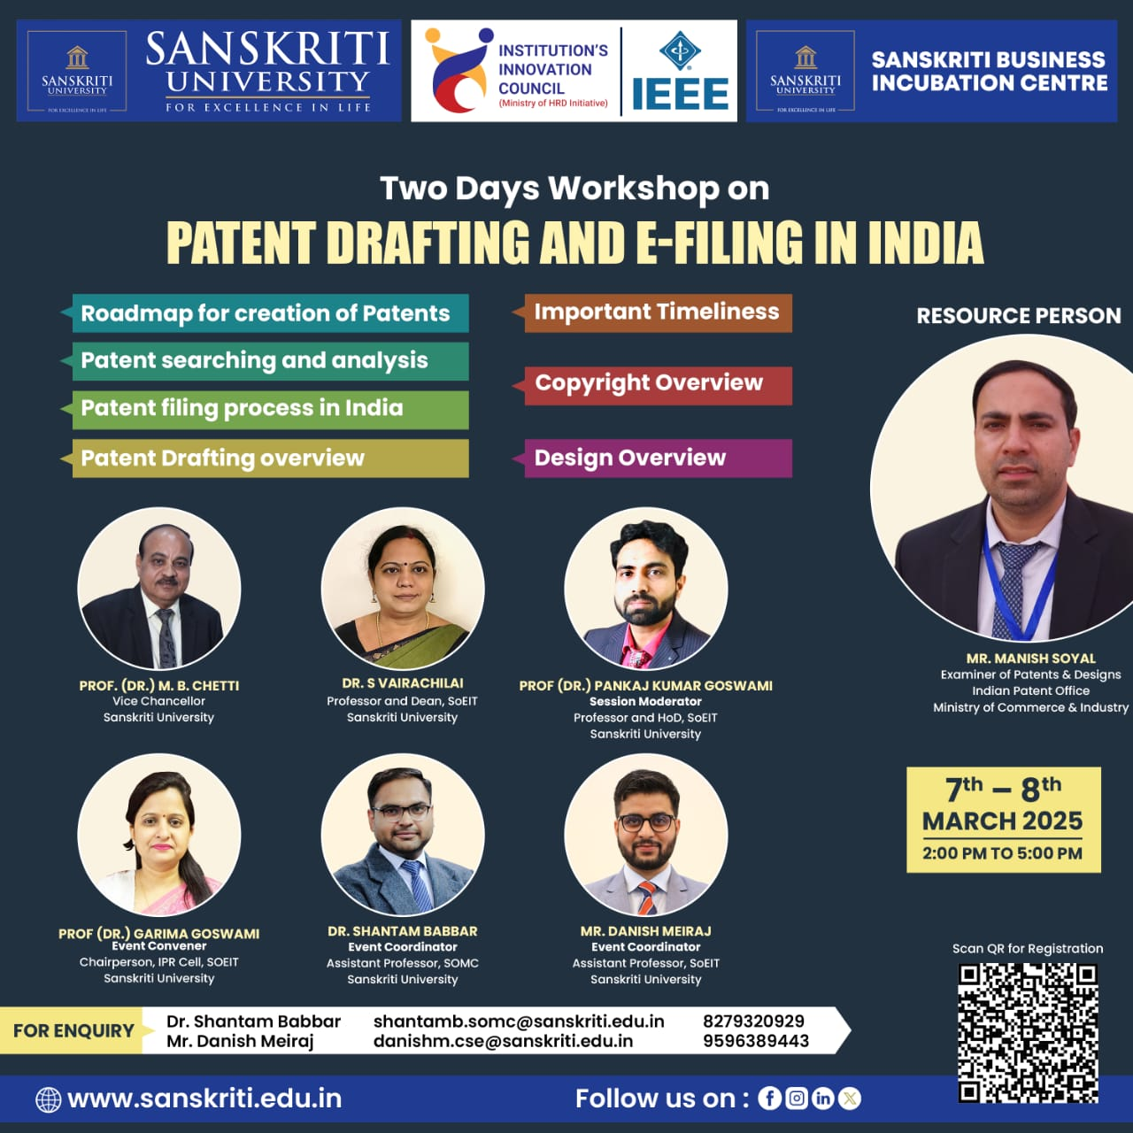

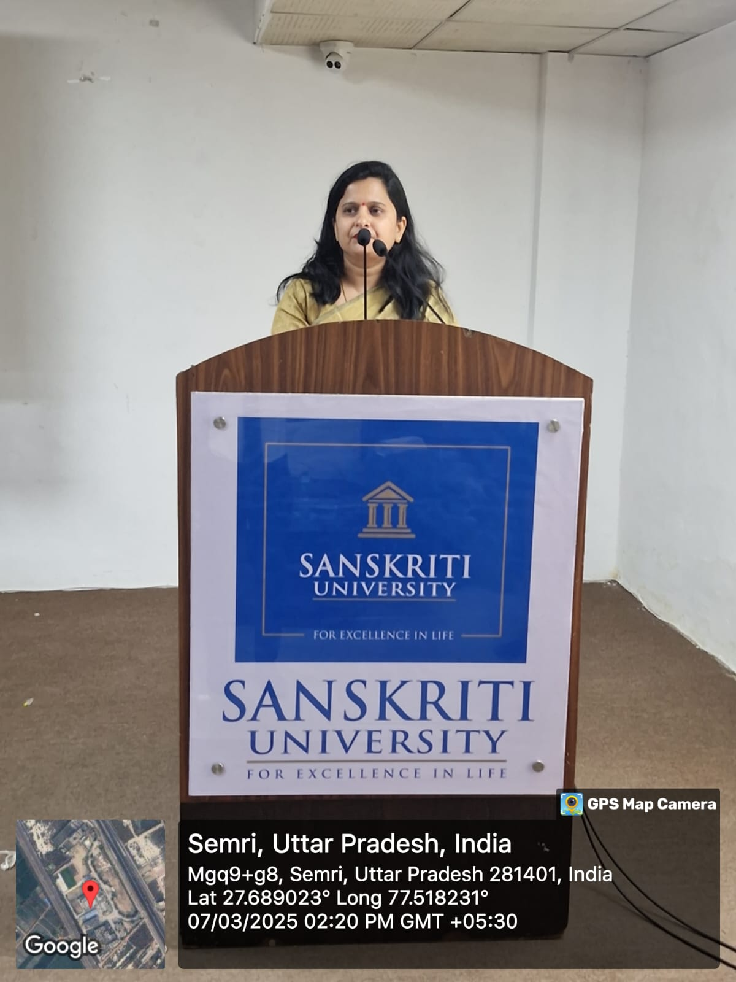

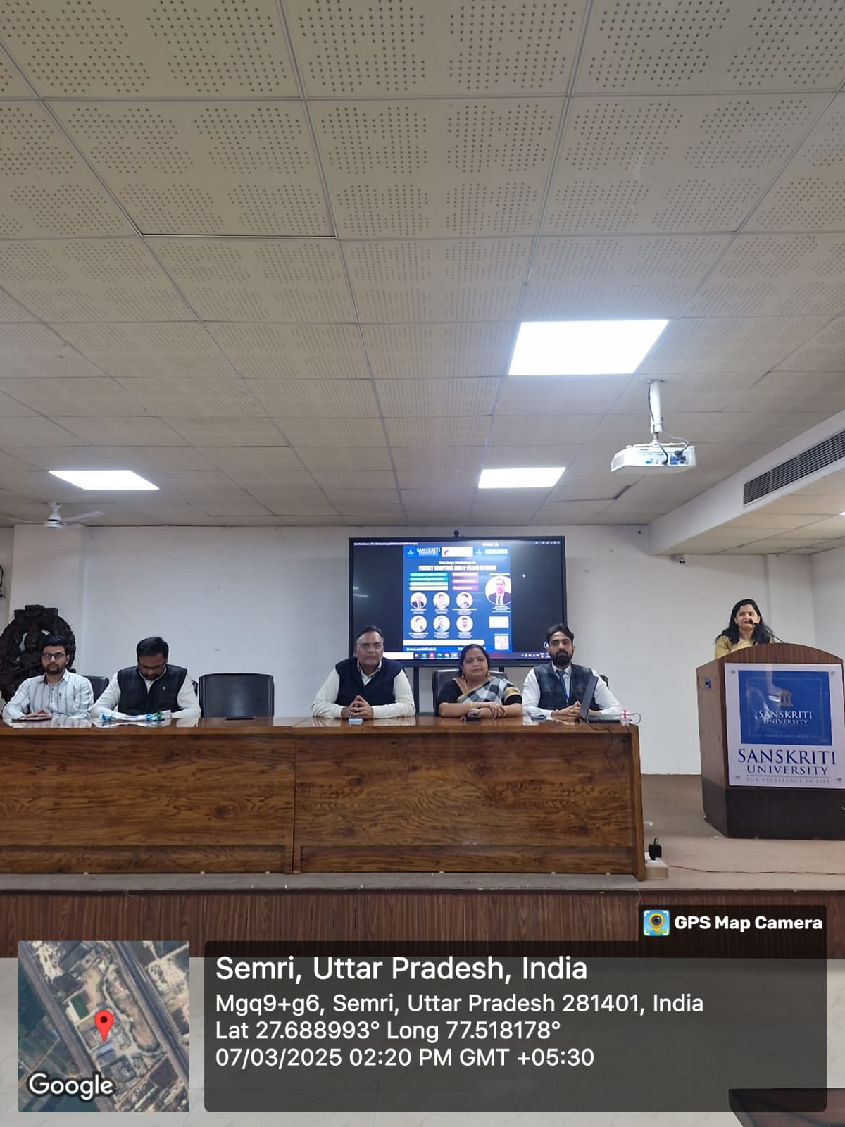

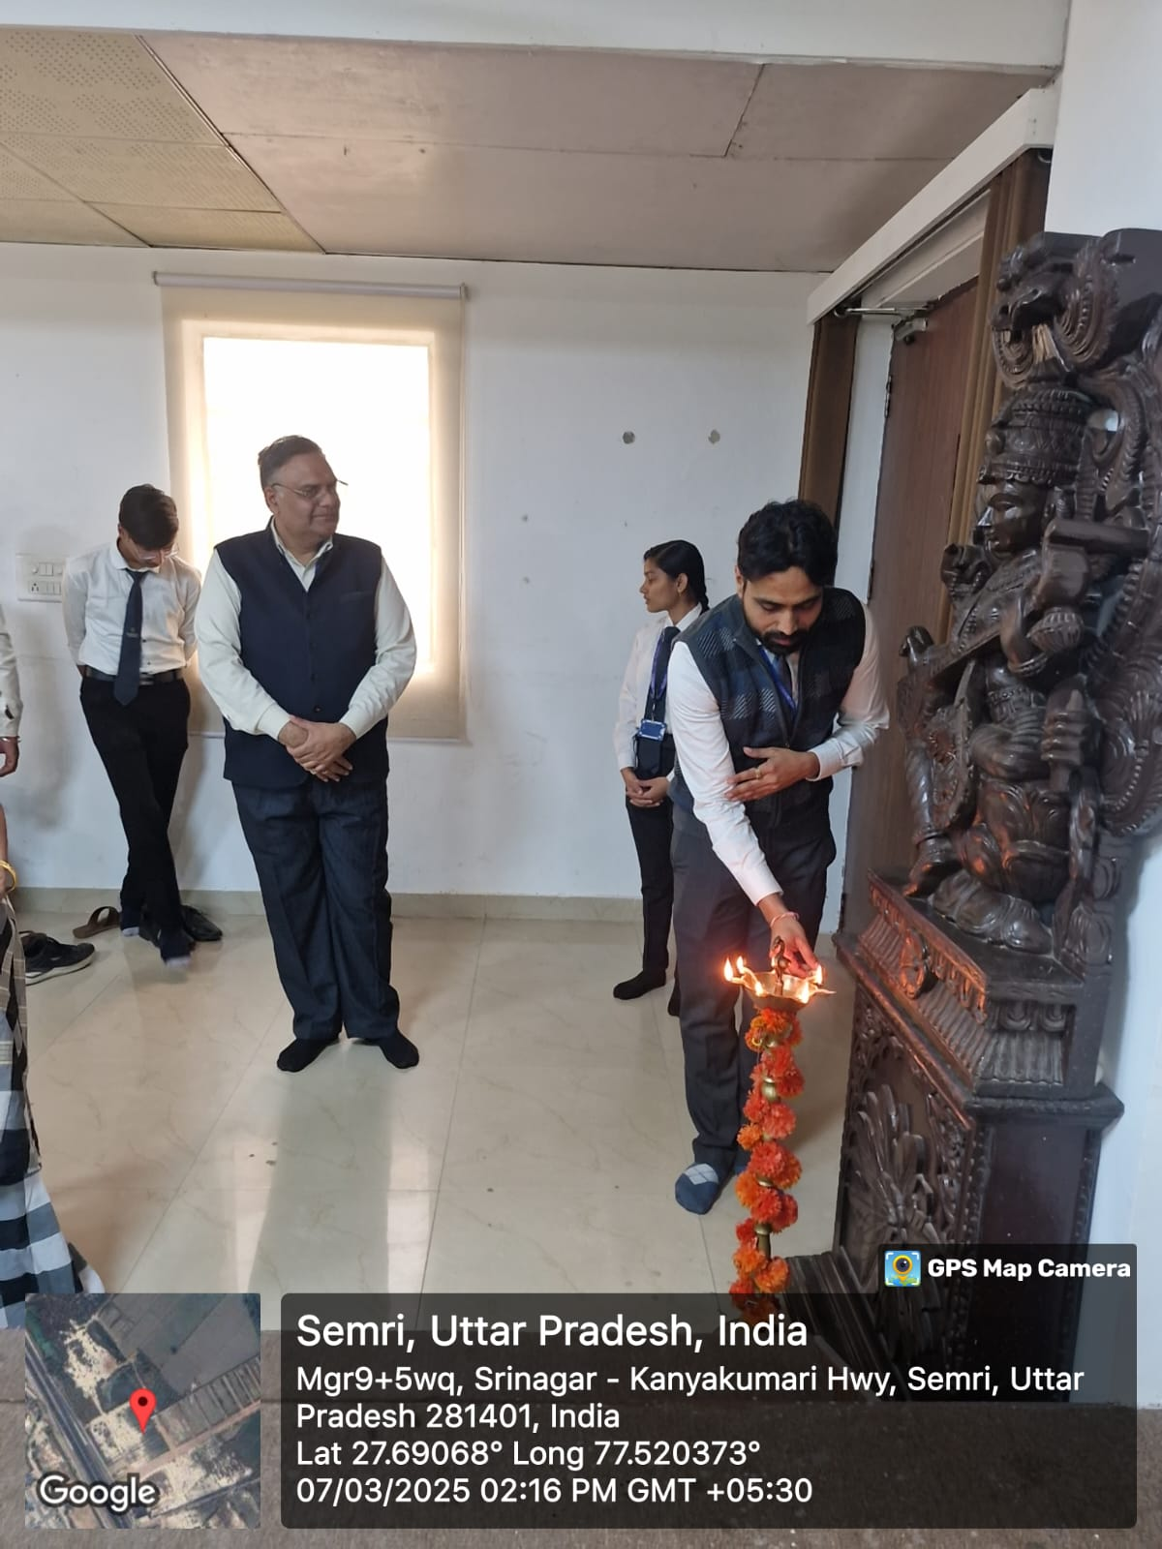

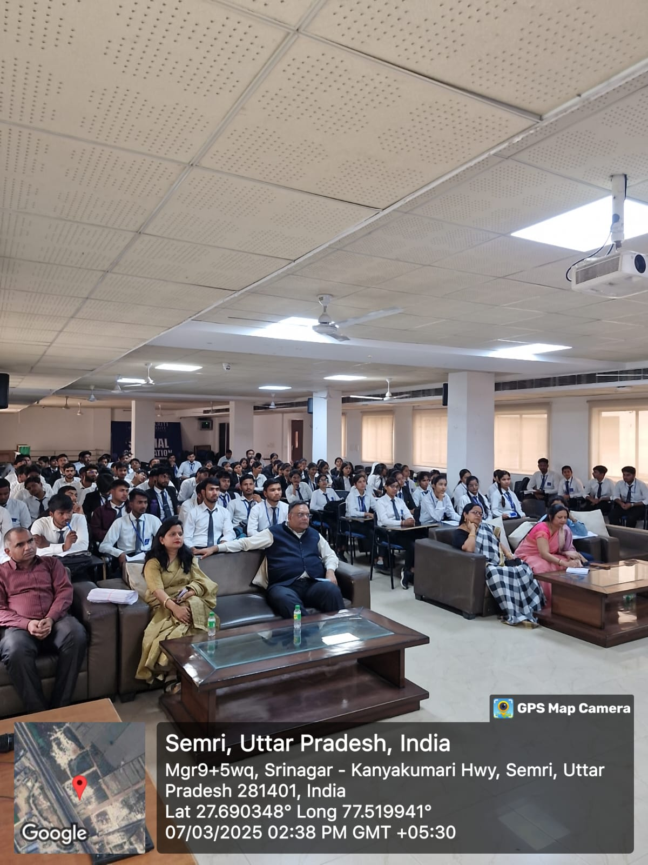

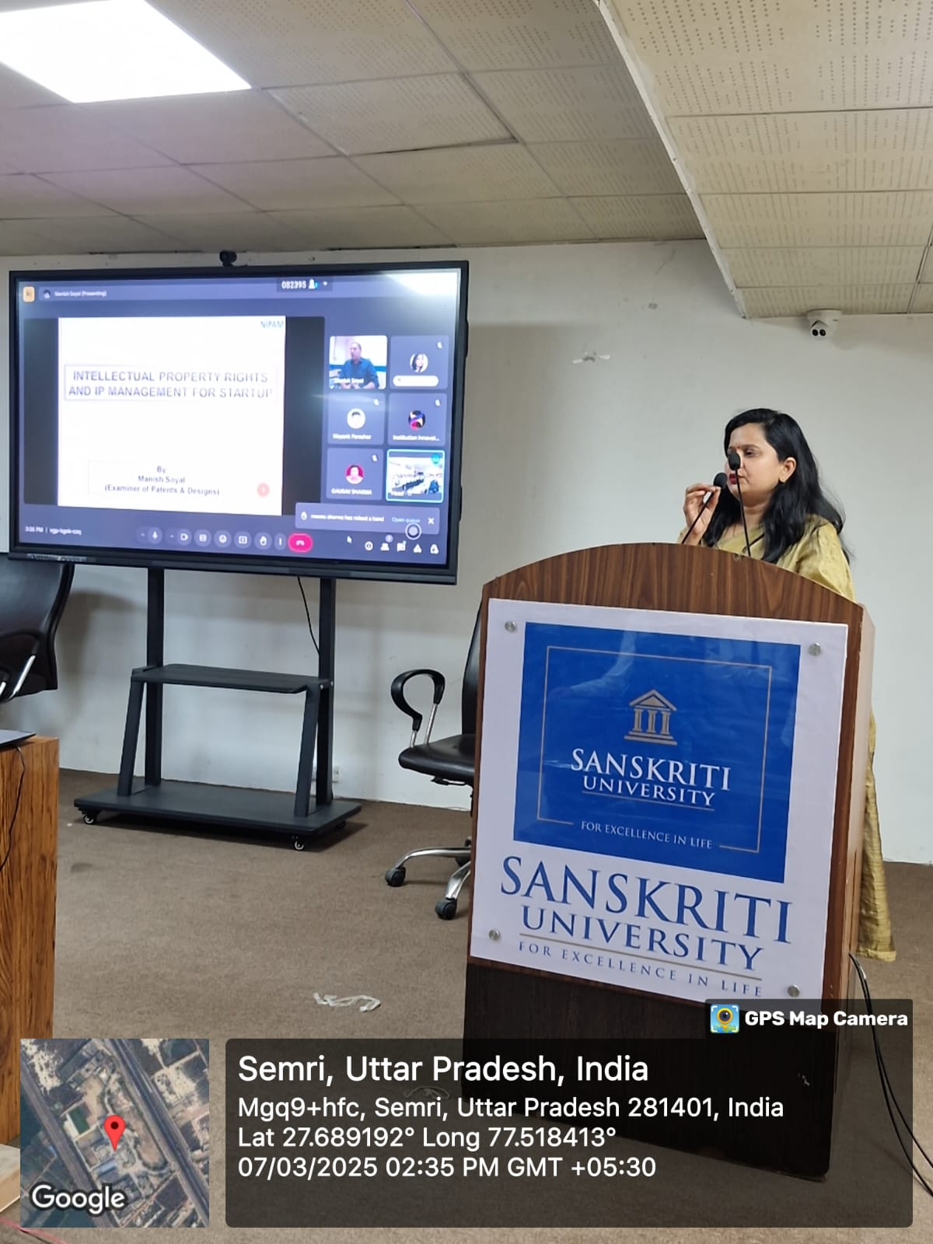

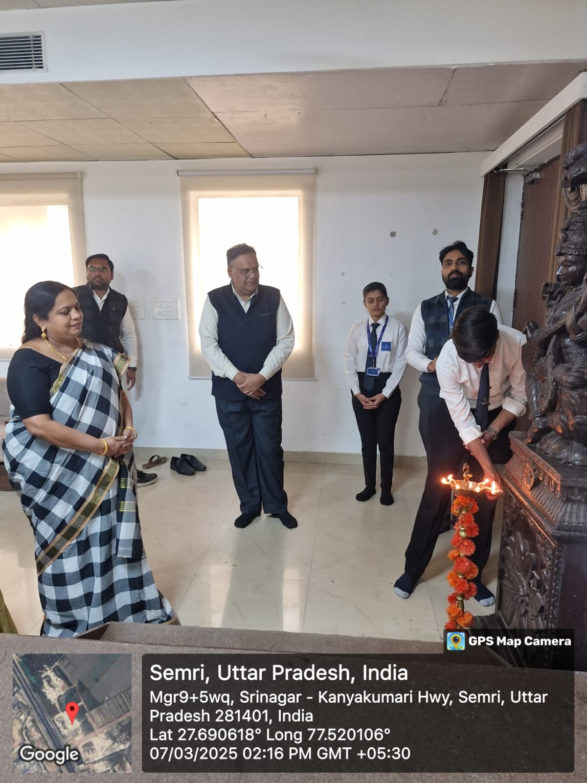



**IPR Event Orgnizing Committee**

**IEEE Members:**

|  |  |  |
| --- | --- | --- |
| **NAME** | **MEMBERSHIP NO.** | **POST** |
| **ASHI AGARWAL** | **101025314** | **CHAIRPERSON** |
| **KESHAV DEV RAO** | **101025404** | **VICE CHAIRPERSON** |
| **ANMOL SINGH** | **101028875** | **SECRETARY** |
| **ROHIT KUSHWAH** | **101031794** | **SECRETARY** |
| **ARPIT KUMAR** | **101035436** | **WEBMASTER** |
| **PREETI YADAV** | **101031712** | **WEBMASTER** |
| **HARSH SENGAR** | **101043539** | **WEBMASTER** |
| **YUVRAJ SINGH** | **101043577** | **TREASURER** |
| **PRIYANSH VERMA** | **101047073** | **TREASURER** |

|  |  |  |  |
| --- | --- | --- | --- |
| **No. of Students** | **Enroll. No/Adm. No** | | **Student Name** |
| 1 | 2304301067 | | Shivani sharma |
| 2 | 2304301122 | | Babli |
| 3 | 2401064 | | Shivani Ojha |
| 4 | 2304301012 | | Anuj chauhan |
| 5 | 2304301064 | | Shivam sisodiya |
| 6 | 2304301077 | | Utkarsh shukla |
| 7 | 2400551 | | Umesh Pandey |
| 8 | 2400694 | | Rajvir Singh |
| 9 | 2402010 | | Meenu Sharma |
| 10 | 2402305010 | | Aman kumar Shrivastava |
| 11 | 2402305011 | | Aman yadav |
| 12 | 2402305026 | | Bhuvnesh |
| 13 | 2402305099 | | Soniya |
| 14 | 2402351 | | Deepanshu sengar |
| 15 | 2403505015 | | Sheljabansal |
| 16 | 2404301041 | | Punam kumari |
| 17 | 2404301048 | | Raushan raj |
| 18 | 2204303018 | | Priyanka |
| 19 | 2204303026 | | Shikha singh |
| 20 | 2204303028 | | Shweta Tiwari |
| 21 | 2300115 | | Piyush Varma |
| 22 | 2302105005 | | Gaurav Sharma |
| 23 | 2302916 | | Ankit Singh |
| 24 | 2302963 | | Avant Pandey |
| 25 | 2304301004 | | Akhilesh |
| 26 | 2304301025 | | Gamini yadav |
| 27 | 2304301046 | | Prem Sharma |
| 28 | 2304301058 | | Sachit pal Singh |
| 29 | 2304301073 | | Swati chaudhary |
| 30 | 2304301079 | | Vikas thakur |
| 31 | 2304301117 | | Rohit Singh |
| 32 | 2304301126 | | Nidhi chaudhary |
| 33 | 2305038 | | Anupriya Sharma |
| 34 | 2305761 | | Mayank Parashar |
| 35 | 2400116 | | DHAIRYA |
| 36 | 2400398 | | Mrityunjay Kumar |
| 37 | 2400751 | | MANSI |
| 38 | 2401739 | | vikash |
| 39 | 2402305008 | | Akshat kulshrestha |
| 40 | 2402305021 | | Ashish Saini |
| 41 | 2402305028 | | Deepak Sharma |
| 42 | 2402305033 | | Divya Verma |
| 43 | 2402305034 | | Gaurav kulshrestha |
| 44 | 2402305058 | | Mayank Rajpoot |
| 45 | 2402305074 | | Prince Tomar |
| 46 | 2402305084 | | ROSHINI |
| 47 | 2404201010 | | Deepak verma |
| 48 | 2404201014 | | Gourav chahar |
| 49 | 2404201043 | | Vedveer Singh |
| 50 | 2400384 | | Vishal Sagar |
| 51 | 2400540 | | Prince kumar |
| 52 | 2401623 | | Devendra upadhyay |
| 53 | 2402176 | | Bhumi chaudhary |
| 54 | 2402305073 | | Prince Rajput |
| 55 | 2402305085 | | Rukhsana khatoon |
| 56 | 2402305121 | | Deepak Chaudhary |
| 57 | 2402644 | | Jyoti |
| 58 | 2404201036 | | Sanjana Sharma |
| 59 | 2304301035 | | Megha Rathore |
| 60 | 2402305036 | | Gopal sharma |
| 61 | 2300883 | | Prashant chaudhary |
| 62 | 2304301036 | | Muskan |
| 63 | 2304301101 | | Samriddhi Tripathi |
| 64 | 2402427 | | Ankit Sharma |
| 65 | 2301103 | | Rohit sharma |
| 66 | 2302550 | | Dhruv singh |
| 67 | 2304301020 | | Deepak Kumar sisodiya |
| 68 | 2304301041 | | Payal Kumari |
| 69 | 2304301099 | | Khushbu |
| 70 | 2400988 | | VIPUL RAI |
| 71 | 2401255 | | Pankaj kumar |
| 72 | 2402305045 | | Kashish |
| 73 | 2402305051 | | MANEESH KUMAR |
| 74 | 2402305060 | | Neha |
| 75 | 2402305104 | | Uday Pratap |
| 76 | 2402305119 | | Abhay Pratap |
| 77 | 2402305138 | | Vaibhav Agrawal |
| 78 | 2403081 | | Vivek |
| 79 | 2302320087 | | Satya Ram |
| 80 | 2302320164 | | MEDEKUNDA SIVA RAMA KRISHNA |
| 81 | 2302328004 | | Harshjeet Pandey |
| 82 | 2303826 | | Shiv-Bhooshan Singh |
| 83 | 2400757 | | Shreya Raj Gupta |
| 84 | 2401259 | | Awanishsingh |
| 85 | 2402301002 | | Mukul |
| 86 | 2402305085 | | Rukhsana khatoon |
| 87 | 2402734 | | Prateek sharma |
| 88 | 2400389 | | Pragati Chaudhary |
| 89 | 2401827 | | Anjali singh |
| 90 | 2404201023 | | Mayank Verma |
| 91 | 2401537 | Rachna Verma | |
| 92 | 2400827 | Sneha | |
| 93 | 2400757 | Shreya Raj Gupta | |
| 94 | 2401709 | Shrishti | |
| 95 | 2401618 | Aditi Chaubey | |
| 96 | 2403272 | Shruti Anand | |