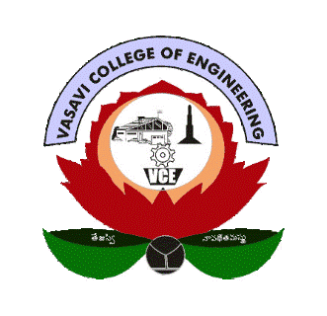**VASAVI COLLEGE OF ENGINEERING**

Ibrahimbagh, Hyderabad – 500031

IEEE MTT-S STUDENT BRANCH CHAPTER

**Academic Year: 2024-25**

**REPORT ON ORIENTATION EVENT**

|  |  |
| --- | --- |
| Event | **Orientation Event for 2nd year students** |
| Date | **07-02-2025** |
| Organized by | **IEEE Student Branch and MTT-S Student Branch Chapter** |
| Attendance | **IEEE members: 40**  **Non IEEE members: 100** |
| Participants | **Members of IEEE Student Branch and Non IEEE members** |
| Objectives | The objectives of the IEEE Student Branch Orientation Program are:   1. **Introduction to IEEE** – Explain the purpose, vision, and benefits of IEEE membership. 2. **Awareness of IEEE Societies** – Highlight various IEEE societies like MTT-S, RAS, PES, etc., and their relevance to different engineering domains. 3. **Opportunities for Skill Development** – Inform students about technical workshops, webinars, hackathons, and networking opportunities available through IEEE. 4. **Professional Growth & Career Advancement** – Discuss benefits like access to research papers, scholarships, competitions, and mentorship programs. 5. **Importance of Technical and Leadership Skills** – Encourage students to participate in IEEE activities to enhance their technical knowledge and leadership abilities. 6. **Overview of IEEE Student Branch Activities** – Present the past and upcoming events organized by the IEEE Student Branch. 7. **Collaboration & Networking** – Emphasize the global networking opportunities available through IEEE events and conferences. 8. **Guidance on Membership & Participation** – Explain the process of becoming an IEEE member and the various membership benefits. 9. **Encouraging Student Involvement** – Motivate students to actively participate in IEEE initiatives, technical projects, and community outreach. 10. **Q&A and Interaction Session** – Provide a platform for students to ask questions and interact with IEEE members and faculty advisors. |
| Outcomes | 1. **Increased Awareness** – Students gain a clear understanding of IEEE, its societies, and the benefits of membership.  2. **Enhanced Participation** – More students show interest in joining IEEE and actively participating in its events, workshops, and technical activities.  3. **Skill Development** – Students become aware of opportunities to improve their technical, leadership, and communication skills.  4. **Networking & Collaboration** – Encourages students to connect with peers, faculty, and industry professionals through IEEE events and activities.  5. **Motivation for Research & Innovation** – Exposure to IEEE resources inspires students to explore research, technical projects, and innovation.  6. **Leadership Development** – Identifying potential student leaders who can take up roles in IEEE Student Branch activities.  7. **Stronger Student Community** – Building a more active and engaged student community within the IEEE Student Branch.  8. **Awareness of Career Opportunities** – Students learn about IEEE-supported internships, certifications, scholarships, and career guidance.  9. **Encouragement for Competitions & Conferences** – More students get motivated to participate in IEEE hackathons, paper presentations, and technical competitions.  10. **Positive Feedback & Future Improvements** – Student responses help in shaping future IEEE Student Branch programs more effectively. |