
IEEE COMPUTER SOCIETY SIT
IGNIT ARENA - REVERSE CODING

NAME OF THE ORGANIZING UNIT: IEEE COMPUTER SOCIETY SIT

DATE OF EVENT: 22nd February, Saturday 2025

TOPIC: REVERSE CODING CHALLENGE

MODE OF EVENT: Online

TARGET AUDIENCE: Student Members

ATTENDANCE: 150

IgnitArena's Reverse Coding Challenge challenged participants problem-solving abilities in two rounds. The first was a programming test, and the second involved coding from input-output pairs without a provided problem statement. The event honed analytical mind, debugging, and flexibility under stress.
TIMINGS: 7:00 PM to 9:00PM

EVENT SUMMARY:
IgnitArena Challenge on Reverse Coding was a thrilling online coding challenge meant to assess participants' logical minds, problem-solving skills, and flexibility in working under constraints. The challenge had two rigorous rounds, each putting the participants through a different kind of challenge.
Round 1: Programming Quiz
The first round involved a programming-themed quiz, which tested the technical aptitude, coding basics, and problem-solving skills of the participants. The leaders in this round received strategic benefits for the next phase, like extra hints or more time.
Round 2: Reverse Coding Challenge
In the second round, participants were provided with input-output pairs without any idea of the initial problem statement. They needed to study the patterns, decipher the logic, and write the appropriate code to produce the desired output. This round checked their capacity to think backwards and build solutions without an immediate problem statement.
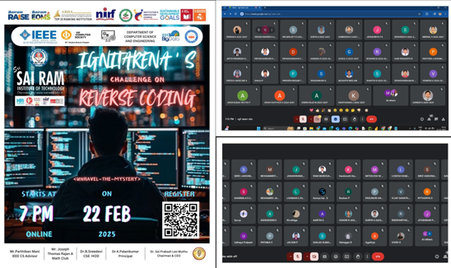
Reported By Suhail Ahmad T

