


IEEE COMPUTER SOCIETY SIT

THE UNVEILED SERIES EPISODE 21

NAME OF THE ORGANIZING UNIT: IEEE COMPUTER SOCIETY SIT

DATE OF EVENT: 1st March, Saturday 2025

TOPIC: THE UNVEILED SERIES EPISODE 21- HUMANOID ROBOTS

MODE OF EVENT: Online

TARGET AUDIENCE: Student Members

ATTENDANCE: 80
On 1st March 2025, the IEEE Computer Society SIT conducted Unveiled Series Episode 21 on the topic "Humanoid Robots: The Future of Human-Machine Interaction." The session explored the evolution, applications, and challenges of humanoid robots across various industries. Attendees gained insights into their impact on healthcare, education, manufacturing, and space exploration.

TIMINGS: 7:00 pm – 8:30 pm

EVENT SUMMARY:
Unveiled Episode 21 explored the fascinating world of Humanoid Robots, revealing their technological history, applications, and future impact.
The session began by defining humanoid robots, highlighting their human-like form, flexible locomotion, and sophisticated AI capabilities. A comparison between traditional robots and humanoid robots emphasized their ability to communicate, learn, and navigate changing environments.
The discussion explored the real-world applications of humanoid robots, such as healthcare, education, manufacturing, retail, and space exploration. Speakers also addressed key challenges, including power consumption, mobility, and AI ethics, while discussing emerging trends like soft robotics, real-time learning, and human-robot collaboration.
The event concluded with thought-provoking discussions on the future of humanoid robots and their long-term implications. By blending theoretical insights with real-world applications, Unveiled Episode 21 provided attendees with a strong foundation to understand and navigate the evolving landscape of humanoid robotics.

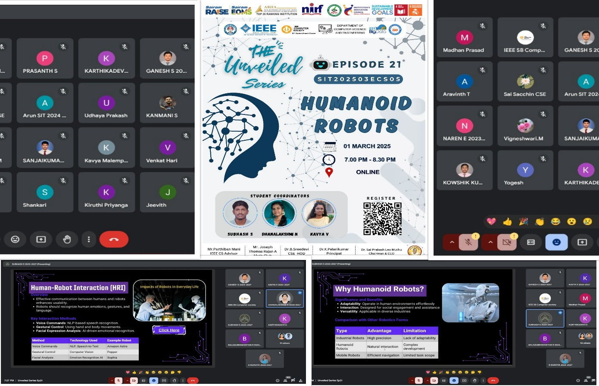
Reported by Suhail Ahmad T

