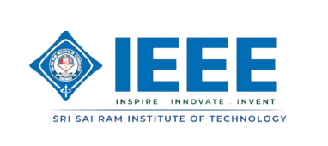
IEEE COMPUTER SOCIETY SIT

DECODING THE MIGHT OF COMMUNITIES

NAME OF THE ORGANIZING UNIT: IEEE COMPUTER SOCIETY SIT

DATE OF EVENT: 6th March, Thursday 2025

TOPIC: DECODING THE MIGHT OF COMMUNITIES

MODE OF EVENT: Offline

TARGET AUDIENCE: Student Members

ATTENDANCE : 80

On 6th March 2025, IEEE Computer Society SIT SB conducted a successful offline event on "Decoding the Might of Communities" at the CSE Seminar Hall, 2nd Floor. The event, 1 PM to 4 PM, had Balaji V S as the keynote speaker.

TIMINGS: 1:00 pm – 4:00 pm

EVENT SUMMARY:

The session emphasized the importance of tech communities, and how they promote connection, cooperation, and growth. Balaji V S shared his experience in the FOSS (Free and Open Source Software) community, and in sharing his insights on volunteering, its importance in tech communities.
Students gained much from Balaji, identified students who would be willing to volunteer. He provided them with different opportunities to give back and even identified potential volunteers for upcoming events. He also instructed students on how to get the GitHub Developer Kit for free, making valuable tools and resources available for their technology journey.
The event not only inspired the students but also allowed them to connect with like-minded people, learn about volunteer opportunities, and b
introduced to useful developer resources
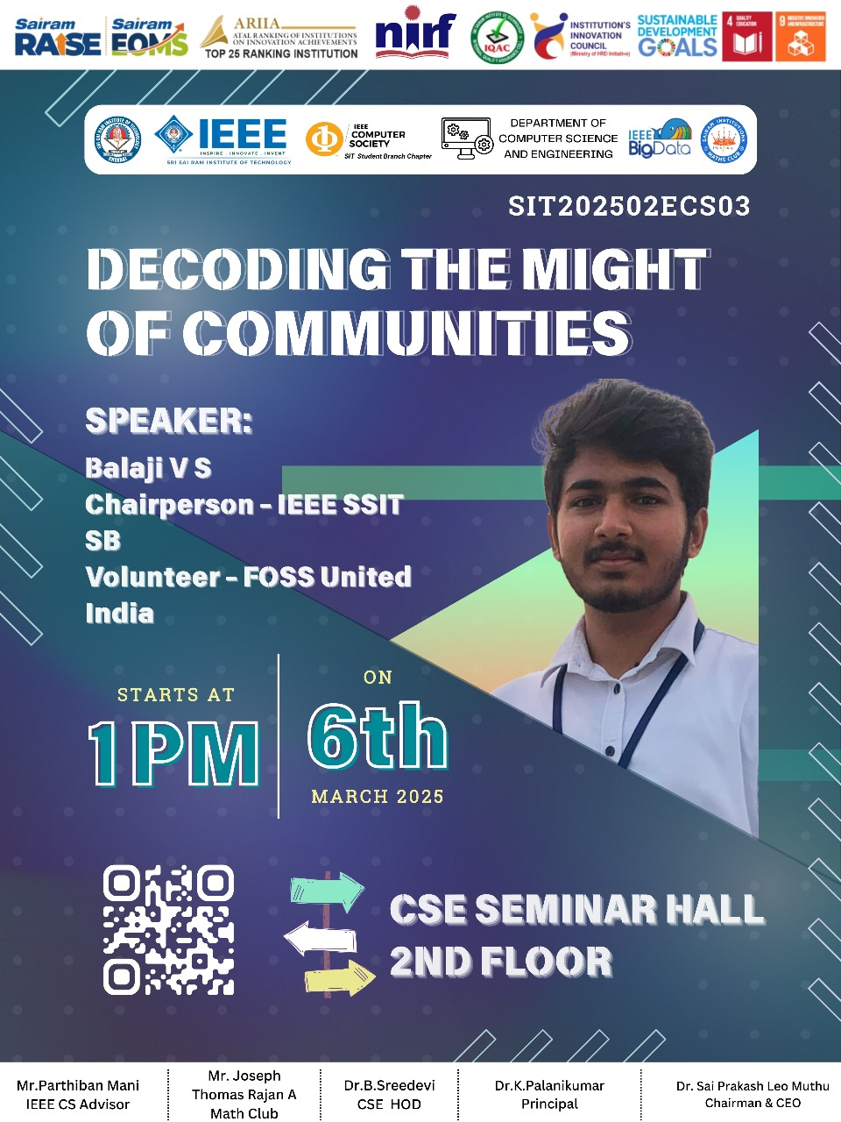
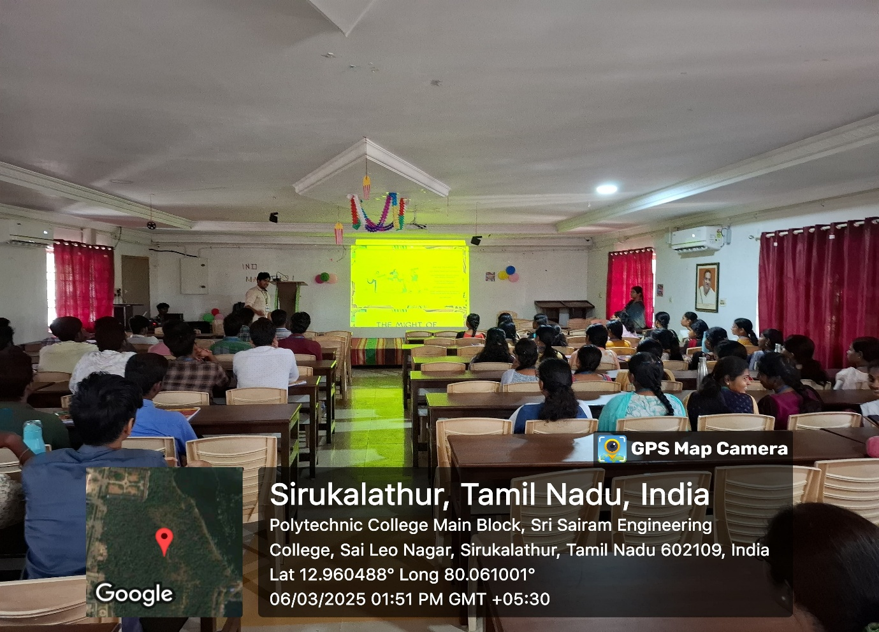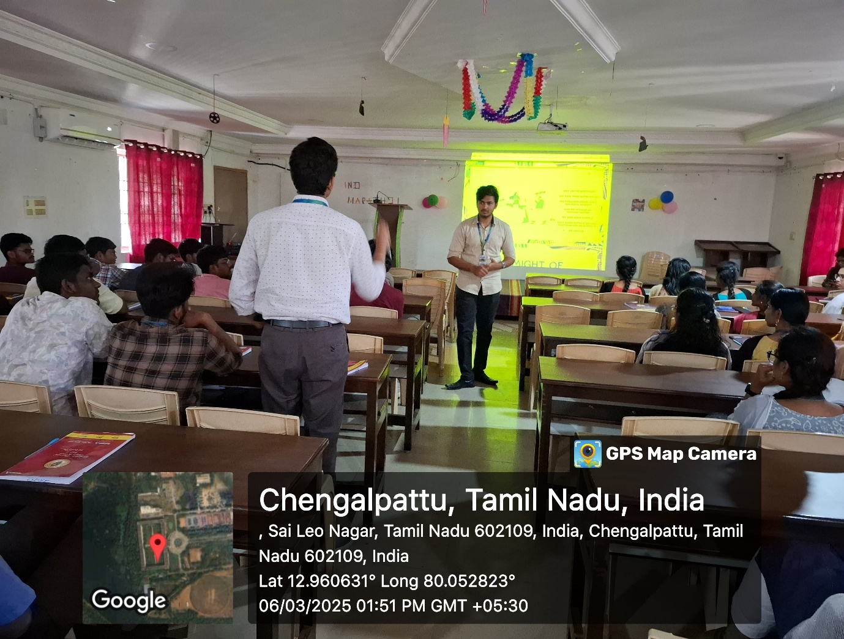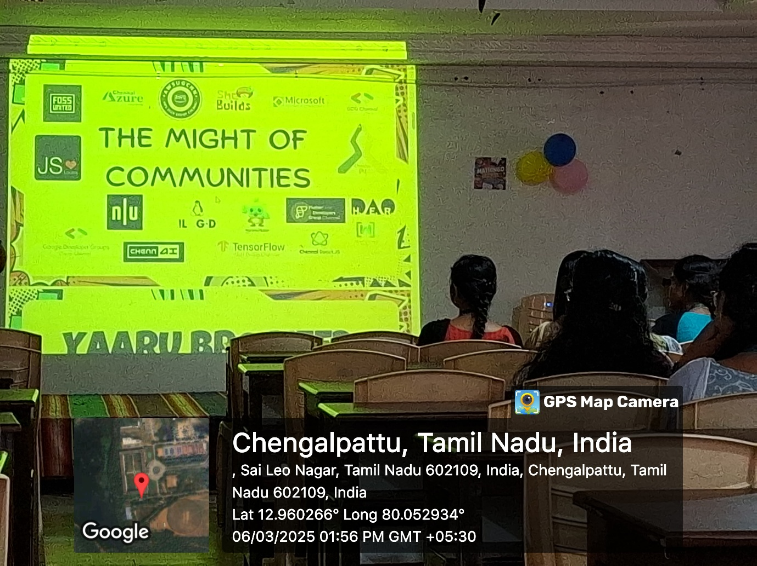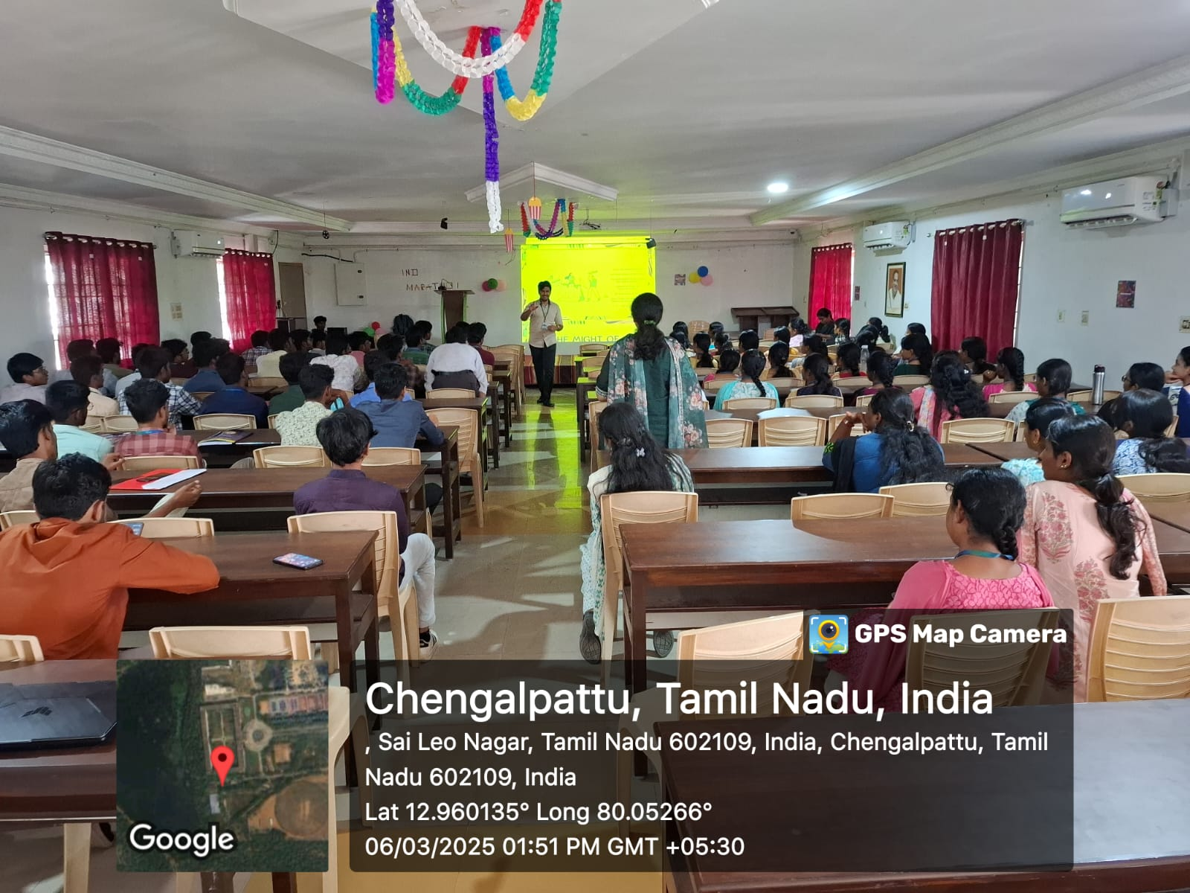
Reported by Suhail Ahmad T

