



IEEE COMPUTER SOCIETY SIT

EXPLORE IEEE CS SOCIETY SCHOLARSHIPS
&
EXPLORE RICHARD E. MERWIN SCHOLARSHIP

NAME OF THE ORGANIZING UNIT: IEEE COMPUTER SOCIETY SIT

DATE OF EVENT: 7th March, Friday

TOPIC: EXPLORE IEEE CS SOCIETY SCHOLARSHIPS & EXPLORE RICHARD E. MERWIN SCHOLARSHIP

MODE OF EVENT: Offline - SSIT Smart Classroom

TARGET AUDIENCE: Student Members

ATTENDANCE: 120
The session featured Dr. Soma Prathibha, who highlighted various funding and scholarship opportunities available through IEEE CS Society, sharing insights on securing support for events. She also discussed her student branch’s success in obtaining multiple scholarships and funded initiatives.
Following this, scholarship awardees Hemalatha Annamalai and Sivasankaran Saravanan provided a detailed walkthrough of the Richard E. Merwin Scholarship application process. They shared key insights on crafting a compelling application, including essay tips and strategies for standing out. The session concluded with an interactive Q&A, addressing participant queries on scholarship opportunities and funding proposals with clear, actionable guidance.

TIMINGS: 1:00 pm – 4:00 pm

EVENT SUMMARY:
The event commenced with an introduction to Dr. Soma Prathibha, a distinguished professor at Sri Sai Ram Engineering College. Her extensive affiliations include IEEE HKN membership, serving as the IEEE CS-SBC Chapter Advisor, and holding executive committee positions in both the IEEE CS Society Madras Section and IEEE WIE Madras Section. Dr. Prathibha elaborated on the myriad opportunities offered by the IEEE Computer Society, emphasizing available scholarships and funding avenues. She highlighted the numerous scholarships and funded events orchestrated under her student branch, providing insights into crafting successful event proposals to secure funding.
Subsequently, the session featured two esteemed scholarship awardees: Hemalatha Annamalai and Sivasankaran Saravanan. They detailed the application process for the Richard E. Merwin Scholarship (REM), offering guidance on eligibility criteria, application components, and deadlines. They underscored the significance of active IEEE Computer Society membership, academic excellence, and leadership in IEEE activities. The awardees also shared personal experiences, offering valuable tips on essay writing and strategies that helped with their successful applications. An interactive Q&A session ensued, addressing inquiries about funded events and providing tailored advice on navigating the scholarship application process.
Key Takeaways:
- Eligibility Criteria: Applicants must be full-time students in electrical or computer engineering, computer science, or related fields, maintaining a minimum GPA of 2.5/4.0. Undergraduate applicants should be in their final two years of study. Active IEEE Computer Society membership for at least three months prior to application is mandatory.
- Application Components: A comprehensive application includes academic transcripts, a primary letter of recommendation from the Student Branch Counselor or Chapter Advisor, and a well-crafted Student Ambassador Vision statement.
- Evaluation Criteria: Applications are assessed based on IEEE involvement (30%), academic achievement (30%), extracurricular activities (10%), recommendation letters (20%), and the quality of the vision statement (10%).
- Deadlines: The scholarship has two application cycles annually, with deadlines on April 30 and September 30. Applicants are advised to prepare and submit materials well in advance.
IEEE Computer Society
This event provided attendees with a thorough understanding of the IEEE Computer Society's scholarship opportunities, particularly the Richard E. Merwin Scholarship, equipping them with the knowledge to effectively pursue these prestigious awards.
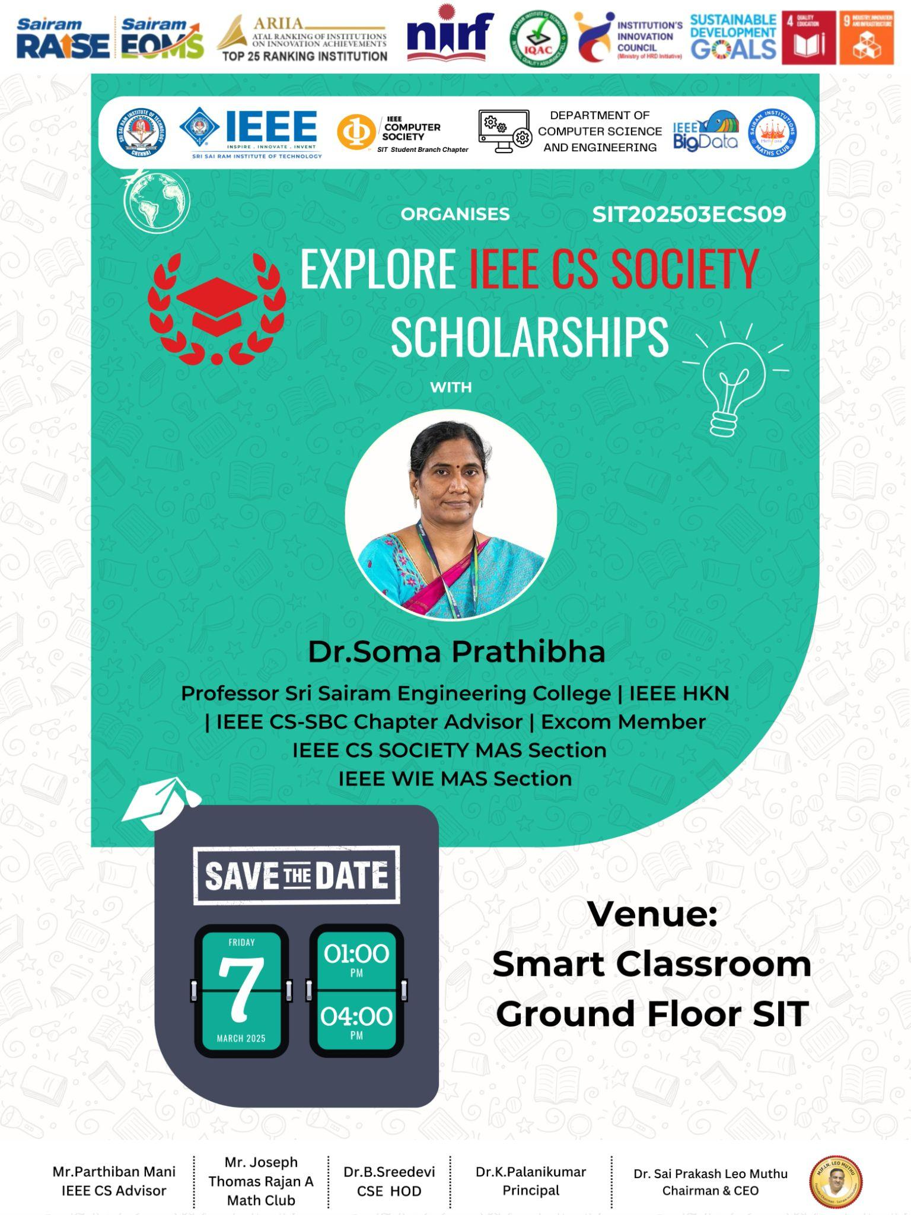
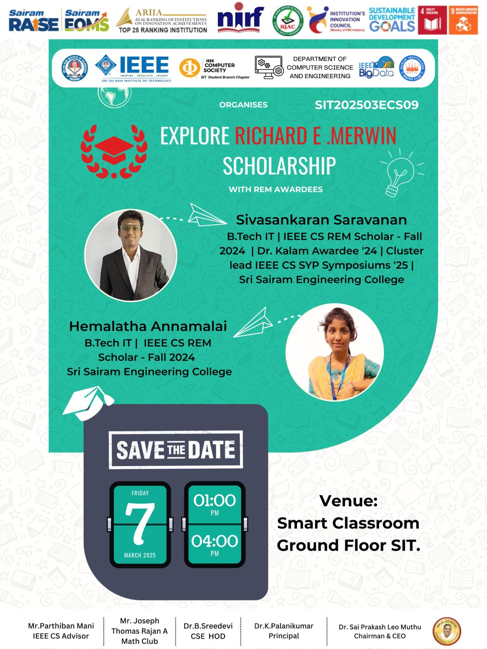

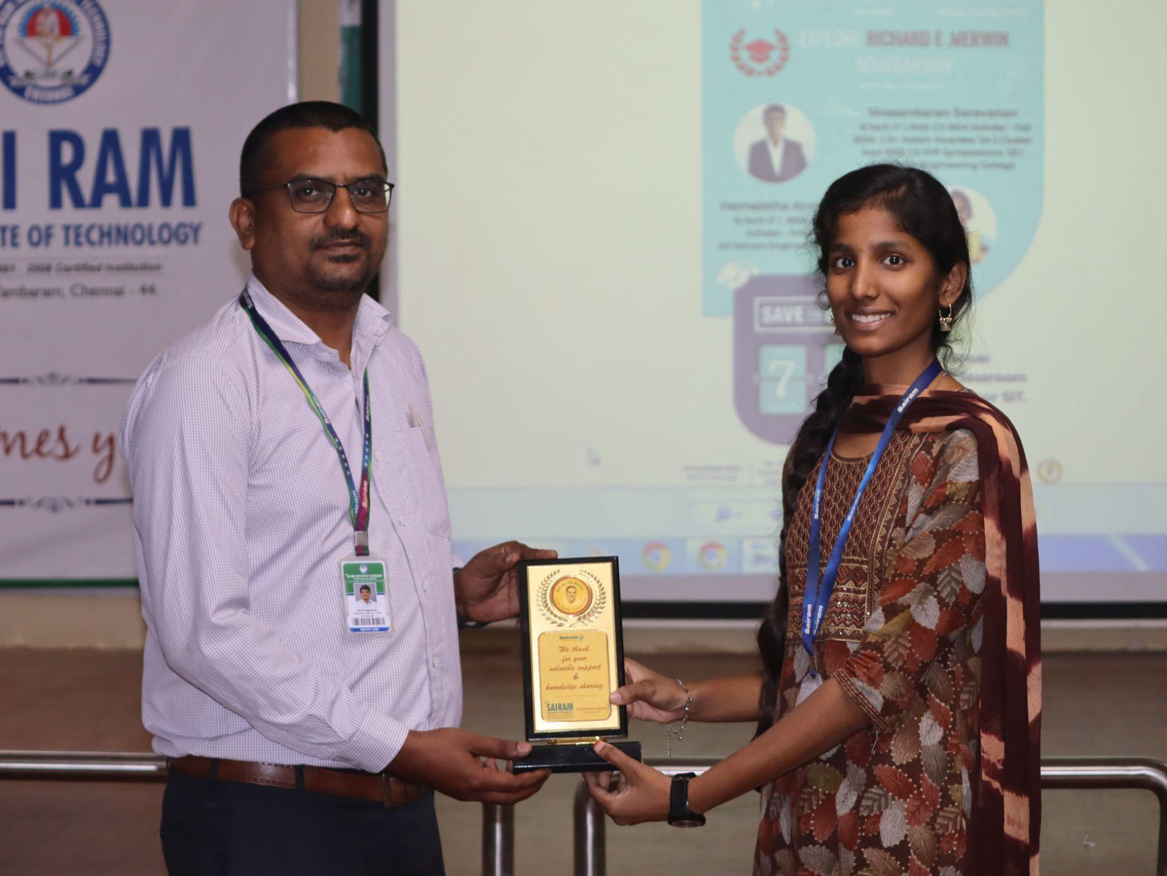
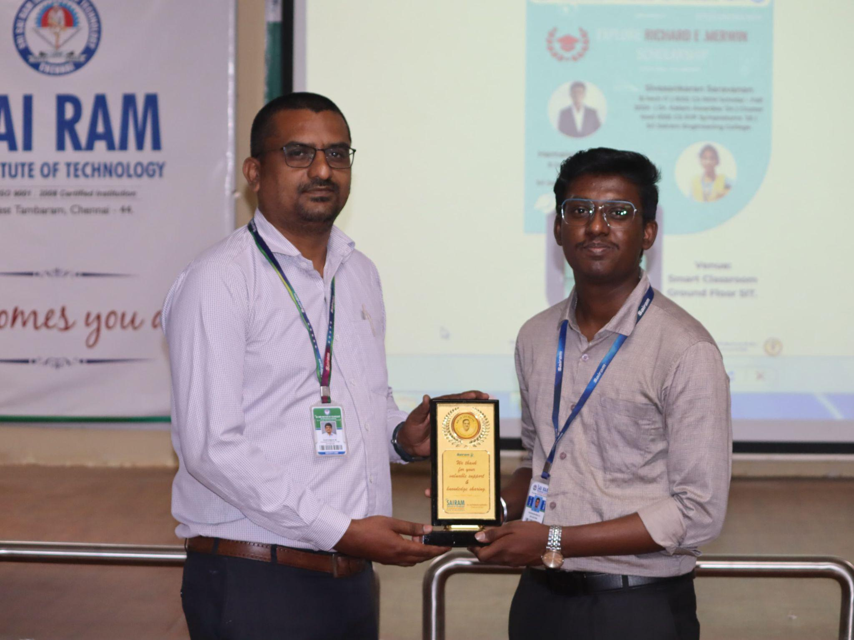
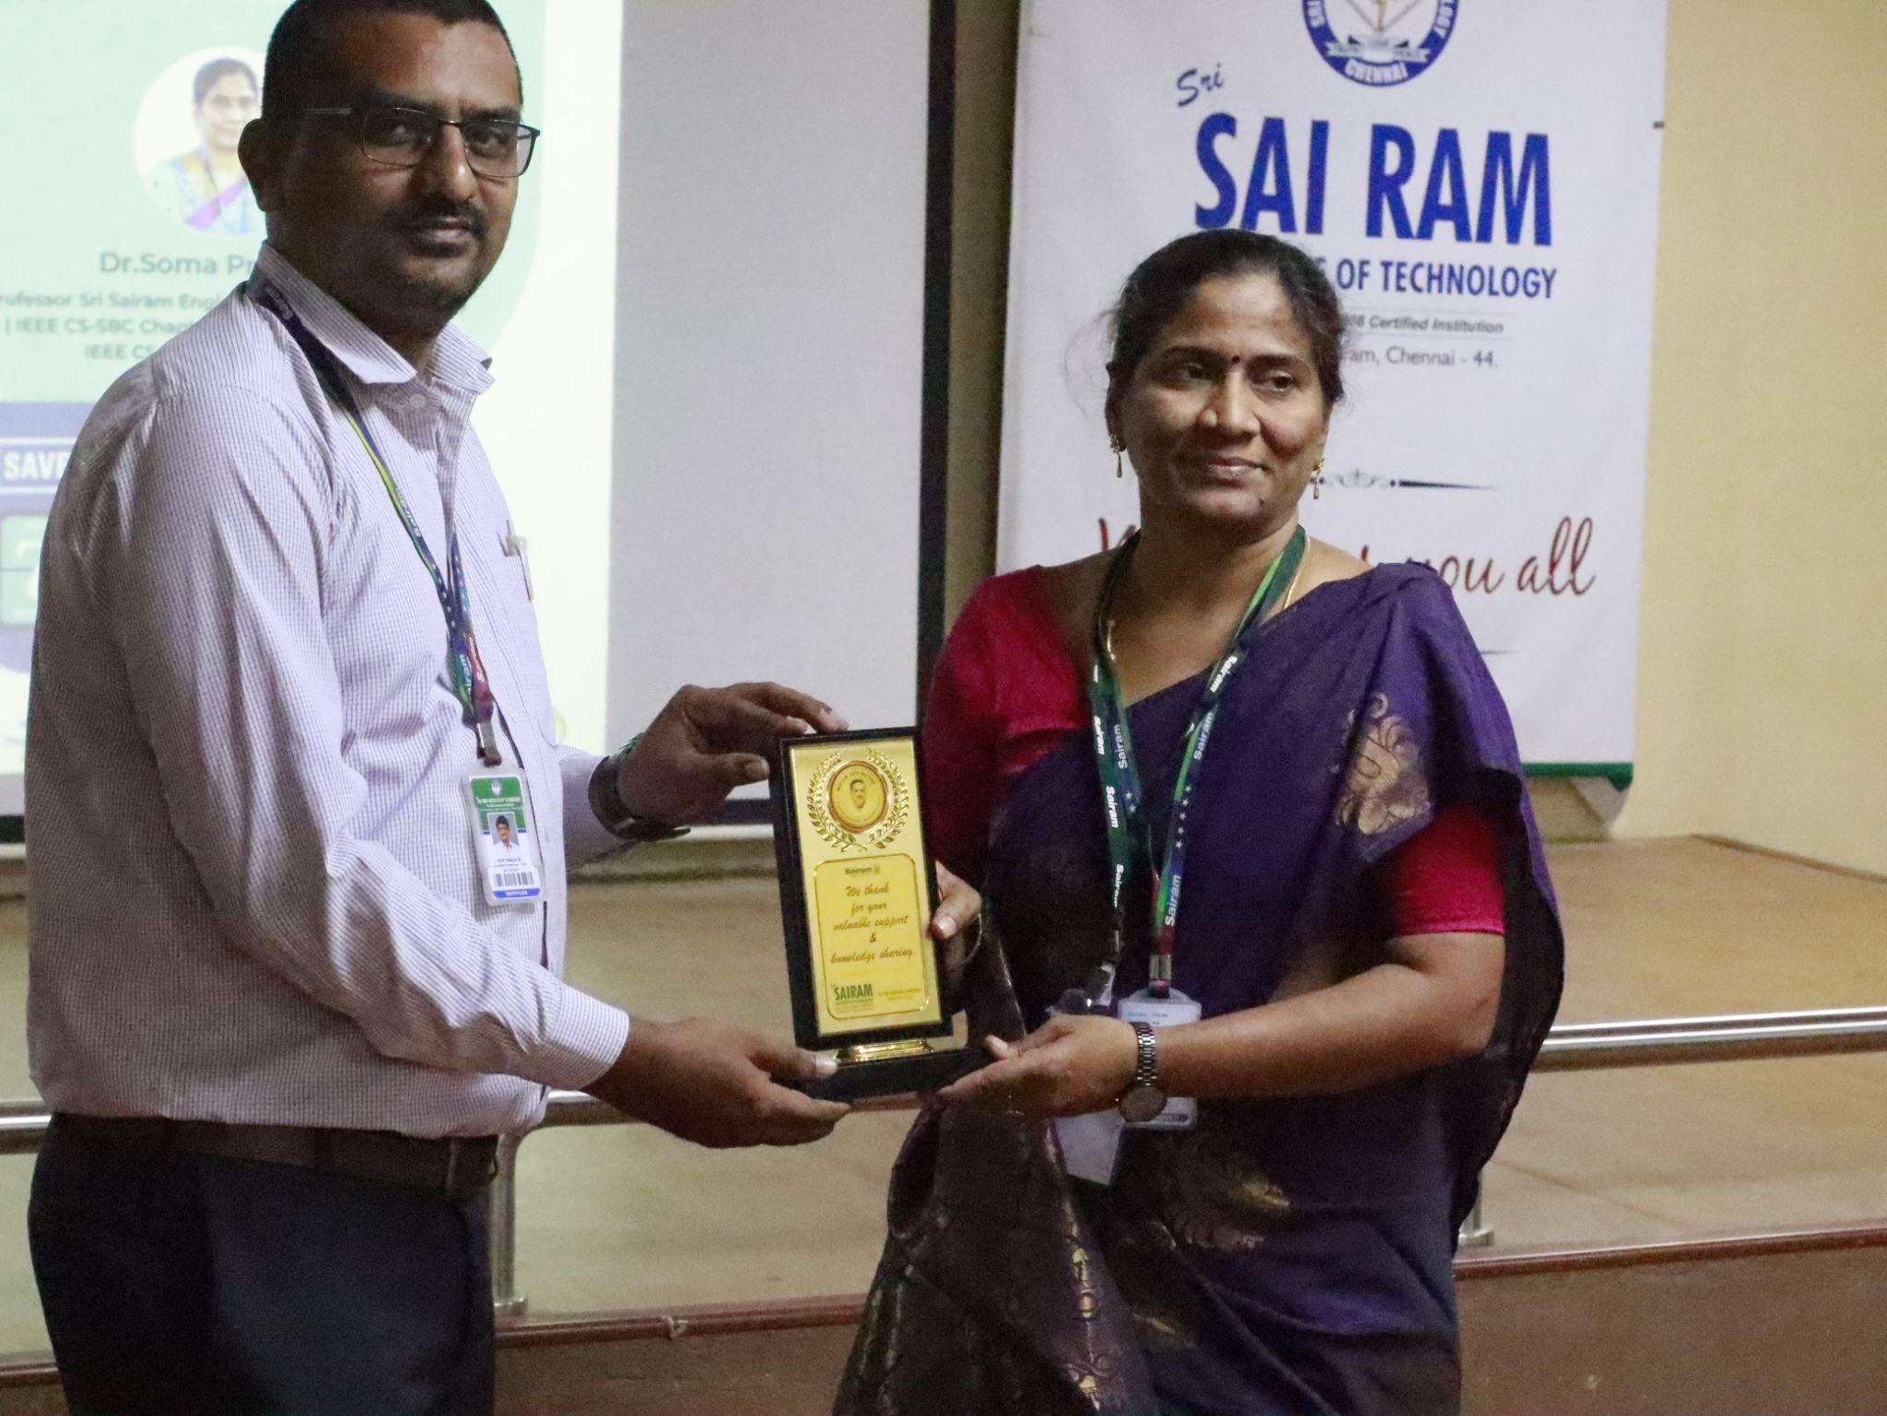

Reported by
Tanushri R M - IEEE CS SECRETARY

