



IEEE COMPUTER SOCIETY SIT
IGNIT ARENA - REELIGN

NAME OF THE ORGANIZING UNIT: IEEE COMPUTER SOCIETY SIT

DATE OF EVENT: 10th March, Monday

TOPIC: IGNIT ARENA - REELIGN

MODE OF EVENT: Online

TARGET AUDIENCE: Student Members

ATTENDANCE: 50

REELIGN was an online event that challenged participants to creatively assemble video clips into a compelling sequence. Teams gained strategic advantages through different tasks, where they could remove clips and earn extra time, and the Mentimeter Quiz, which rewarded the top five teams with the ability to switch clip orders. The event enhanced participants' storytelling, editing, and decision-making skills, while also testing their technical knowledge and adaptability.

TIMINGS: 7:00 pm – 8:30 pm

EVENT SUMMARY:
IGNIT ARENA’s REELIGN was an online event designed to challenge participants’ creativity, storytelling, and editing skills. Teams were provided with a set of video clips and tasked with assembling them into a compelling sequence. Along the way, they engaged in interactive challenges that offered strategic advantages, allowing them to manipulate the clips in creative ways. The event tested not just their technical abilities but also their decision-making and adaptability under constraints.

Tasks – Advantage Rounds: Teams could remove certain clips, unmute their mic to earn extra time, and make creative decisions.
Mentimeter Quiz: A mix of general and technical questions, where the top five teams gained the ability to completely switch clips assigned.
Final Assembly: Teams had to creatively piece together the clips into a cohesive and impactful sequence.

Participants developed a stronger sense of storytelling and video editing, learning how to structure a narrative using limited resources. The event also honed their decision-making skills, as they had to think strategically to make the best use of the advantages provided. By working under time constraints, they improved their problem-solving and adaptability, essential skills in content creation and media production. Additionally, the quiz element tested and reinforced both technical and general knowledge, adding a layer of critical thinking to the competition. Beyond technical skills, REELIGN fostered team collaboration, as participants had to communicate effectively to align their creative vision.
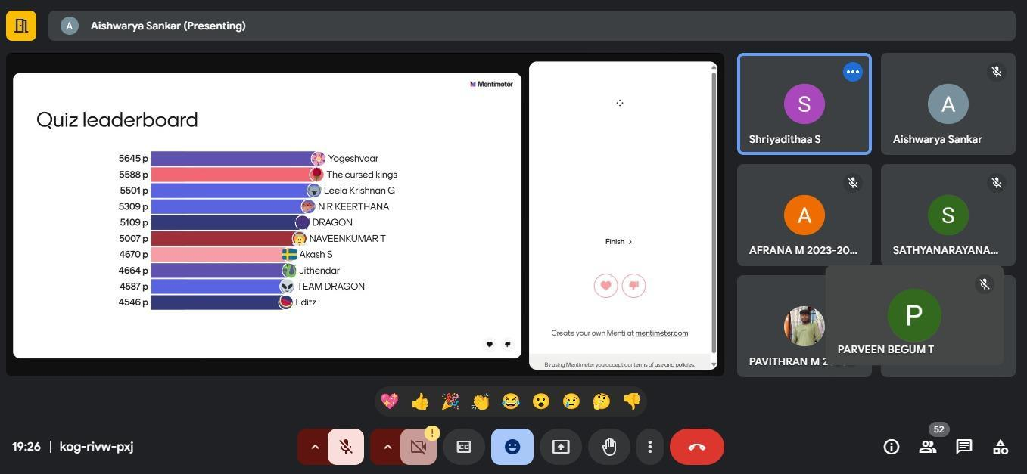

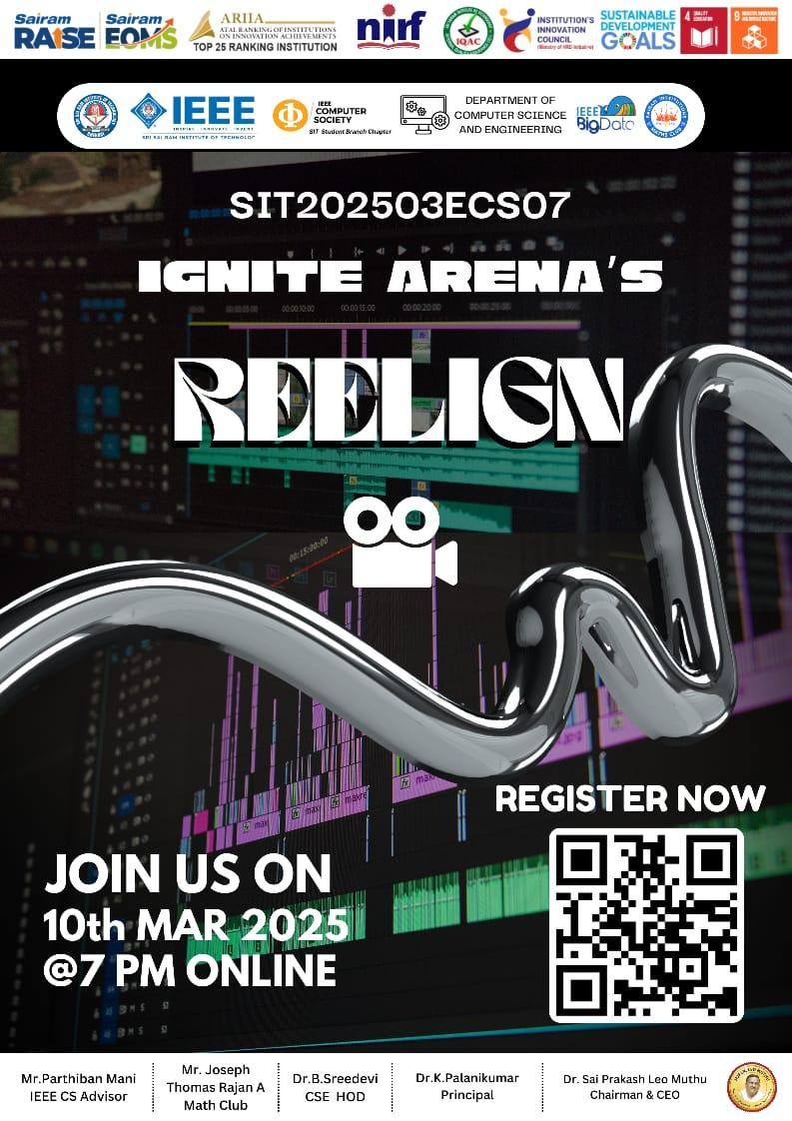

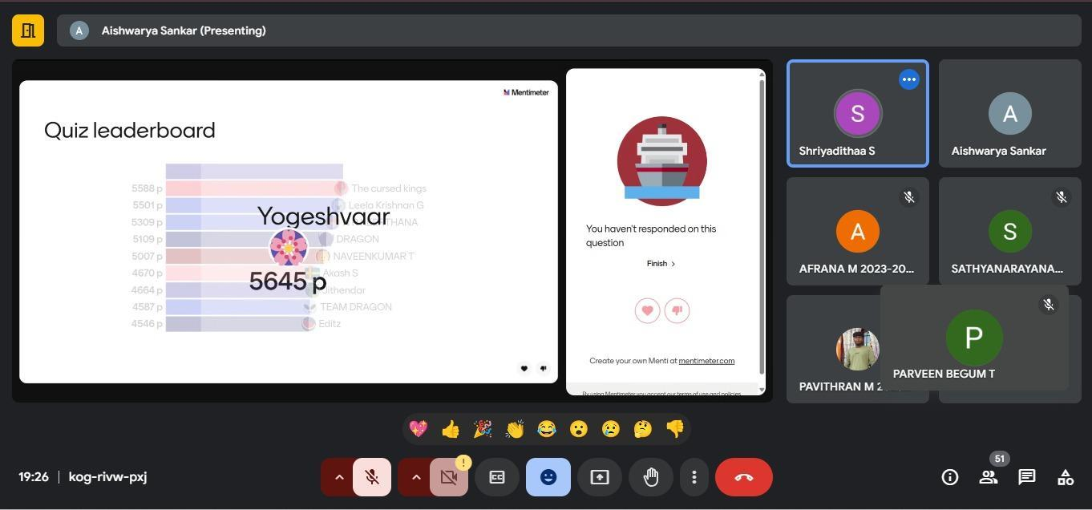

Reported by
Tanushri R M - IEEE CS SECRETARY

