



IEEE COMPUTER SOCIETY SIT
IGNIT ARENA - UI SPRINT

NAME OF THE ORGANIZING UNIT: IEEE COMPUTER SOCIETY SIT

DATE OF EVENT: 13th March, Wednesday

TOPIC: IGNIT ARENA - UI SPRINT

MODE OF EVENT: Online

TARGET AUDIENCE: Student Members

ATTENDANCE: 100
UI SPRINT was a UI/UX design challenge that tested participants’ creativity and problem-solving in digital design. In Round 1, teams redesigned a poorly designed mock website, focusing on usability and interactivity. Shortlisted teams advanced to Round 2, where they built a complete UI/UX from a basic prototype, requiring a structured and user-centric approach. The event helped participants refine their design thinking, prototyping, and usability analysis skills, providing hands-on experience in crafting intuitive and engaging digital interfaces.

TIMINGS: 7:00 pm – 8:30 pm

EVENT SUMMARY:

UI SPRINT was a UI/UX design challenge that tested participants' ability to create functional and visually appealing digital experiences. In an era where intuitive design plays a crucial role in user engagement, this event provided a real-world challenge to help participants think critically about user interaction, accessibility, and aesthetics. The competition focused not just on improving design but also on enhancing the overall user experience, making digital interfaces more seamless and engaging.
The event consisted of two rounds, each testing different aspects of design thinking, creativity, and problem-solving:
- Round 1: Participants were given a poorly designed mock website and had to redesign it by improving its interface, layout, and usability. Their submissions were evaluated based on creativity, interactivity, and overall user experience, with the best designs moving to the next round.
- Round 2 (Finals): The shortlisted teams were challenged to design an entire UI/UX from scratch based on a basic prototype. This round tested their ability to structure a well-thought-out, intuitive, and user-friendly interface from the ground up.
Through this event, participants gained hands-on experience in UI/UX design, strengthened their problem-solving skills, and learned how to create interfaces that are not only aesthetically pleasing but also highly functional. UI PRINT encouraged a user-centric approach, fostering skills in prototyping, usability analysis, and interactive design, making it a valuable challenge for aspiring designers looking to refine their craft.

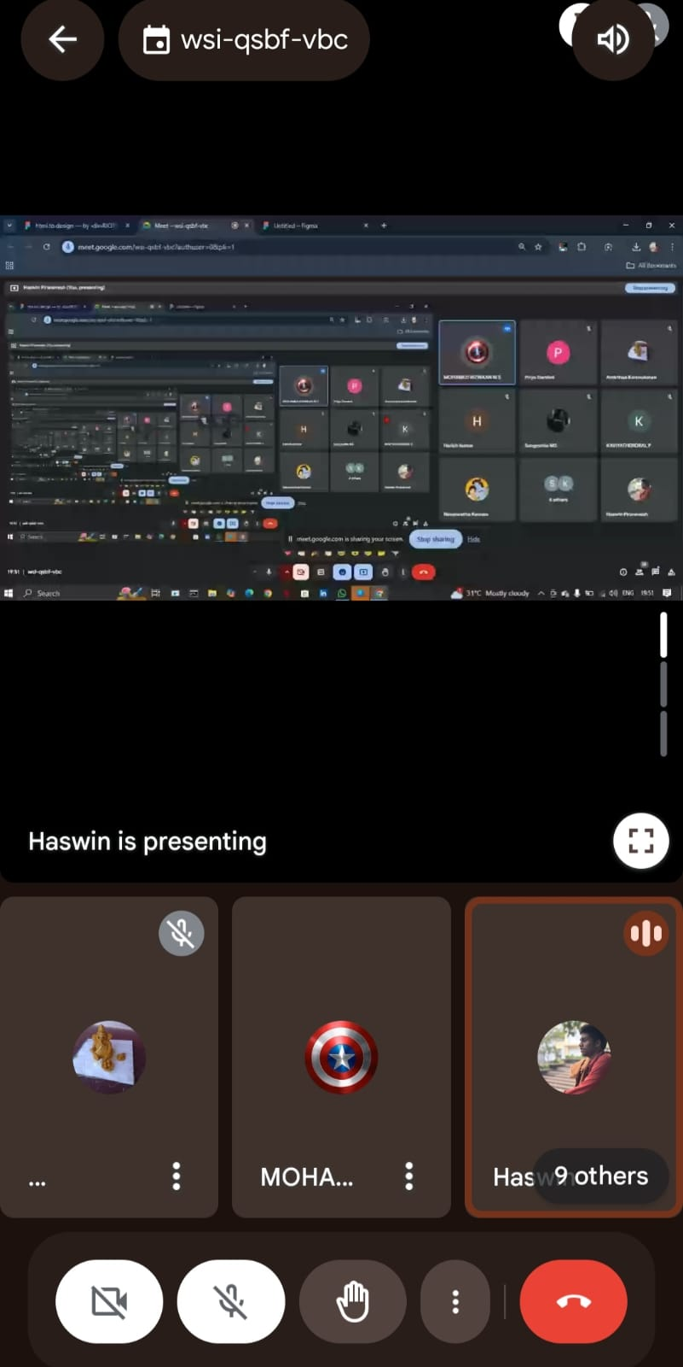

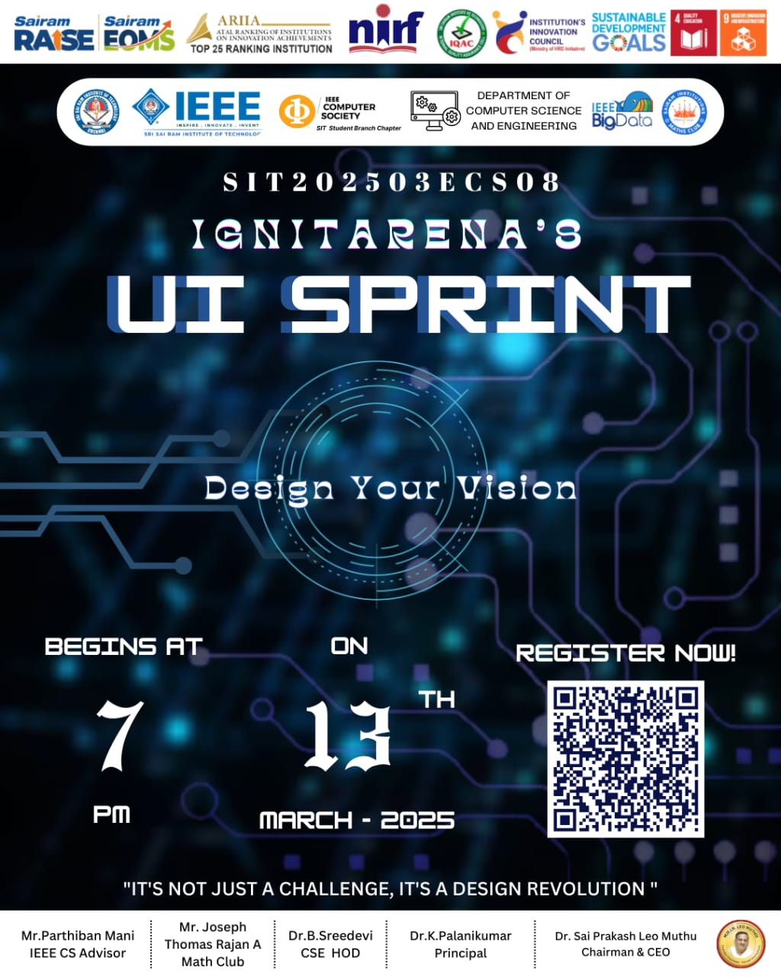

Kkjkjjkjkjkj

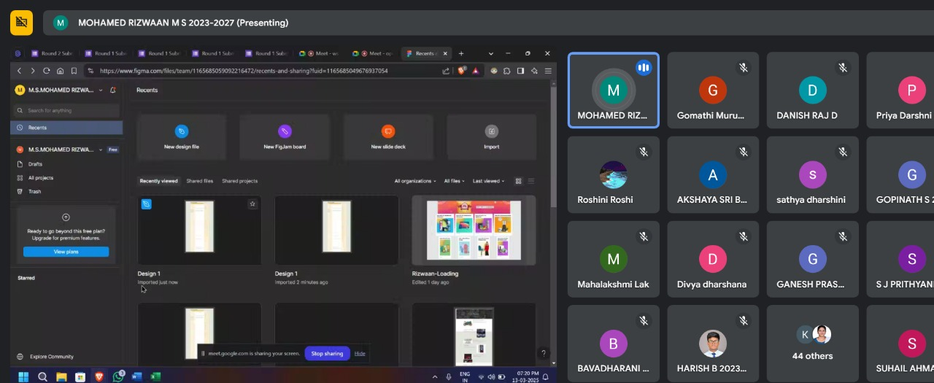

Reported by
Tanushri R M - IEEE CS SECRETARY

