



**IEEE Mysore Subsection – R0011903**

[Home - IEEE Mysore Subsection](https://ieeemyss.org/)

**Minutes of the EXECOM Meeting**

Date: 12-03-2025

Time: 05 PM onwards

Mode: Blended

Venue: Alok’s Kitchen, JSS STU Campus, Mysuru-06

Meeting Link: <https://meet.google.com/ppf-xkhp-iwg>

**AGENDA**

1. Report on last month events.
2. Discussion on SOP
3. Student Congress
4. Celebration of National Science day.
5. Any other matter with the permission of the chair.

Chair, Dr. Ravichandra, welcomed all EXECOM members and briefly reviewed the details of the last EXECOM meeting.

1. The MCAA in collaboration with the Mysore Subsection, successfully celebrated the International Day of Women and Girls in Science on 11th February 2025, conducted by SJCE, JSS STU, Mysuru.
2. Malnad College of Engineering has agreed to host the Student Congress in the last week of April or the first week of May 2025.
3. As suggested by Shashidhar Dongre Sir, the EXECOM members have agreed to conduct a technical talk during the EXECOM meeting and Chair suggested that the talks by execom members can be held at SBs too.
4. The National Science and Women’s Day event will be held at Govt. Engineering College, K R Pete, before 25th March 2025.
5. The SOP will be finalized by the committee members.
6. Dr. Keerthi D. S., from MCE, Hassan, has been nominated as the SAC Chair for the year 2025.
7. Dr. Keerthi D. S., from MCE, has discussed the establishment of a new student branch with Rajeev College of Engineering.
8. ICETEG 2025, organized by JSS STU, Mysuru, with IEEE MYSS as the technical sponsor, is scheduled for this year.
9. The AICTE-sponsored IEEE Conference, with IEEE MYSS Technical Sponsorship, will take place on June 27th and 28th, 2025, at VVCE, Mysuru. A total of 800 papers were received, with 100 papers being desk-rejected.
10. For MysuruCon 2024, IEEE MCE requested clarification regarding the conference publication. The committee members have sent the clarification to MCE and are awaiting approval.
11. Immediate past chair suggested on a sky watching show and the same was decided to be pursued.
12. The MysuruCon 2025 application was submitted but declined due to a technical issue in the application form.
13. Regarding the organization of MysuruCon 2025, EXECOM members suggested Various options like, taking break in organizing conference for a year, looking for other conference venue, doing independently were all deliberated. It was decided to take a call considering all options.

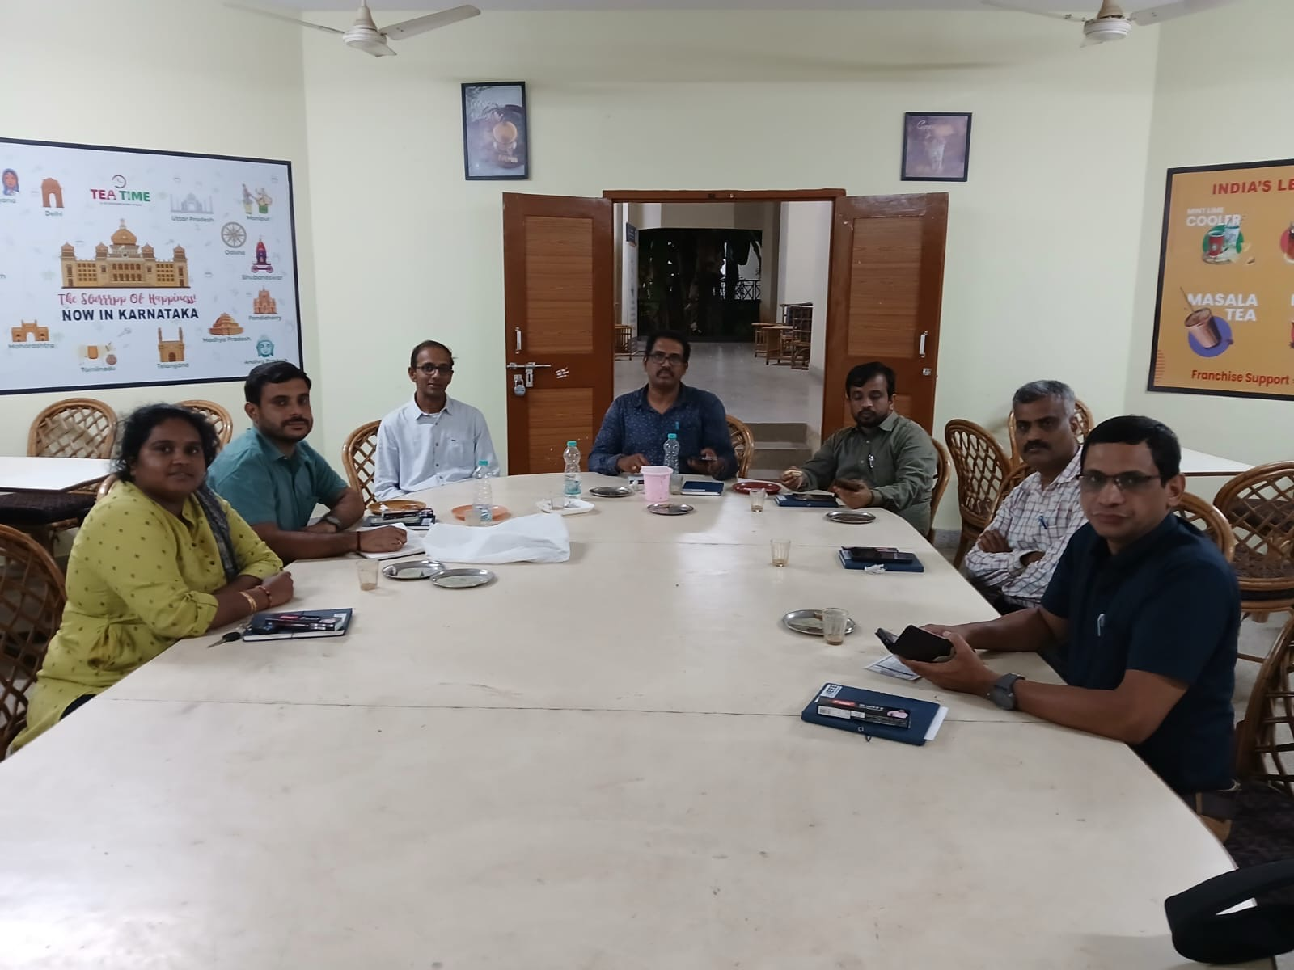

Fig.1 Offline Meeting Attendees

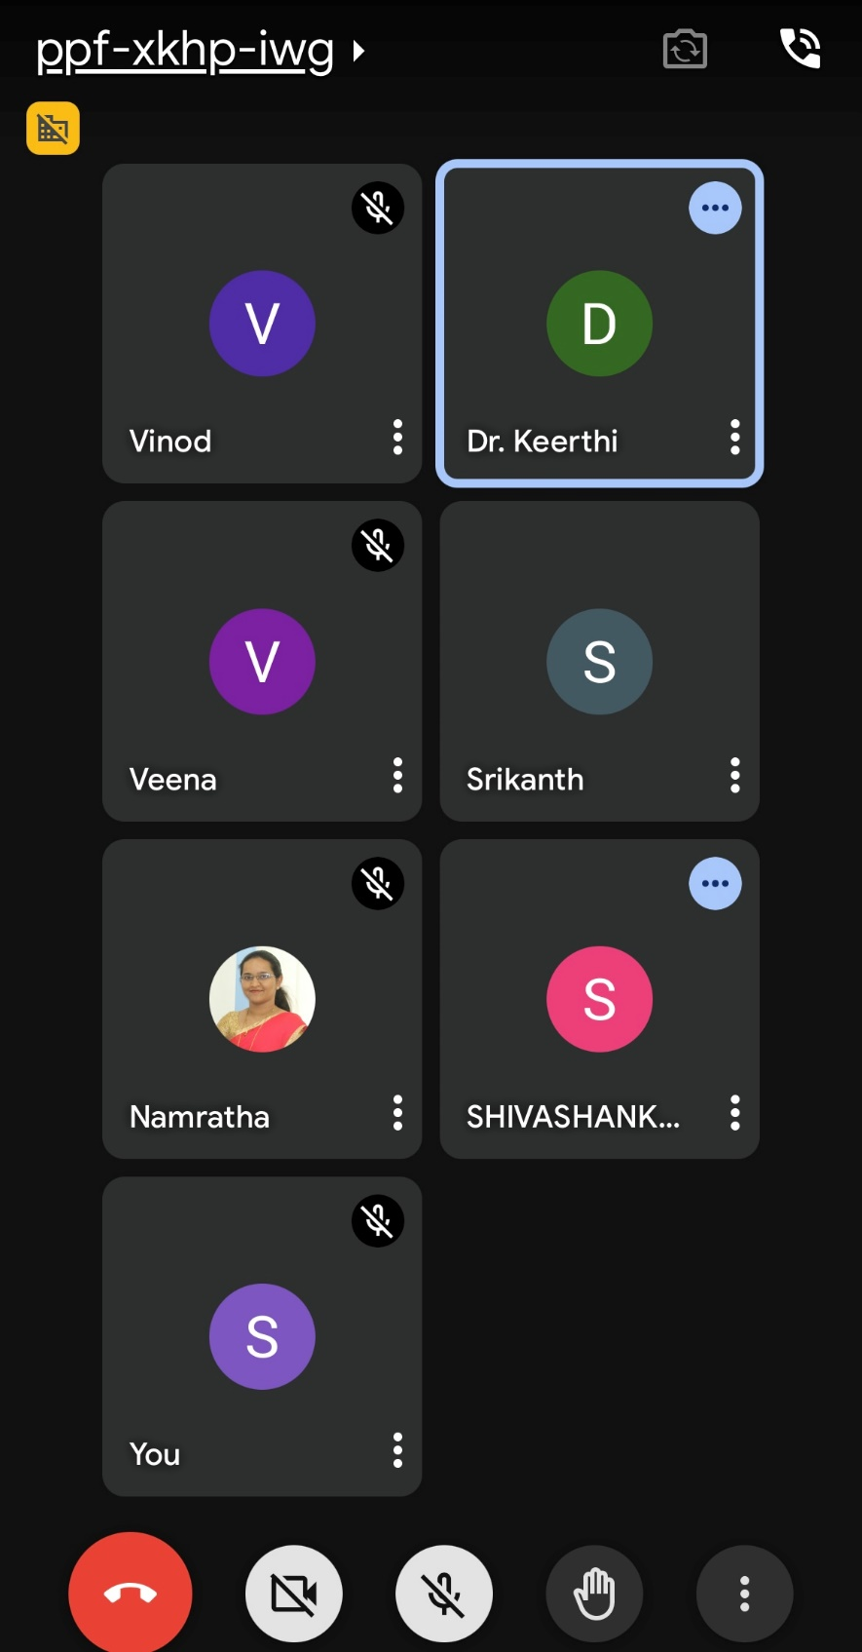

Fig.2 Online Meeting Attendees

|  |  |  |
| --- | --- | --- |
| **Members Present offline** | **Members Present online** | **Member absent** |
| Dr Ravichandra Kulkarni | Dr. Keerthi D S | MHP Kumar Raja |
| Dr Vishwas Lakkundi | Dr. Vinod Kumar P | Dr Archana N V |
| Dr Shivashankar | Dr. Srikanth | Dr Shashidhar H R |
| Dr Ramakrishna Hegde | Dr. Veena M G | Dr Deepak H A |
| Dr Shashidhar R | Prof Namratha Dcruz | Vamsi Krishna Addepalli |
| Prof. Supreetha M |  |  |
| Dr. Sudarshan Patilkulkarni |  |  |

Prepared by, Approved by,

Dr. Shashidhar R, Dr. Ravichandra Kulkarni  
Secretary, IEEE MYSS-2025 Chair, IEEE MYSS-2025