A Report on the Invited Talk
Of
IEEE ComSoc Chapter-Guwahati (Kolkata Section) and IEEE Guwahati Subsection

The invited talk by Dr. Alexis A. Dowhuszko was jointly organized by the IEEE Communications Society (ComSoc) Chapter-Guwahati (Kolkata Section) and IEEE Guwahati Subsection.

The details of the talk are as follows:

Title of Talk: Optical Wireless Technologies in beyond 5G
Date: March 21, 2025 (Friday)
Time: 3.00 PM to 4.00 PM (IST)
Mode: Seminar room (2nd Floor), EEE Dept., IIT Guwahati

Details of the event:
Alexis A. Dowhuszko (Senior Member, IEEE) received the degree in telecommunications engineer from Blas Pascal University, Córdoba, Argentina, in 2002, and the Ph.D. degree in engineering sciences from Universidad Nacional de Córdoba, Córdoba, Argentina, in 2010. From 2010 to 2015, he was a Post-Doctoral Researcher with the Department of Communications and Networking, Aalto University, Helsinki, Finland. In 2016, he moved to Spain to take a Senior Researcher position with Centre Tecnològic de Telecomunicacions de Catalunya, Barcelona, Spain. In August 2020, he returned to Finland and joined Aalto University, as a Research Fellow. He has authored or coauthored more than 25 journal articles, 60 conference papers, one book chapter, and five patent applications.
During the talk, Dr. Alexis introduced a novel optical communication strategy. Optical Wireless Technologies (OWT) are emerging as a pivotal component in the evolution of beyond 5G (B5G) networks, offering high-capacity, low-latency, and energy-efficient communication solutions. Unlike traditional radio frequency (RF) systems, OWT leverages the vast unlicensed optical spectrum, including visible light, infrared, and ultraviolet bands, to enable ultra-high data rate transmissions. Technologies such as Visible Light Communication (VLC), Free Space Optical Communication (FSO), and LiFi are particularly promising for high-density environments, indoor networks, and backhaul/fronthaul links in heterogeneous networks. By complementing RF-based systems, OWT can significantly enhance spectrum efficiency, security, and spatial reuse in B5G networks. However, challenges like line-of-sight requirements, atmospheric interference, and mobility support need to be addressed to fully harness the potential of optical wireless communication in the next-generation wireless ecosystem. All the attendees benefitted immensely through this interaction.

Event Photograph:
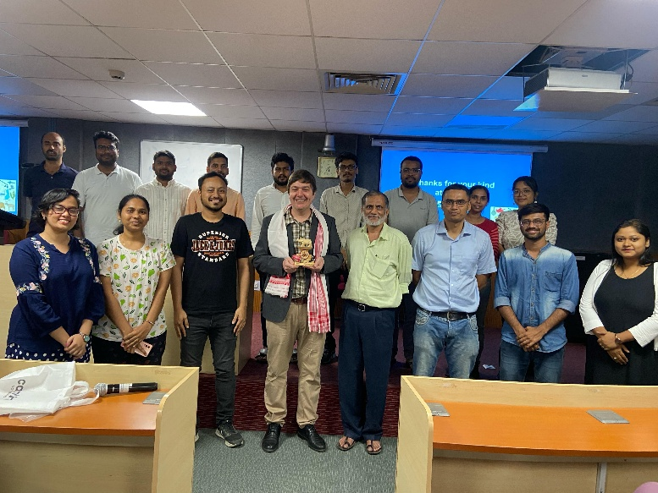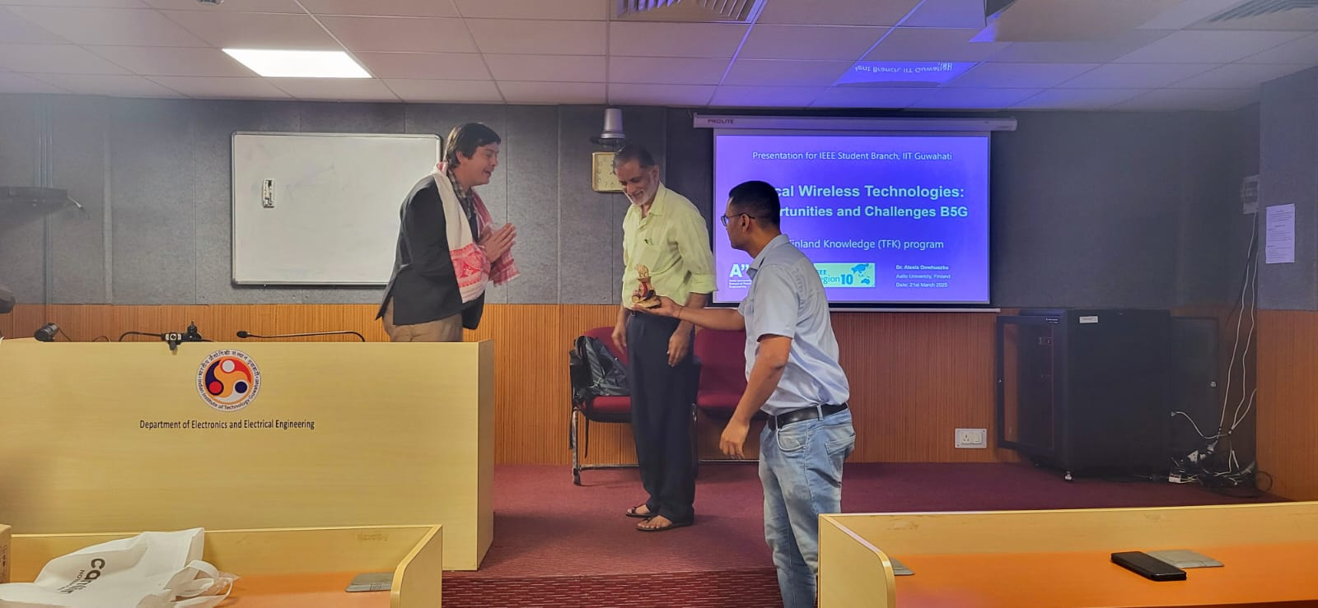

Link for VTools event details: https://events.vtools.ieee.org/m/475673

