
IEEE COMPUTER SOCIETY SIT

THE UNVEILED SERIES EPISODE 23

NAME OF THE ORGANIZING UNIT: IEEE COMPUTER SOCIETY SIT

DATE OF EVENT: 3rd May, Saturday 2025

TOPIC: THE UNVEILED SERIES EPISODE 23 - FREELANCING

MODE OF EVENT: Online

TARGET AUDIENCE: Student Members

On 3rd May 2025, the IEEE Computer Society SIT hosted Unveiled Series Episode 23 on the topic "Freelancing." The session offered valuable guidance for students looking to transform their skills into income through freelance work. Covering essentials such as finding clients, building a personal brand, and sustaining a career in the freelance world, the event featured practical tips and real-life experiences.

ATTENDANCE: 50

EVENT SUMMARY:
Unveiled Episode 23: Freelancing explored the dynamic world of freelance work, offering attendees a roadmap to transform their skills into meaningful income. The session opened by breaking down the fundamentals of freelancing—how to get started, build a strong profile, and navigate common platforms to land the first client.
Drawing from real-world experiences and practical examples, the speaker shared valuable insights into client communication, portfolio building, rate negotiation, and creating a sustainable freelance career. Challenges such as inconsistent income, self-discipline, and competition were addressed with practical strategies and mindset shifts to overcome them.
The event concluded with an engaging Q&A session and actionable guidance, encouraging participants to take confident steps toward independence. By combining motivational stories with clear direction, Unveiled Episode 23 equipped attendees with the clarity and confidence to begin or enhance their freelancing journey in today’s digital economy.
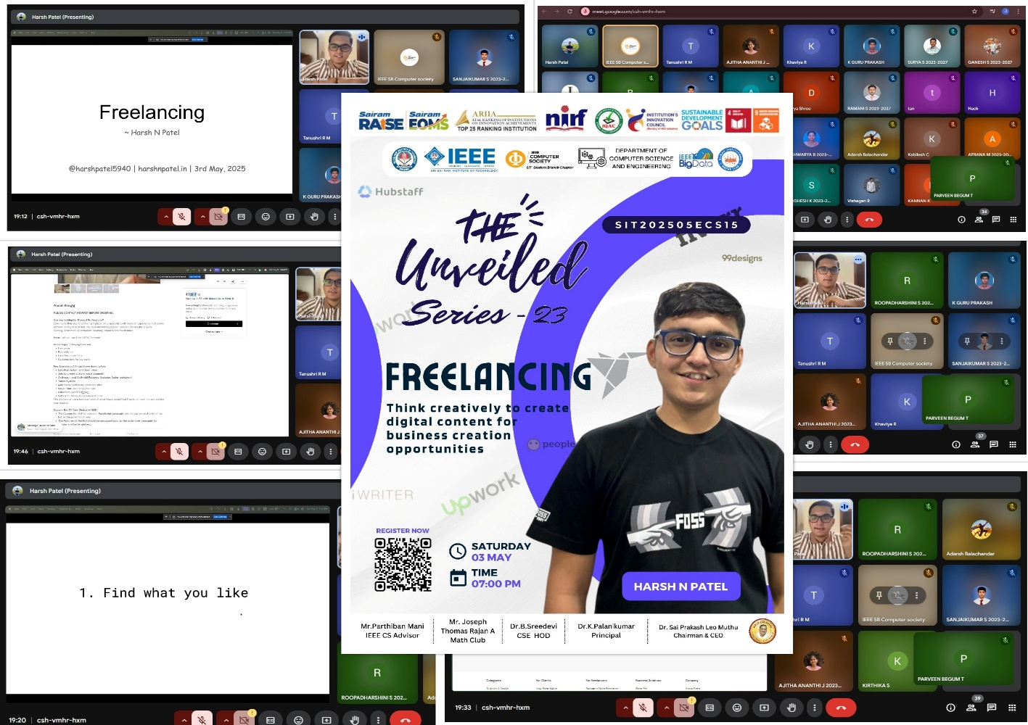
REPORTED BY SUHAIL AHMAD T – IEEE CS SECRETARY

