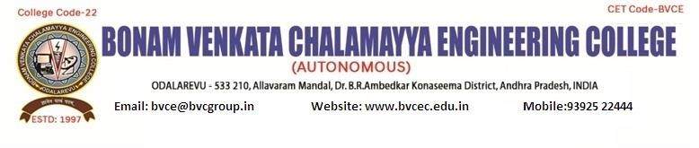

IEEE PES SB Chapter 13691

IEEEPESDAY EVENT Webinar: "Green power".

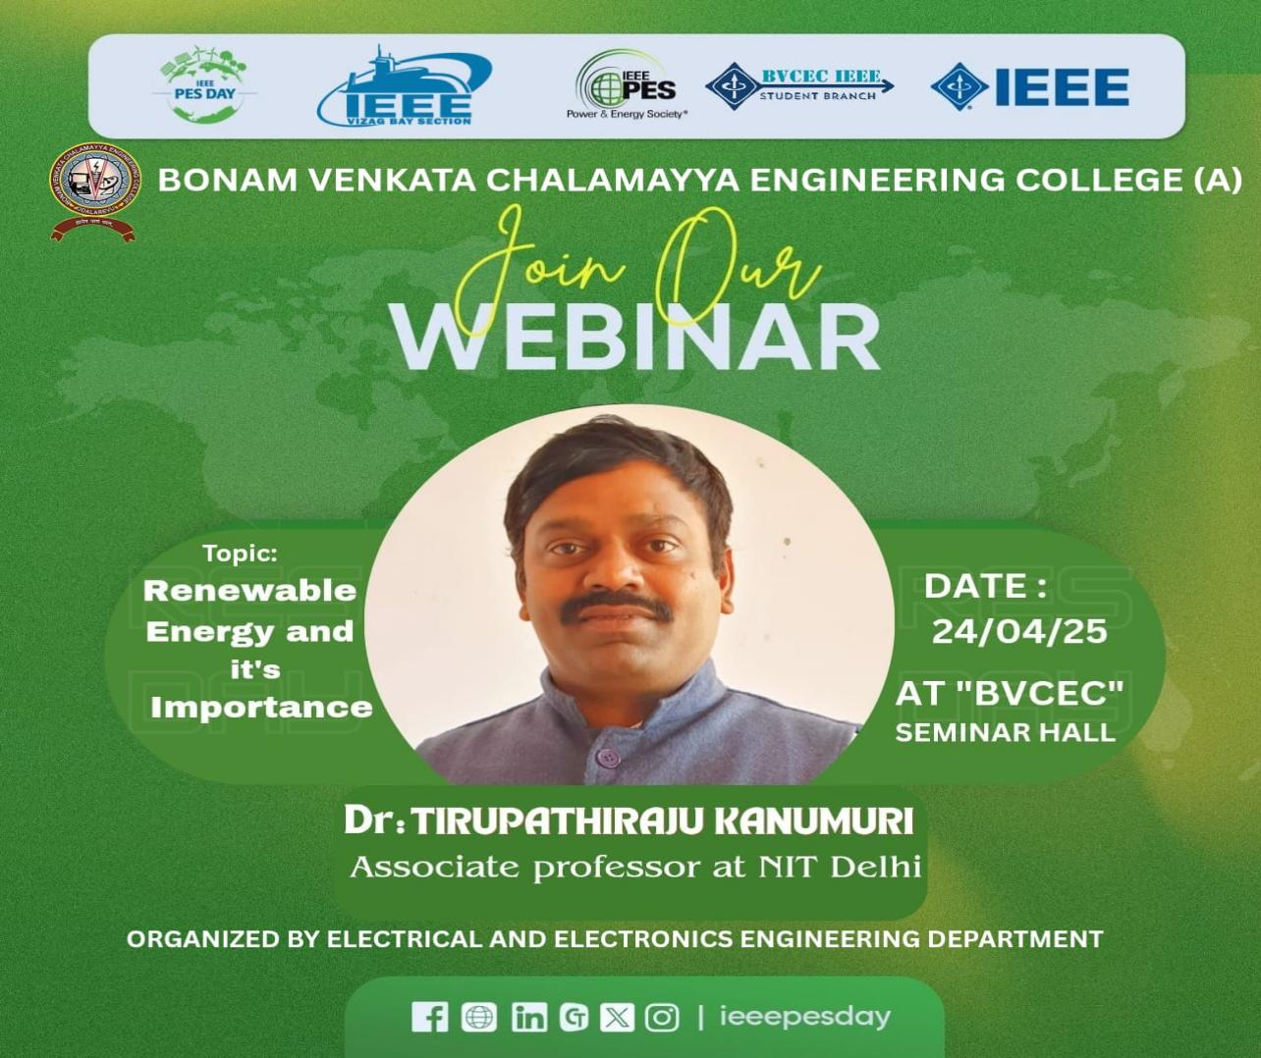

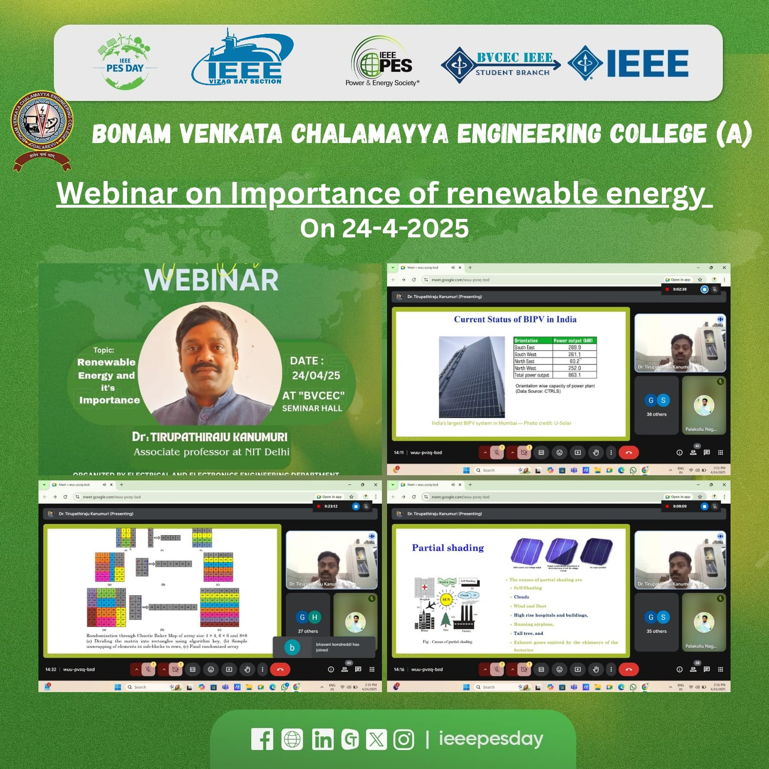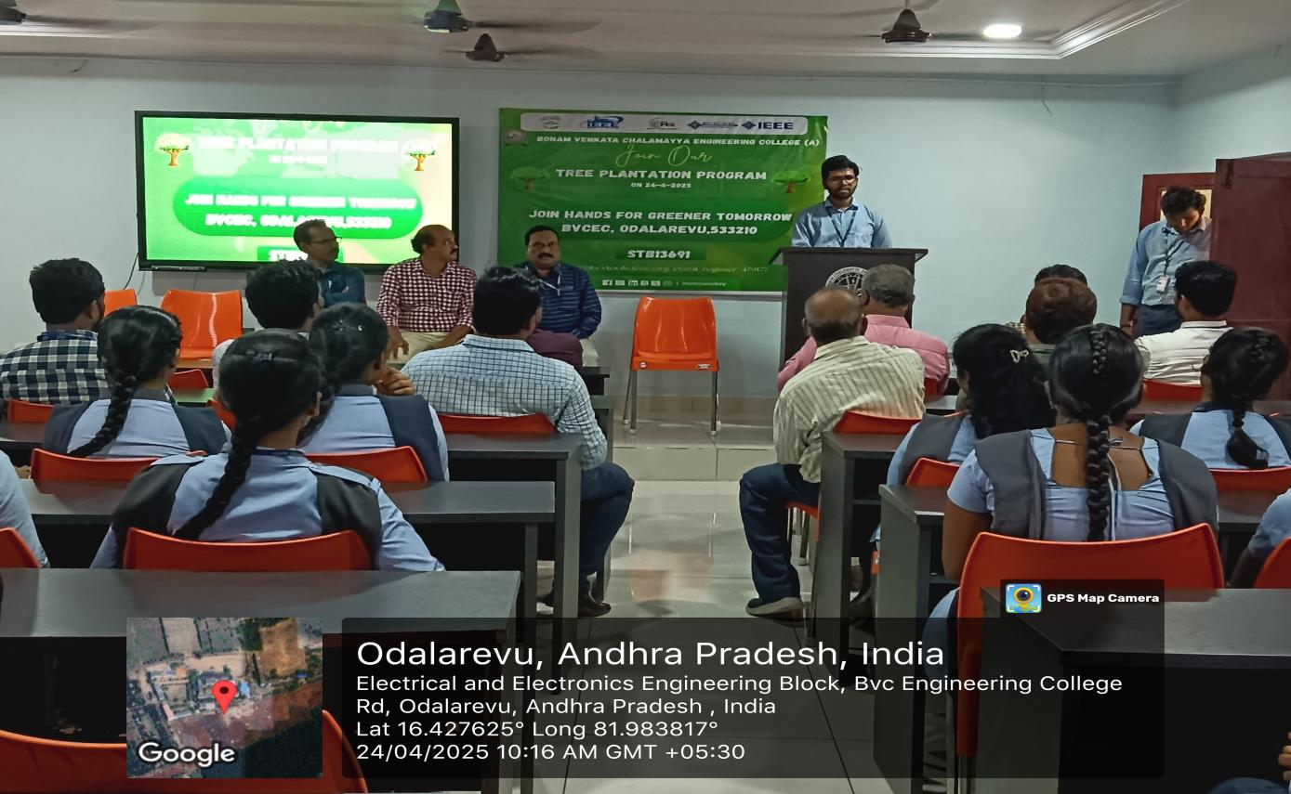

# EVENT DESCRIPTION:

This is an announcement for a “WEBINAR”organized by **BVC Engineering College**, specifically the **Department of Electrical and Electronics Engineering (EEE)**, in association with **IEEE PES SB Chapter 13691**. Below is the detailed description:

## Program Details:

* **Event Name**: Webinar on **"Importance of Renewable Energy"**.
* **Date**: Scheduled for **24-4-2025**.

### Organized by:

* + **Department of EEE**, BVC Engineering College.

### IEEE Power & Energy Society (PES) Student Branch Chapter (13691).

* + Supported by the **Institution’s Innovation Council (Ministry of Education Initiative)**.
  + **NAAC-accredited** institution affiliated with **JNTU Kakinada**.

## About the Speaker:

### Name: Dr. Tirupathiraju Kanumuri.

* **Designation**: Associate Professor.

### Institution: National Institute of Technology (NIT), Delhi.

Dr. Tirupathiraju Kanumuri is an expert in the field of electrical engineering, with significant academic and research credentials. His association with **NIT Delhi**, a premier engineering institute, highlights his expertise in innovative applications and advancements in electrical engineering.

## Purpose and Significance:

On the ocassion of IEEPESDAY this ecture aims to provide students and faculty members with insights into the latest **applications and importance of RENEWABLE ENERGY** , potentially covering topics such as energy systems, Wind energy,Hydro energy,Solar energy , other cutting-edge technologies. This session will benefit participants by expanding their knowledge and exposing them to real-world applications in the field of electrical engineering.

It also reflects the institution's commitment to fostering learning and innovation by collaborating with esteemed professionals.

Dr. Tirupathiraju Kanumuri is an esteemed academic currently serving as an Associate Professor at

the National Institute of Technology (NIT), Delhi. He is also the head of the Department of Electrical and Electronics Engineering at the institution. His research interests focus on areas such as **pattern recognition, biometrics, and medical image processing**, showcasing his expertise in cutting-edge applications of electrical and electronics engineering in interdisciplinary domains

Dr. Tirupathiraju is actively involved in research and innovation, contributing significantly to the advancement of engineering education and technology. At NIT Delhi, he is known for fostering innovation and guiding students in exploring emerging technologies within electrical engineering

For the program depicted in the poster, Dr. **Tirupathiraju** will deliver a **guest lecture on "Electrical Engineering Applications"** under the collaboration of the IEEE Power and Energy Society Student

Branch Chapter at BVC Engineering College. The event is scheduled for **December 30, 2023**, and aims to provide insights into practical and innovative uses of electrical engineering principles. This session is a great opportunity for students and professionals to learn from his extensive expertise and contributions to the field.

# EVENT DETAILS:

**Date: 24/04/2025**

**Timings: 2:**00 PM. to 4.00 P.M.

**Venue:** EEE Department E-Class Room, BVCE

**Participants attended:** 60

**Branch Counselor:** Dr. S. Srikanth

**Faculty Coordinator:** Mr. G. Lova Raju

**Faculty Coordinator:** Mr. N. Siva Nagendra

# PE31, IEEE-BVCE SBC13691:

CH.V.S.J.SWATESH – Chairperson (PESDAY AMBASSADOR)

1. ASWINI –Vice Chairperson

Y S S VARA PRASAD– Secretary

P.SATISH - Treasurer

K.SANJU – Web Master

T.RAMYA – Web Master

P.GAYATHRI – PES Representative

K.ANJHANEE SRI - IEEE AMBASODOR

R.VISWAS - IEEE MEMBER

M.HARSHA VARDHAN - IEEE MEMBER

L.SAI RAMA VARMA - IEEE MEMBER

R.GOWTHAM - IEEE MEMBER

U.DEVENDRA SRI - IEEE MEMBER

P.MANIKANTA SAI - IEEE MEMBER

CH.SHALINI - IEEE MEMBER

1. VALLIKA - IEEE MEMBER

A.KARUNA - IEEE MEMBER

