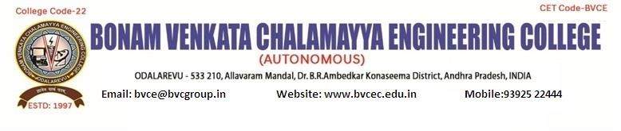

IEEE PES SB Chapter 13691

**IEEEPESDAY EVENT : "Project Expo"**

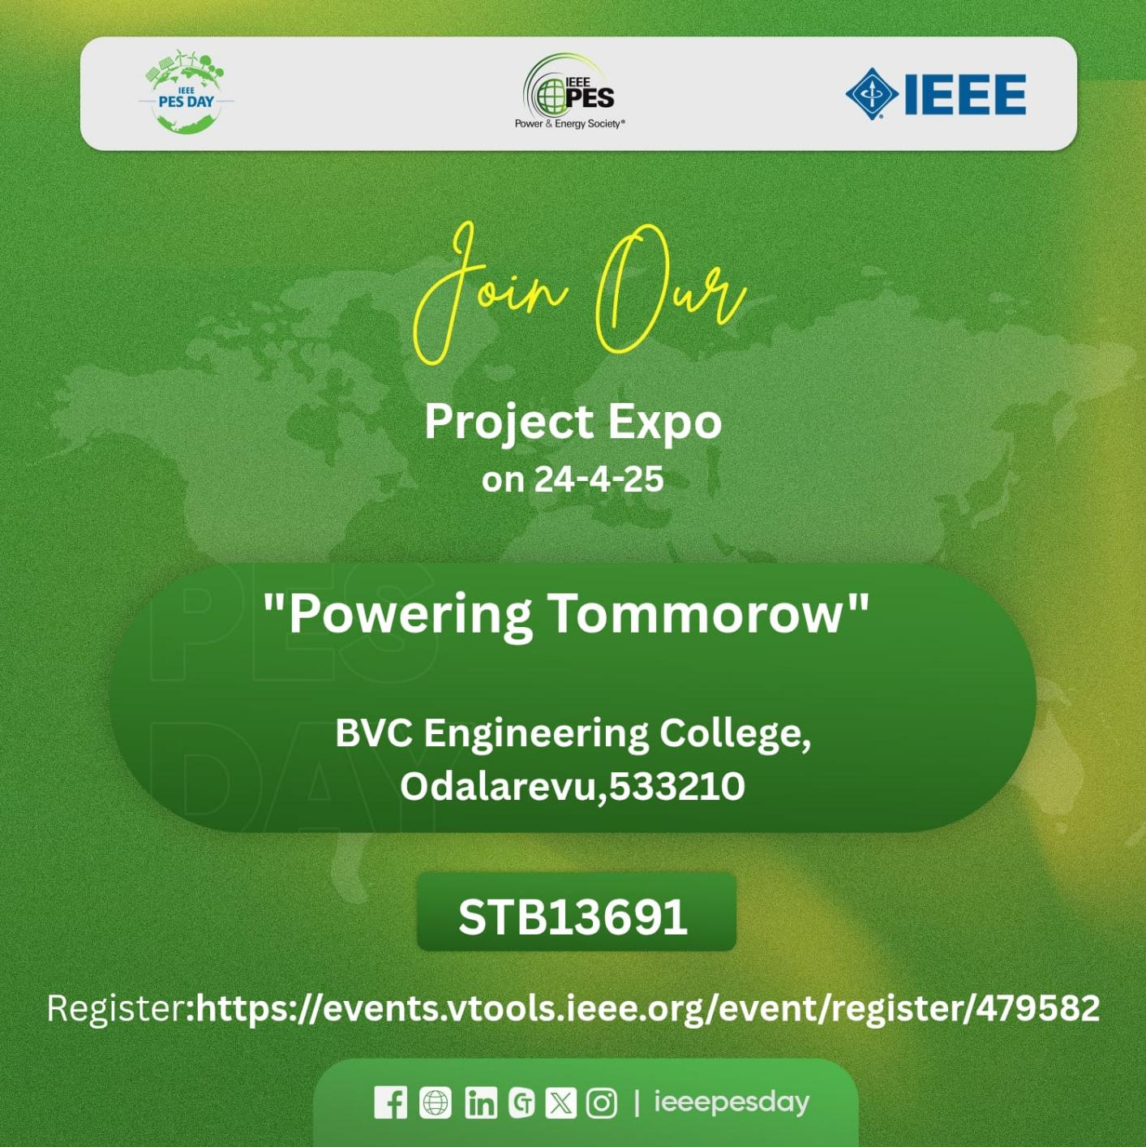

# EVENT DESCRIPTION:

This is an announcement for a “Project - Expo”organized by **BVC Engineering College**, specifically the **Department of Electrical and Electronics Engineering (EEE)**, in association with **IEEE PES SB Chapter 13691**. Below is the detailed description:

## Program Details:

* **Event Name**: **IEEEPESDAY** - **Project Expo**
* **Date**: Scheduled for **24-4-2025**.

### Organized by:

* + **Department of EEE**, BVC Engineering College.

### IEEE Power & Energy Society (PES) Student Branch Chapter (13691).

* + Supported by the **Institution’s Innovation Council (Ministry of Education Initiative)**.
  + **NAAC-accredited** institution affiliated with **JNTU Kakinada**.

## About the Judge:

### Name: Dr.S Srikanth

* **Designation**: **Professor & HOD of EEE DPT.**

### Institution: Bonam venkata chalamayya engineering college

# EVENT DETAILS:

**Date: 24/04/2025**

**Timings: 10:**00 AM. to 12.00 P.M.

**Venue:** EEE Department E-Class Room, BVCE

**Participants attended: 40**

**Branch Counselor:** Dr. S. Srikanth

**Faculty Coordinator:** Mr. G. Lova Raju

**Faculty Coordinator:** Mr. N. Siva Nagendra

# PE31, IEEE-BVCE SBC13691:

**CH.V.S.J.SWATESH – Chairperson (PESDAY AMBASSADOR)**

1. ASWINI –Vice Chairperson

Y S S VARA PRASAD– Secretary

P.SATISH - Treasurer

K.SANJU – Web Master

T.RAMYA – Web Master

P.GAYATHRI – PES Representative

R.VISWAS - IEEE MEMBER

M.HARSHA VARDHAN - IEEE MEMBER

L.SAI RAMA VARMA - IEEE MEMBER

R.GOWTHAM - IEEE MEMBER

P.MANIKANTA SAI - IEEE MEMBER

CH.SHALINI - IEEE MEMBER

A.KARUNA - IEEE MEMBER

