REPORT WRITING:

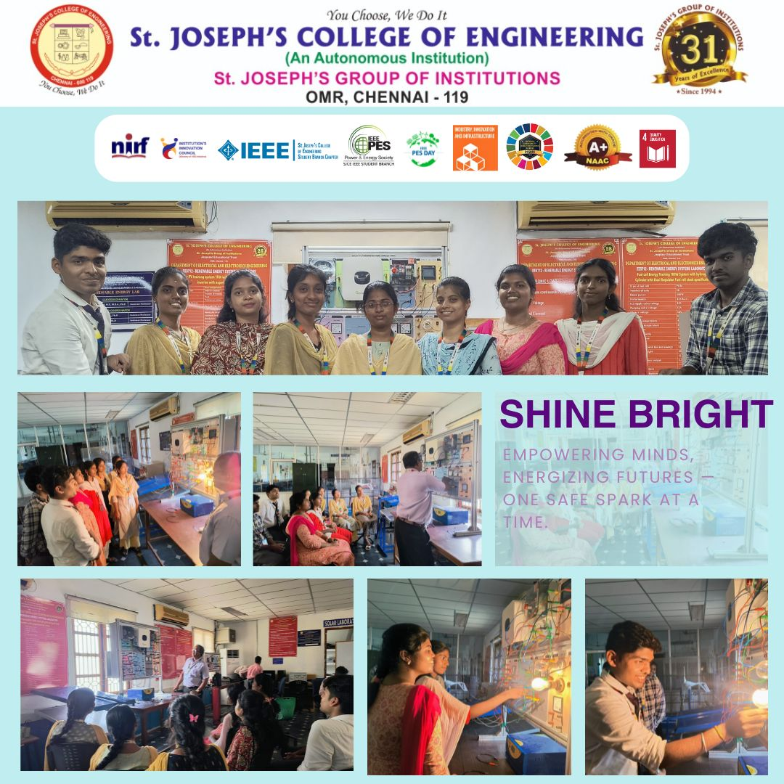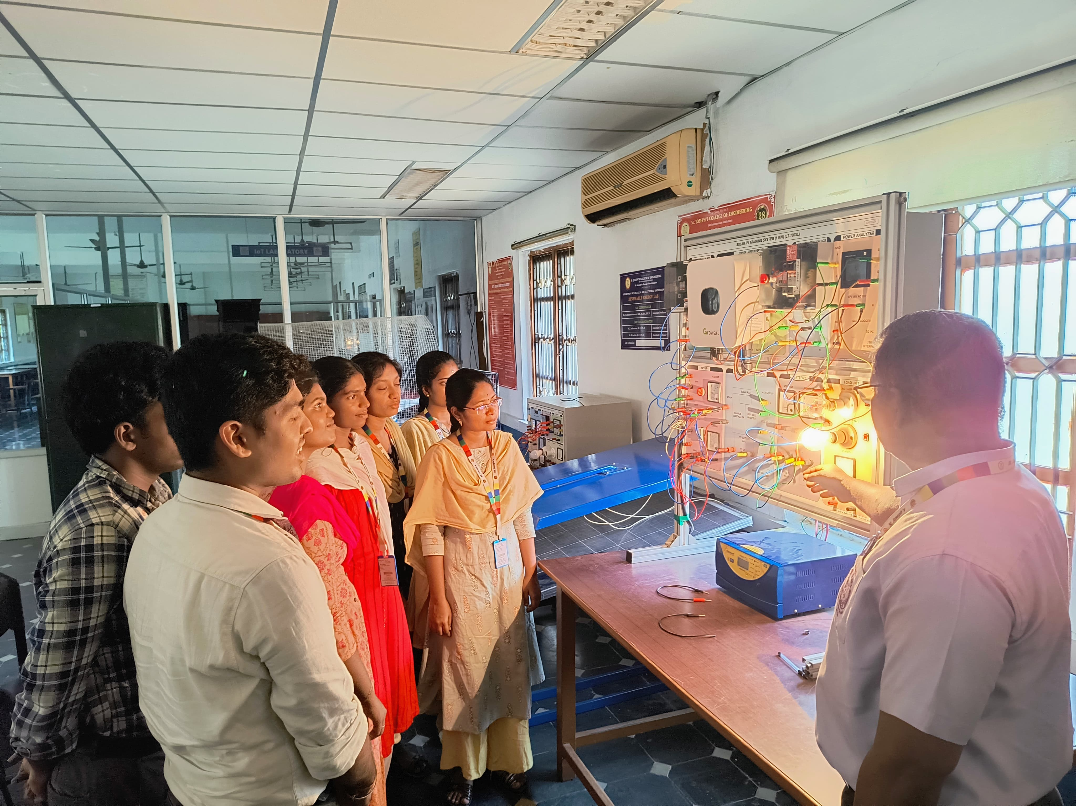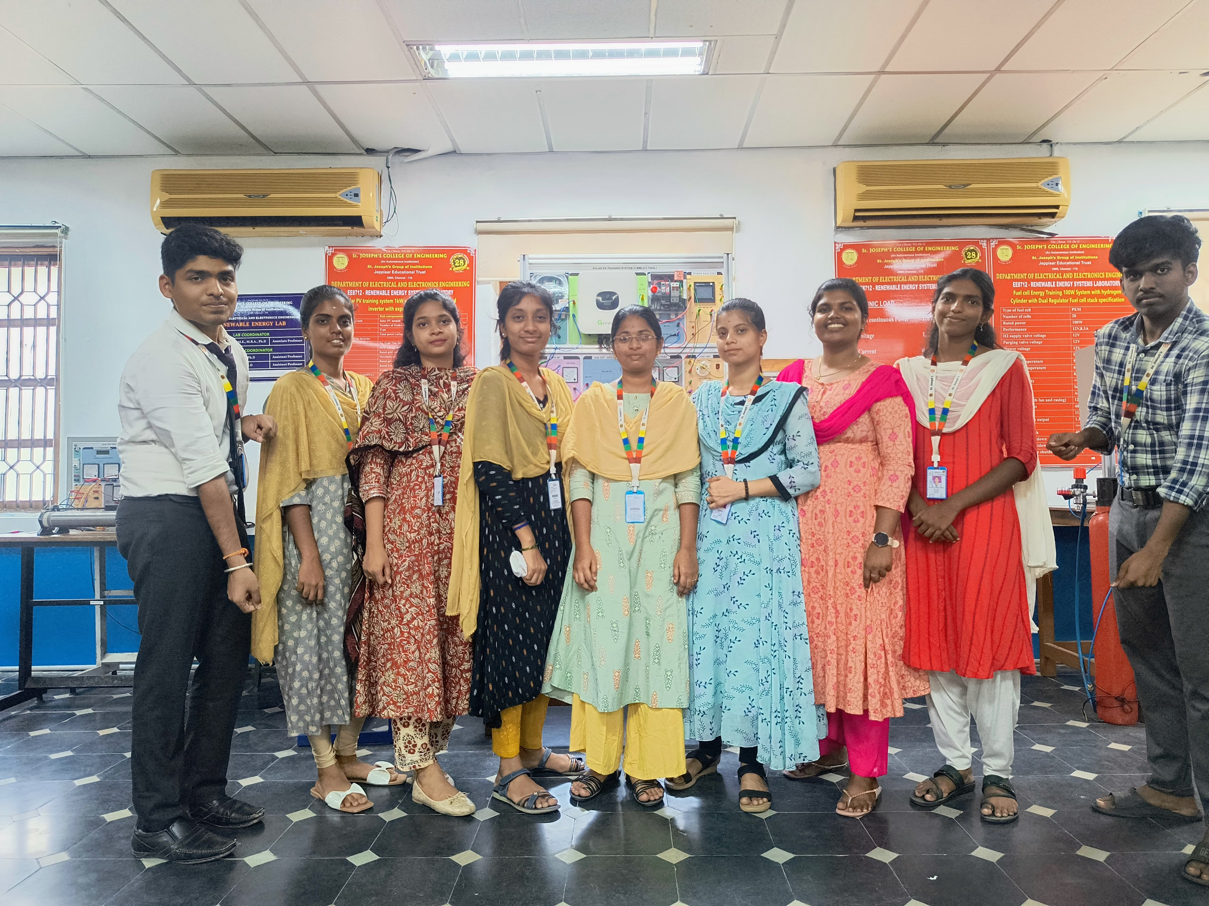

**The** **IEEE St. Joseph’s College of Engineering Student Branch Chapter (SBC60101)** in association with **IEEE Power and Energy Society PE31 (SBC60101K)**, successfully organized a hands-on awareness session titled **“Shine Bright – Empowering Minds, Energizing Futures One Safe Spark at a Time”** on **27th April 2025.** As a culminating event of PES Day 2025 celebrations, “Shine Bright” was more than just a seminar it was a transformational learning experience. Hosted in collaboration with the IEEE SB and IEEE PES, the session shed light on the vital role of solar energy and the critical importance of renewable energy safety. It was designed to spark curiosity, build responsibility, and promote sustainable thinking among students. The session dove deep into how sunlight, an everyday resource, can be harnessed into clean, efficient energy; real-world safety measures in installation, maintenance, and operation of solar systems; emerging smart solar technologies and community-based scalable solutions; and the broader impact of renewable energy on environmental sustainability and economic empowerment. Participants engaged in live demonstrations, interactive discussions, and hands-on activities, making the session both educational and engaging. This final PES Day event provided a warm, practical touch to a month full of Google Meets, workshops, and student-led awareness drives. It was a fitting finale to a celebration that stood for empowering minds and energizing futures, reinforcing the idea that energy isn’t just about power — it’s about purpose. E- certificates were issued to participants as a token of appreciation