IEEE PES SB Chapter 13201

TREE PLANTATION PROGRAM AS A PART OF IEEE PES DAY CELEBRATIONS
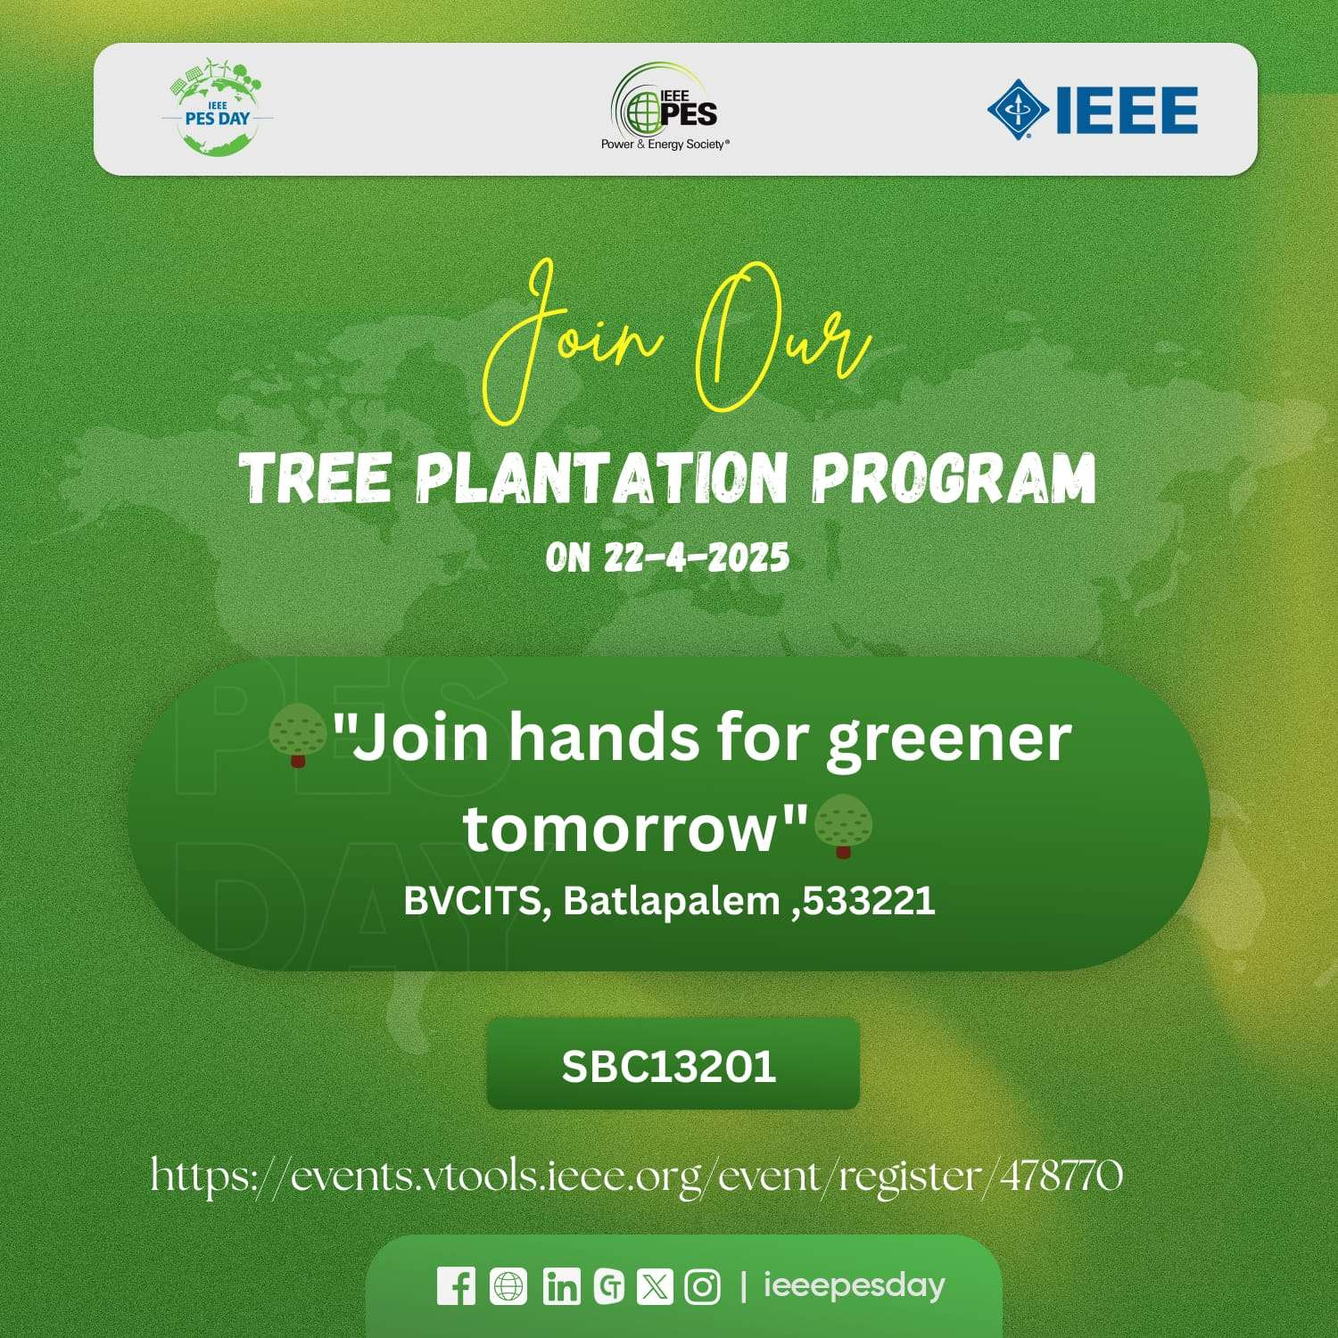

EVENT DETAILS:
Date:22/04/2025
Timings:9:45 A.M. to 1:00 P.M.
Venue: E-Class Room,EEEDepartment,BVCITS
Participants attended:
ADVISIOR:Mr. ANDE N V J RAJA GOPAL
AMBASSADOR: P.S N D C AYYAPPA
PE31, IEEE-BVCITS SBC13201:
P.S N D C Ayyappa – Chairperson
M. Devaki Sanjana –Vice Chairperson
G. Sai Babu– Secretary
Ch. Satya Sravya - Treasurer
Ch. Swathi–Web Master
D. Somesh -Branch Chair
P.R.S.Kiran-Volunteer
EVENT DESCRIPTION:
TREE PLANTATION PROGRAM AS A PART OF IEEE PES DAY CELEBRATIONS The event is scheduled to take place on April 22, 2025, at BVCITS, Batlapalem, 533221, under the theme of "Join hands for greener tomorrow" .

