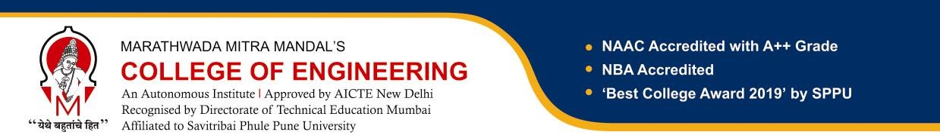
Report on Git and GitHub Workshop
Introduction:
On 26th July 2025, the IEEE Student Branch of Marathwada Mitra Mandal’s College of Engineering (MMCOE), Pune, organized a GitHub Workshop in collaboration with the IEEE Pune Section. The event took place at MB405, Seminar Hall, MMCOE, starting at 9:30 A.M.
The workshop was conducted by Mr. Bharat Mazire, an accomplished alumnus of MMCOE. Drawing from his industry experience, Mr. Mazire provided students with in-depth insights into GitHub, one of the most widely used version control and collaboration platforms for developers.

Event Details:
● Event Name: Hands-on Workshop on Git and GitHub.
● Date: 26 July, 2025
● Venue: MMCOE College, MB405 Seminar Hall.
● Organized by: IEEE Student Branch, MMCOE
● Total Participants: 85 (individual participation)
● Type of Event: District
● Speaker: Mr. Bharat Mazire, R&D Engineer II @ Ansys

Topics Covered:
- Introduction to Git and GitHub – Understanding version control and its importance.
- Repository creation and management – Setting up projects, organizing files, and maintaining clean code histories.
- Branching and merging – Best practices for collaborative work and managing multiple development streams.
- Pull requests and code reviews – How to contribute to projects and ensure code quality.
- Using GitHub for professional growth – Leveraging the platform for building a strong developer profile and contributing to open-source projects.

Impact and Future Scope:
Mr. Mazire shared valuable career advice, highlighting how mastering tools like GitHub can significantly improve employability and teamwork efficiency in software development roles. He encouraged students to contribute to open-source projects and use GitHub to showcase their skills to potential employers.
The workshop was highly interactive, with live demonstrations and hands-on exercises. Students scanned the registration QR code beforehand to confirm attendance, and many actively engaged during the Q&A session.
The event successfully bridged academic learning with practical skills, equipping participants with the knowledge to integrate GitHub into their daily coding practices.

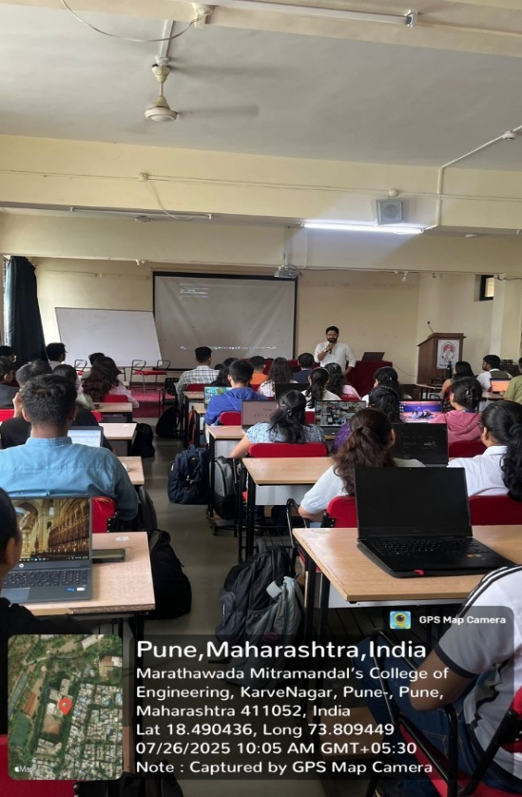
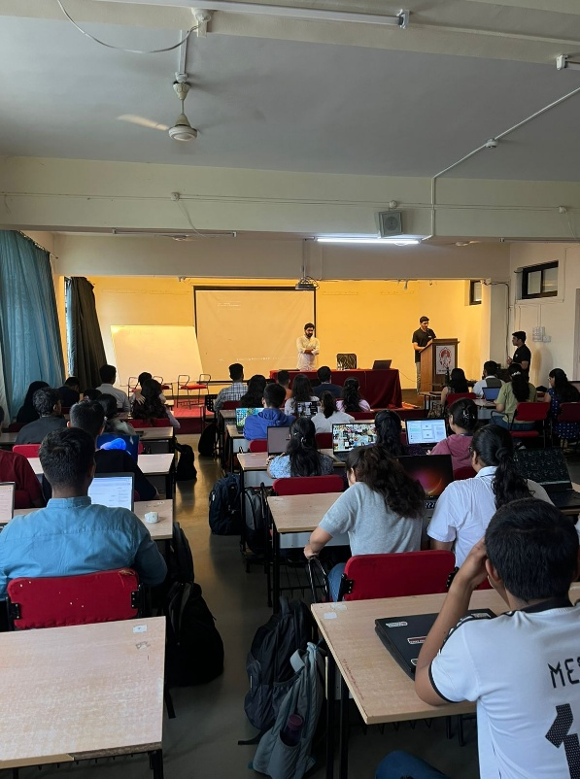
Highlights:

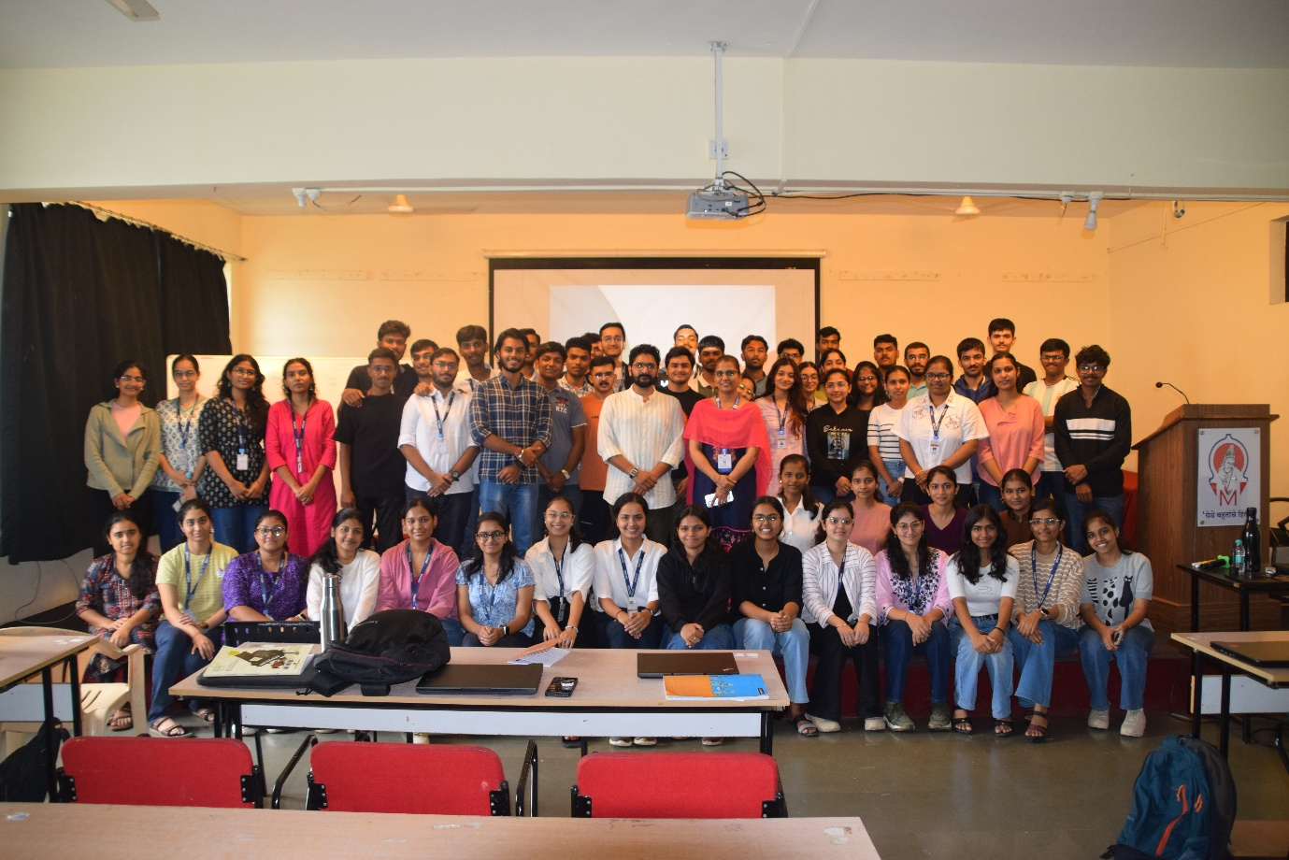
Pic: Mr. Bharat Mazire, Ms. Shubhada Mone along with the participants.
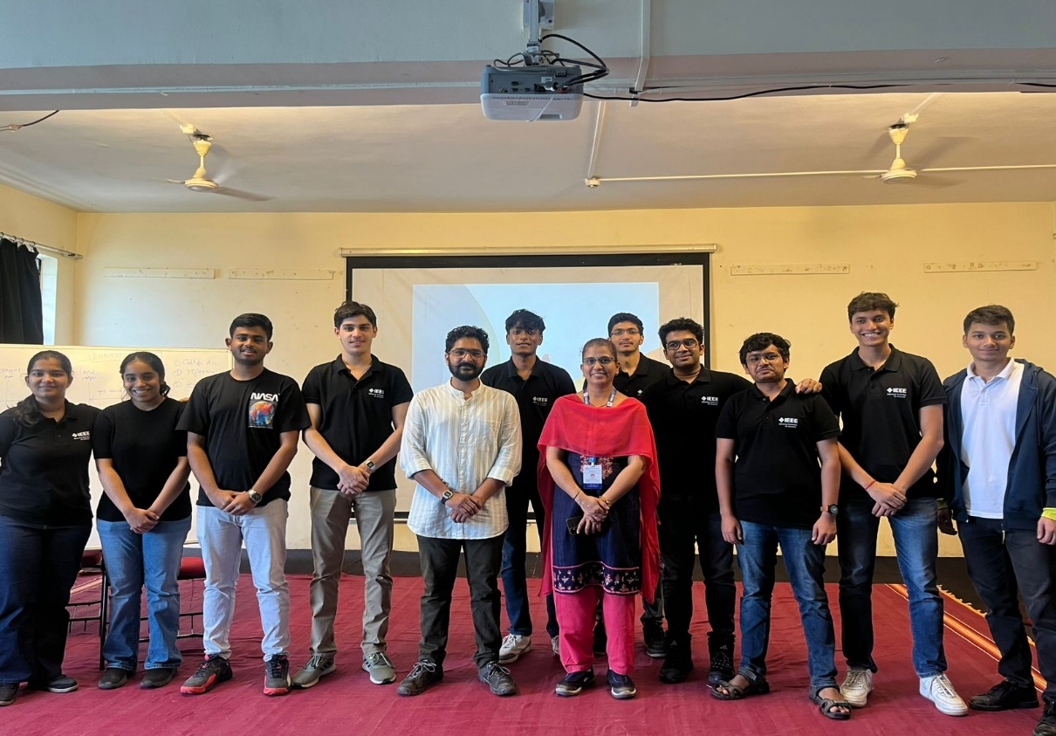

Pic: IEEE MMCOE SB Core team with Mr. Bharat Mazire & Ms. Shubhada Mone.

