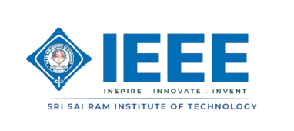
IEEE COMPUTER SOCIETY SIT

THE UNVEILED SERIES EPISODE 24

NAME OF THE ORGANIZING UNIT: IEEE COMPUTER SOCIETY SIT

DATE OF EVENT: 1st August, Friday 2025

TOPIC: THE UNVEILED SERIES EPISODE 24 - Wi-Fi 7 and Beyond

MODE OF EVENT: Online

TARGET AUDIENCE: Student Members

On 1st August 2025, the IEEE Computer Society SIT hosted Unveiled Series Episode 24, focusing on "Wi-Fi 7 and Beyond." The session looked at how Wi-Fi technology has evolved and what makes Wi-Fi 7 different from earlier versions. Participants learned about its new design, faster speeds, lower latency, and better efficiency. They also discussed how it could affect future connectivity. The event helped attendees gain a solid understanding of the technology, allowing them to see the possibilities for the next generation of wireless networks.

ATTENDANCE: 50
EVENT SUMMARY:
Unveiled Episode 24: Wi-Fi 7 and Beyond took attendees on a detailed look at the future of wireless technology. It moved past the hype to reveal the real engineering innovations that will shape connectivity.
The session began with a look at the history of Wi-Fi, showing how each generation has changed network performance, reliability, and user experience. The discussion then focused on what makes Wi-Fi 7 unique. It highlighted its new architecture, modulation techniques, and multi-link operation.
These features lead to faster speeds, lower latency, and better efficiency in crowded environments. Attendees received important technical insights into how networks are designed and improved to meet the needs of a more connected world.
The session also looked at the wider effects of Wi-Fi 7 on industries, smart homes, and the IoT ecosystem. It provided a sneak peek into what the next decade of wireless might bring. Complex topics were presented clearly, so that both tech lovers and curious learners could follow the discussion.
The event wrapped up with an interactive Q&A. Participants had a chance to ask questions and discuss real-world uses of the technology. By blending technical details with simple explanations, Unveiled Episode 24 helped attendees understand Wi-Fi 7’s abilities and its influence on the future of connectivity.
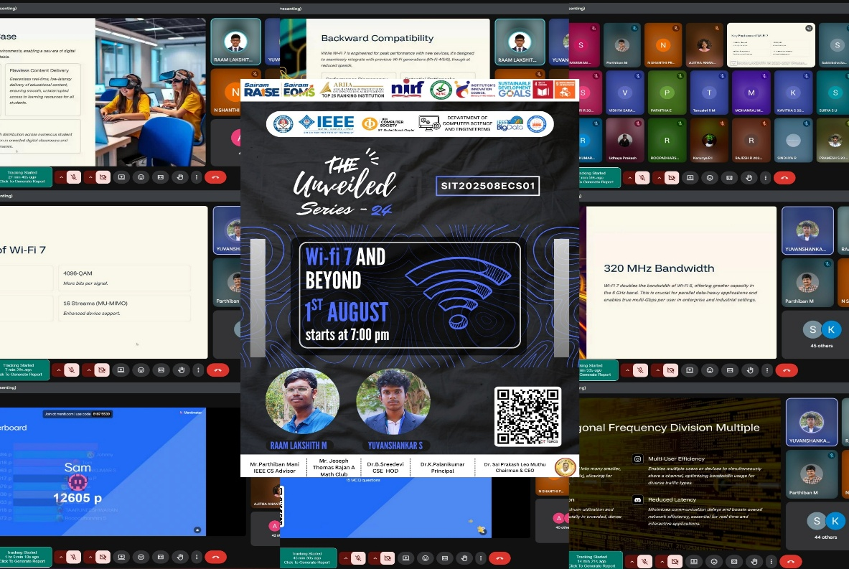
Reported by Suhail Ahmad T- IEEE CS SECRETARY

