# Name of the Activity: Awareness Session on Sexual Harassment of Women at Workplace

Type of Activity: Awareness Session

Date: 07th March 2025

Venue: CGC Jhanjeri Campus

Duration of the Activity: One Day

## Objective of the Activity:

The objective of the awareness session was to educate students and staff about workplace rights, legal frameworks, and preventive measures against sexual harassment. The session aimed to empower participants with knowledge of the Sexual Harassment of Women at Workplace Act, 2013, and encourage a respectful and safe environment.

## Outcome of the Activity:

• Students and staff gained legal awareness regarding workplace harassment and available remedies.  
• Eminent speakers shared insights on laws, reporting mechanisms, and employer responsibilities.  
• The interactive session encouraged open discussion and boosted confidence among participants.  
• The initiative fostered awareness, equality, and a sense of security within the CGC community.

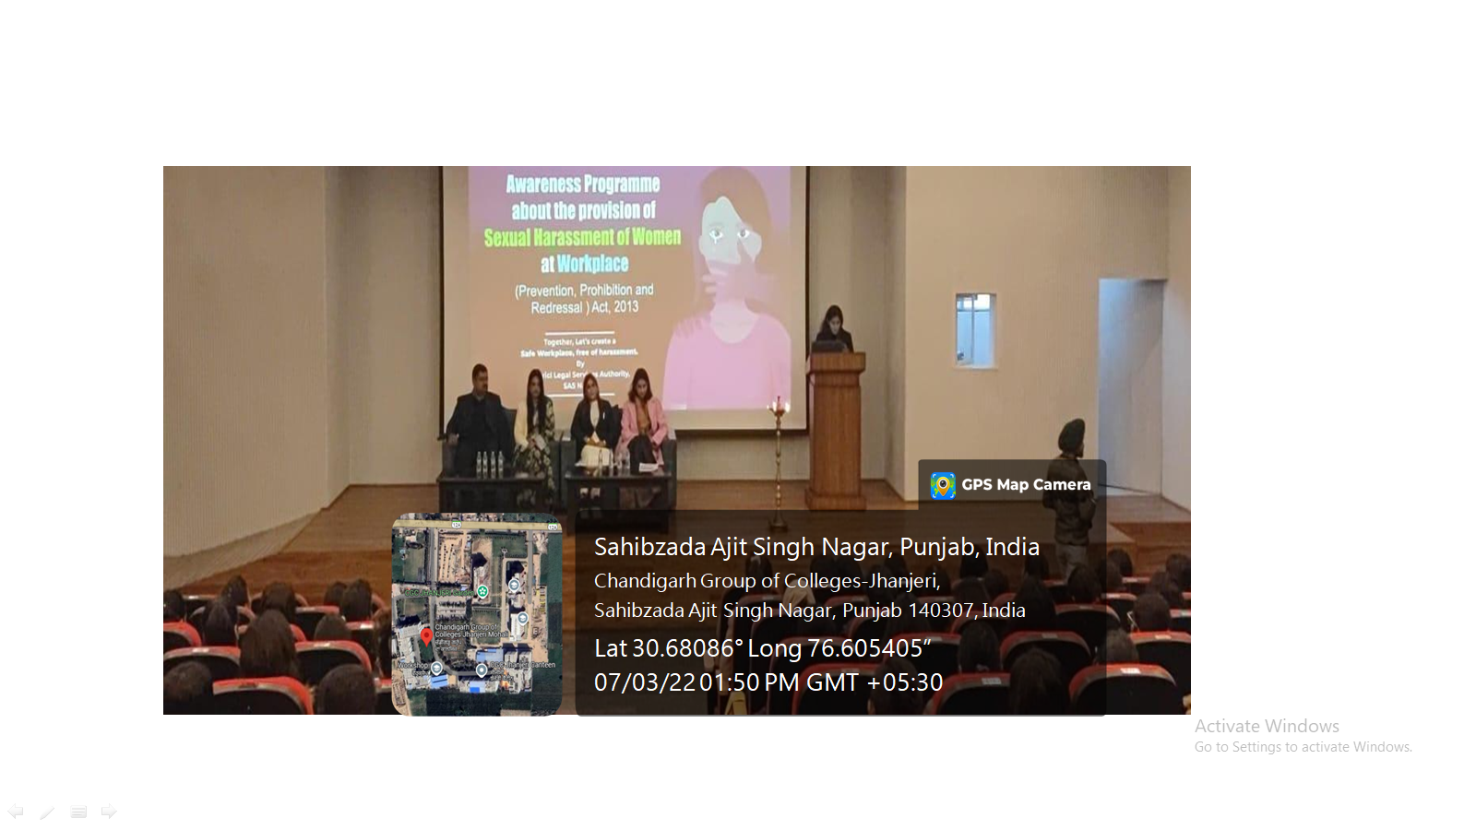

**Awareness Session on Sexual Harassment of Women at Workplace.**

