

** **  

**IEEE REPORT**

The Department of Computer Science and Engineering, in collaboration with the IEEE Computer Society and the Institution’s Innovation Council (IIC) of **St. Joseph’s Institute of Technology**, successfully organized the "A Tribute to your Teacher" - MESSAGE/POEM contest at 10 am in CSE Lab 1.

**Event Highlights:**

- Objective: Celebrating teachers through messages and poems submitted by students.

- Activities: Students were encouraged to submit messages or poems as a tribute to their teachers.

- Theme: "Celebrating Our Teachers"

- 50 students registered and post a message about their teachers.

-LOSHNI PM & PRAVEENA P of II-year CSE, IEEE Members got best poem award.

**Event Significance:**

- Part of Teacher's Day celebrations, honoring the contributions of teachers.

- Opportunity for students to express gratitude through creative submissions.

The program was coordinated by Dr. J. Dafni Rose, Head of Department & IEEE CS Chapter Advisor, Mr. Mithun P, Assistant Professor & IEEE Coordinator CSE.

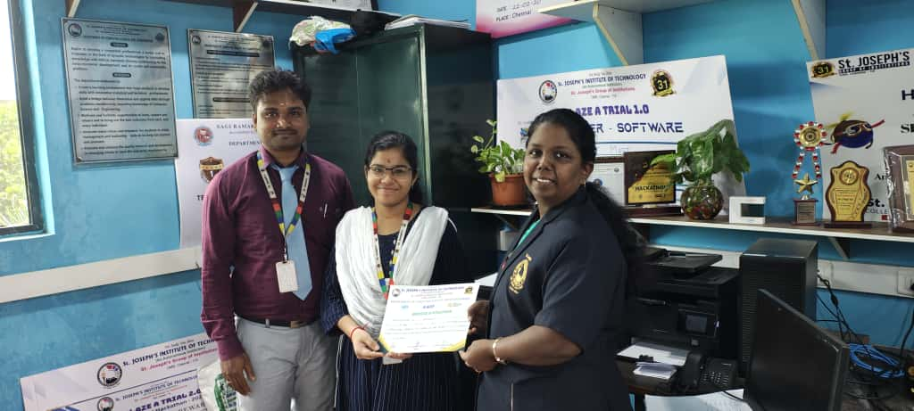

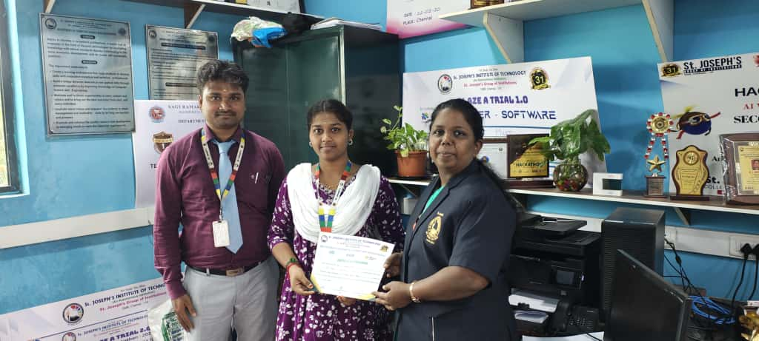

**HOD**