Join us via Webex! https://events.vtools.ieee.org/m/502843
Attention Engineers, Students, Faculty, and IEEE Members and Guests! 🎓
Join Us for an Exciting Online Technical Presentation!
NEUROMORPHIC COMPUTING
🗓 Date: Tuesday, October 28, 2025
🕒 Time: 12:00 PM – 1:00 PM MDT
📍
🌟 Featured Speaker: Professor Jason K. Eshraghian, Ph.D. 🌟
University of California, Santa Cruz
IEEE EMBS Distinguished Lecturer
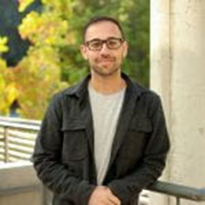
Principal Investigator
Jason K. Eshraghian, Ph.D

https://ncg.ucsc.edu/jason-eshraghian-bio/
- Jason K. Eshraghian leads the Neuromorphic Computing Group and is an Assistant Professor with the Department of Electrical and Computer Engineering, University of California, Santa Cruz.
- Fulbright Scholar | Entrepreneur | Researcher
- Google Scholar
- Film Director and Photographer
Presentation Topic:
🚀 Everything you always wanted to know about Neuromorphic Computing but were afraid to ask🚀
The brain is the perfect place to look for inspiration to develop more efficient neural networks. The inner workings of our synapses and neurons offer a glimpse at what the future of deep learning might look like. Our brains are constantly adapting, our neurons processing all that we know, mistakes we’ve made, failed predictions—all working to anticipate what will happen next with incredible speed. Our brains are also amazingly efficient. Training large-scale neural networks can cost more than $100 million in energy expense, yet the human brain does remarkably well on a power budget of 20 watts.
Agenda:
- 11:50 AM – 12:00 PM MDT -Check in on Webex
- 12:00 -12-:50 PM – Main Presentation: Neuromorphic Computing
- Final ten minutes for Q&A

Don’t miss this opportunity to learn about future technologies from an expert at the forefront of biomedical research!

