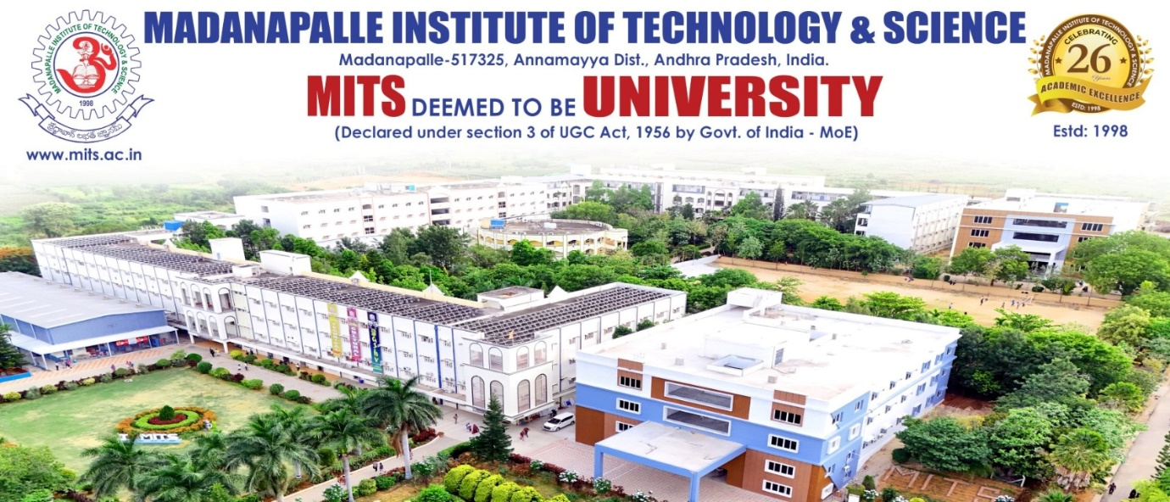
A Report on
Expert Lecture titled
" AI Evolution and Transformation in Digital Technologies "
Organized by
Department of Computer Science and Engineering (Artificial Intelligence)
In association with
IEEE RAS Student Chapter
On 17.10.2025

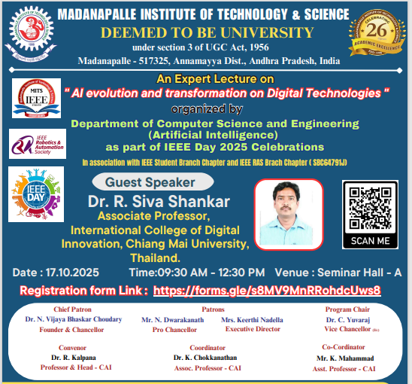

Report Submitted by: Mr K. Mahammad, Assistant Professor, Department of CSE(AI).

Coordinators Details: Dr. K. Chokkanathan, Associate Professor, Department of CSE(AI) & Mr K. Mahammad, Assistant Professor, Department of CSE(AI).

Resource Person Details: Dr. R. Siva Shankar, Lecturer, Chiang Mai University, Thailand.

Venue: Seminar Hall-A

Time: 09:30AM -12:30 PM

Mode of Conduct: Offline

Attendees Count: 128 students from the department of CSE(AI)

Inaugural Session

The program began with a warm welcome by II AI-A Students B. Bhavya Sree(24691A3139) and S. Bhavana(24691A3134). As part of the IEEE Week celebrations, the Department of Artificial Intelligence, in collaboration with the IEEE Robotics and Automation Society (RAS) Chapter, hosted an expert lecture titled "AI Evolution and Transformation in Digital Technologies."
The event was inaugurated by inviting the Department IEEE Coordinator Mr. K. Mahammad to the dais, followed by the program Coordinator Dr. K. Chokkanathan, the Head of the Department of AI Dr. R. Kalpana, the Principal of MITS Dr. P. Ramanathan, and finally, the resource person Dr. R. Siva Shankar from the International College of Digital Innovation, Chiang Mai University, Thailand. S. Bhavana(24691A3134) introduced the esteemed speaker by reading out his profile.
Each dignitary shared valuable insights and wished the success of the program. Following the formal addresses, Dr. Siva Shankar took over the session and commenced the lecture.

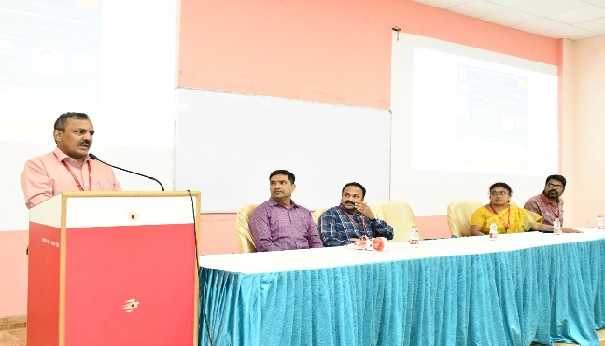 | 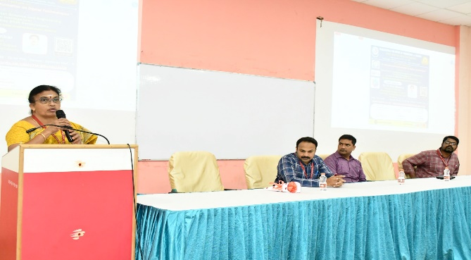
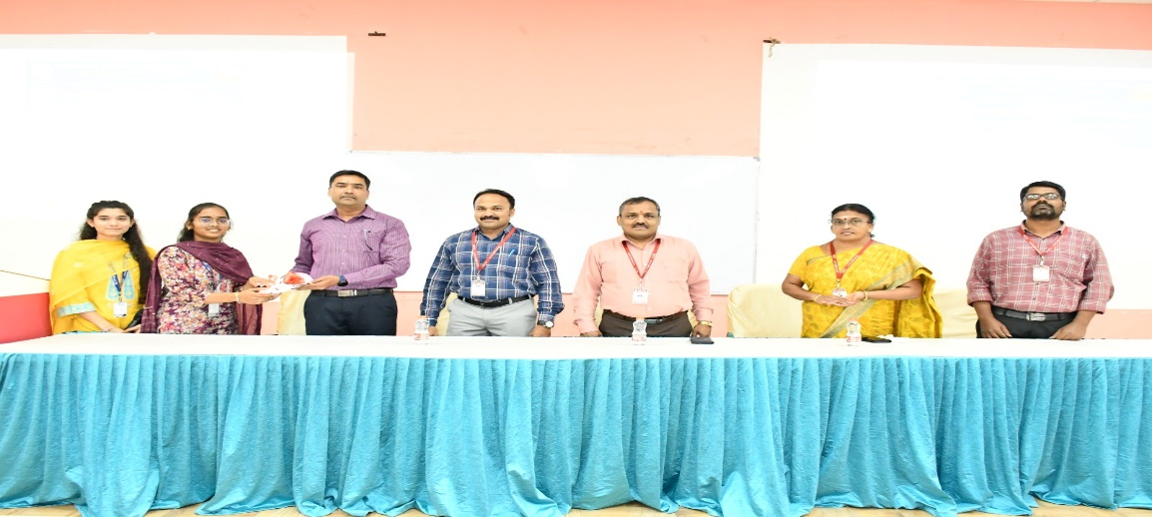

Expert Lecture Summary:

On October 17, 2025, Dr. R. Siva Shankar delivered an insightful lecture on "AI Evolution and Transformation in Digital Technologies." The session aimed at educating students on the development of AI and how it has integrated with modern digital technologies, with a focus on practical examples and interactive discussions.

Key Themes and Topics Discussed:
- AI Evolution: The Beginning and Growth

Resource Person began the lecture by tracing the origins of AI, from the early concept of machines that "think" and "learn" like humans. He discussed the slow but steady evolution of AI, from basic rule-based systems to the intelligent, data-driven systems we see today. The lecture highlighted how technological advancements like faster computers and larger datasets have helped AI overcome initial challenges and led to breakthroughs in machine learning and deep learning.
- AI and its Integration with Emerging Technologies

The lecture focused on the following integrations:
  - AI and IoT (Internet of Things):AI-powered sensors can detect environmental changes, such as temperature or humidity, triggering actions like regulating heating or detecting fires.
  - AI and Blockchain: AI’s ability to enhance the security of blockchain systems by analysing transactions for potential fraud was discussed. This integration makes blockchain networks more efficient and secure.
  - AI and Cloud Computing: The lecturer emphasized how cloud platforms provide the computational power and storage required for running AI models at scale. AI is also used to optimize cloud resources, improving speed and reliability. The concept of Edge Computing, where AI processes data locally on devices to reduce latency, was introduced as a key component of modern AI applications.
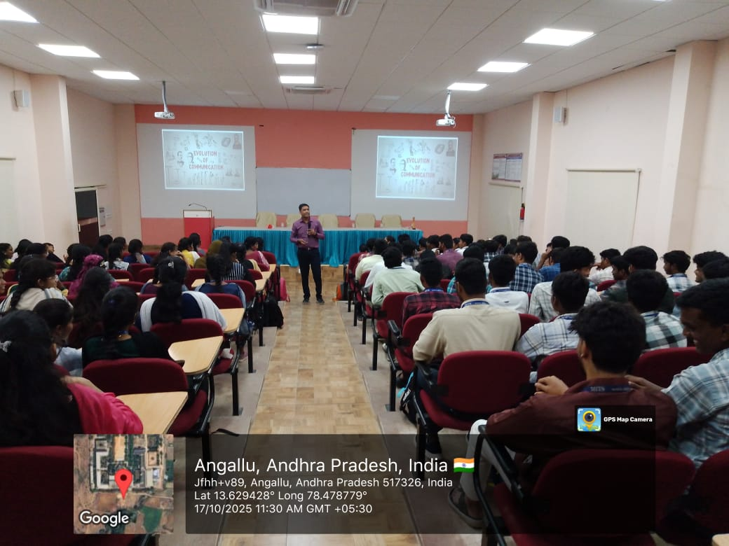 | 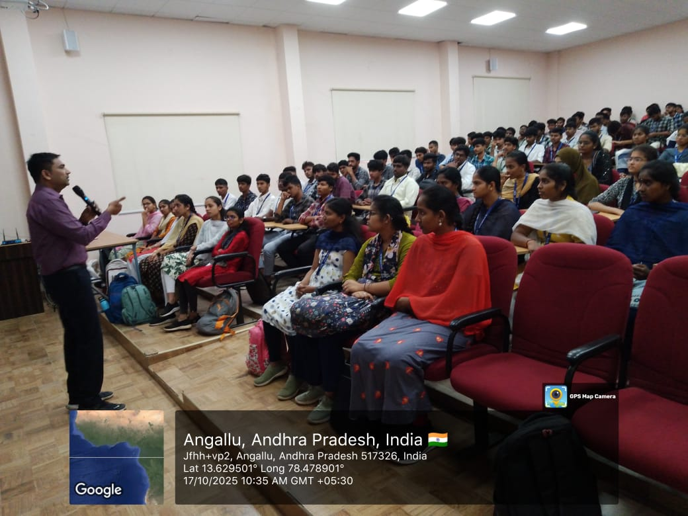
- Real-life Examples of AI in Action
To make the concepts more tangible, the speaker shared a practical example: AI-powered sensors in forests that help predict and prevent forest fires. By monitoring temperature and humidity, the AI systems can detect early signs of fire and send out alerts. This case demonstrated how AI can contribute to environmental protection and safety.
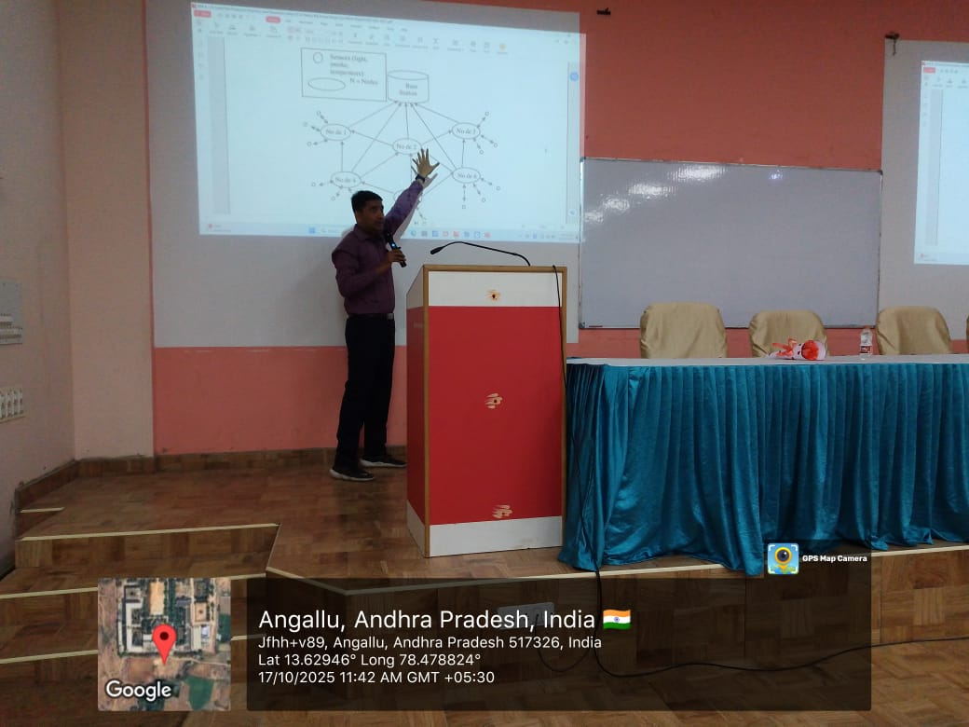 | 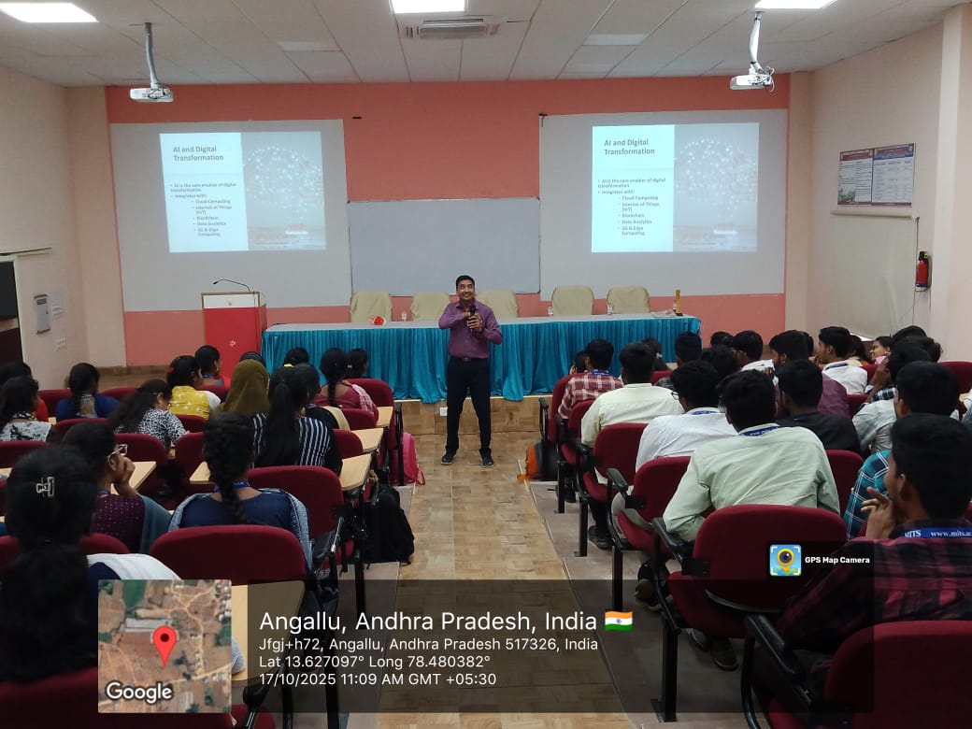
- Encouragement and Motivation:
Dr. Siva Shankar urged students to remain curious and creative in their approach to AI. He stressed that AI is not just about programming but also about finding innovative solutions to real-world challenges. The session left students inspired to explore AI’s potential and apply it to various fields.

Vote of Thanks and Felicitation

The program concluded with a vote of thanks by Dr. K. Chokkanathan, Coordinator of the program. Dr. R. Siva Shankar was felicitated with a shawl and a memento as a token of appreciation for his valuable contribution to the event.

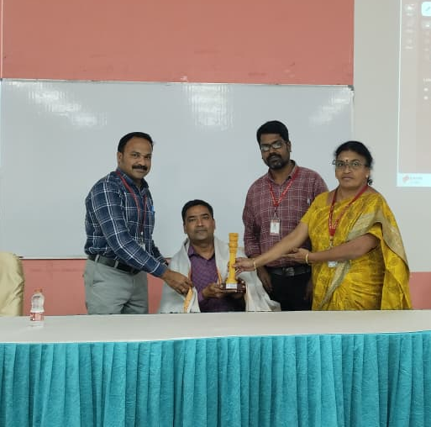

Event Outcome:

Dr. Siva Shankar’s lecture provided a clear and comprehensive overview of AI’s evolution and its integration with various digital technologies like IoT, blockchain, data analytics, 5G, and edge computing. Real-life examples, such as the forest fire prevention scenario, helped students understand the practical applications of AI. The session was both informative and motivational, leaving the students with a deeper understanding of AI’s potential to transform industries and solve global challenges.

