

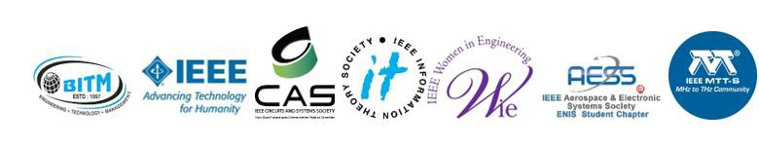
`

IEEE STUDENT BRANCH, BALLARI

BALLARI INSTITUTE OF TECHNOLOGY AND MANAGEMENT

“Jnana Gangotri Campus, Ballari, Hospete Road
Near Allipura, Ballari, Karnataka583104, India

TITLE: Online Session on “Mastering Coding Challenges – Problem Solving to Real-World Applications”.
Speaker: Dr. Sunil C K, IIIT Dharwad
DATE: 16th October 2025
Organized by: IEEE Student Branch BITM.

Coordinator: Dr. Abdul Lateef Haroon P S, IEEE Branch Counsellor, BITM.

About the event:

Dr. Sunil C. K’s session titled “Mastering the Coding Challenges” provided participants with a comprehensive understanding of problem-solving and coding strategies essential for excelling in the modern technological landscape. The talk emphasized the significance of analytical thinking, structured programming, and algorithmic efficiency in tackling real-world coding challenges. Dr. Sunil discussed the importance of understanding problem statements thoroughly, identifying key requirements, and planning solutions through pseudocode to ensure clarity and efficiency. He also highlighted the role of choosing the right data structures, and understanding time and space complexity to optimize code performance. The session explored real-world applications such as debugging, system design, and performance optimization, linking them to the problem-solving mindset required in professional environments. Furthermore, Dr. Sunil encouraged students to participate in hackathons and coding competitions to gain practical exposure and apply their learning in collaborative and time-bound settings. The talk also introduced various funding agencies and government initiatives like KSCST, NAIN, E-Step, Vriddhi Scheme, KITVEN Fund, Elevate-Unnati, Idea2PoC, and AVISHKAR, which support student innovation and startup ideas. The session concluded with an interactive discussion addressing implementation challenges, career-oriented problem-solving approaches, and the importance of innovation in technology. Participants gained valuable insights into effective coding practices, algorithmic thinking, and the resources available for turning their innovative ideas into impactful solutions.

Session Start time: 6:15 PM
Session end time: 7:30 PM
Session duration: 1hr 15min

