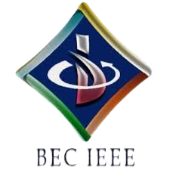

BASAVESHWAR ENGINEERING COLLEGE

BAGALKOTE-587102

IEEE STUDENT BRANCH (Code: STB35261)

\
Event Name | Quiz-A-Thon (Day-9 by BEC-IEEE VTS Society)
Organizer’(s) | BEC-IEEE VTS (SBC35261G)  BEC-IEEE (STB35261)
Date | 15.10.2025 | Time | 7:00 PM – 7:30 PM | Platform | Unstop
Brief Report | Introduction:  The BEC-IEEE Vehicular Technology Society (VTS) (SBC35261G) organized the ninth quiz of the Quiz-A-Thon series on 15th October 2025. The Quiz-A-Thon is a 12-day online quiz series hosted by various IEEE societies and affinity groups under the BEC-IEEE Student Branch. Each quiz is designed around the respective society’s or affinity group’s theme to enhance domain-specific learning and engagement.  Objectives:  - To initiate the Quiz-A-Thon series with an engaging and educational event.  - To highlight the IEEE VTS theme - advancing innovation in vehicular technology and intelligent transportation systems.  - To create awareness about the latest developments and contributions in the field of vehicular technology and mobility solutions.  - To encourage students to participate in quizzes based on specific IEEE society themes.  - To foster knowledge sharing, healthy competition, and technical curiosity among IEEE members.  Brief Description:  The Day 9 Quiz-A-Thon was conducted by the BEC IEEE VTS Society (SBC35261G) on 15th October 2025 from 7:00 PM to 7:30 PM via the Unstop platform. The quiz focused on the VTS theme and featured multiple-choice questions related to vehicular technology, intelligent transportation systems, IEEE awareness, and general technical knowledge. The event witnessed enthusiastic participation from students across various branches, who actively engaged during the 30-minute session, demonstrating their knowledge and keen interest in the IEEE VTS initiatives.  Conclusion:  The VTS Society successfully set the tone for the 12-day Quiz-A-Thon series with its Day 9 event. The quiz reflected the society’s mission to inspire participation, promote innovation in vehicular technology, and strengthen awareness about advancements in intelligent transportation and mobility systems. .
Number of participants | 106
Photographs | 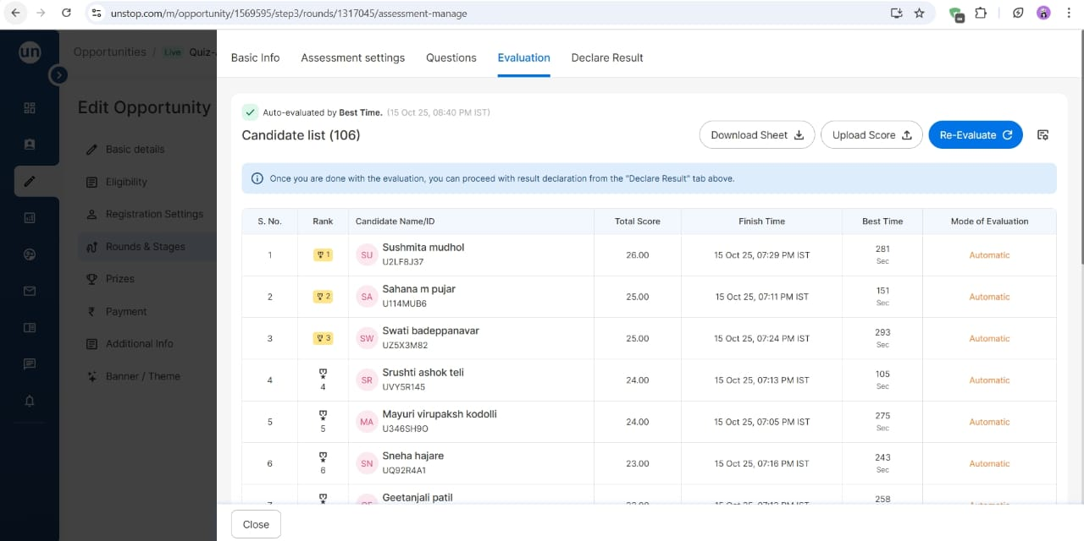  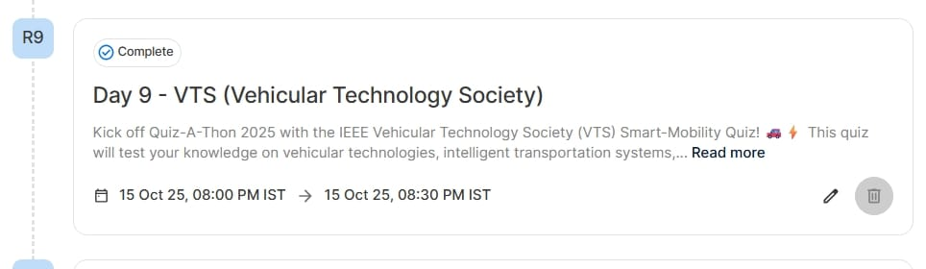  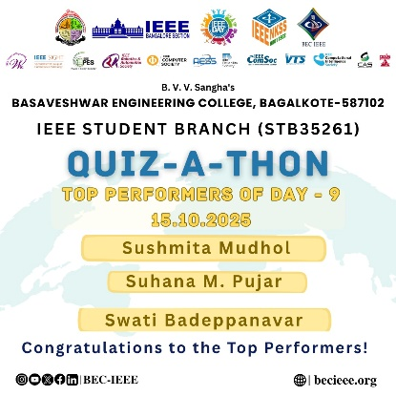
Feedbacks | Participants appreciated the quiz’s theme, the relevance of questions, and the smooth conduct of the event. They found it informative, inspiring, and well-aligned with the objectives of the IEEE VTS Society. Many expressed eagerness to take part in the upcoming quizzes of the series.

Chair Branch counselor

