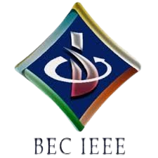

BASAVESHWAR ENGINEERING COLLEGE

BAGALKOTE-587102

IEEE STUDENT BRANCH (Code: STB35261)

\
Event Name | Quiz-A-Thon (Day-7 by BEC-IEEE RLS SBC)
Organizer’(s) | BEC-IEEE RLS (SBC35261E)  BEC-IEEE (STB35261)
Date | 13.10.2025 | Time | 7:00 PM – 7:30 PM | Platform | Unstop
Brief Report | Introduction:  The BEC-IEEE Reliability Society (SBC35261-E) organized the seventh quiz of the Quiz-A-Thon series on 13th October 2025. The Quiz-A-Thon is a 12-day online quiz series hosted by various IEEE societies and affinity groups under the BEC-IEEE Student Branch. Each quiz is designed around the respective society’s or affinity group’s theme to enhance domain-specific learning and engagement.  Objectives:  • To conduct the seventh quiz in the Quiz-A-Thon series with a focus on reliability engineering concepts.  • To create awareness about the IEEE Reliability Society and its importance in ensuring system dependability and performance.  • To encourage students to explore the principles of reliability, maintainability, and risk analysis.  • To foster technical learning, problem-solving, and analytical thinking among participants.  • To promote active participation and strengthen engagement within the IEEE community.  Brief Description:  The Day 7 Quiz-A-Thon was conducted by the BEC IEEE Reliability Society on 13th October 2025 from 7:00 PM to 7:30 PM via the Unstop platform. The quiz was centered on reliability engineering and included multiple-choice questions covering reliability analysis, system safety, fault tolerance, and IEEE awareness. Students from various branches participated with great enthusiasm, displaying their understanding of reliability concepts and their relevance in real-world engineering applications. The event provided a platform for participants to test their knowledge and gain insights into the field of reliability engineering.  Conclusion:  The IEEE Reliability Society successfully conducted the Day 7 quiz of the Quiz-A-Thon series, highlighting the importance of reliability in modern engineering systems. The event promoted awareness of reliability engineering principles while encouraging active participation and learning among IEEE members. It served as a motivating step toward fostering technical curiosity and strengthening engagement within the student branch community.
Number of participants | 86
Photographs | 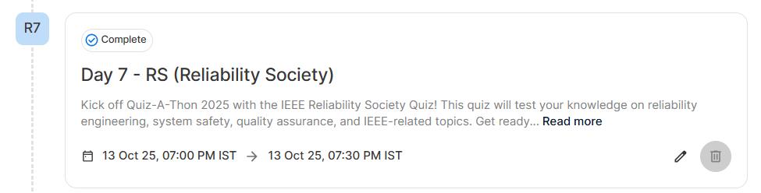  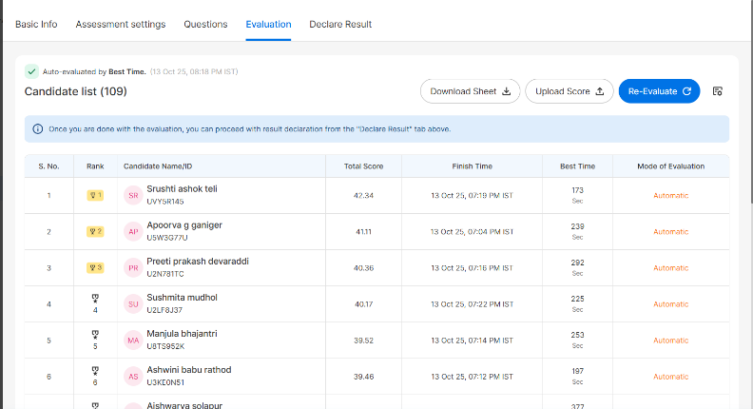  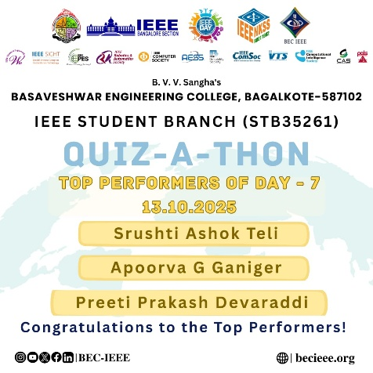
Feedbacks | Participants appreciated the quiz’s focus on reliability engineering, the well-structured questions, and the smooth conduct of the event. They found it insightful, engaging, and closely aligned with the objectives of the IEEE Reliability Society. Many expressed interest in participating in the upcoming quizzes of the series.

Chair Branch counselor

