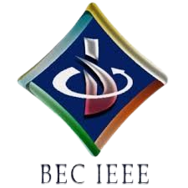

BASAVESHWAR ENGINEERING COLLEGE

BAGALKOTE-587102

IEEE STUDENT BRANCH (Code: STB35261)

\
Event Name | Quiz-A-Thon (Day-1 by BEC-IEEE WIE Affinity Group)
Organizer’(s) | BEC-IEEE WIE (SBA35261)  BEC-IEEE (STB35261)
Date | 07.10.2025 | Time | 7:00 PM – 7:30 PM | Platform | Unstop
Brief Report | Introduction:  The BEC-IEEE Women in Engineering (WIE) Affinity Group (SBA35261) organized the first quiz of the Quiz-A-Thon series on 7th October 2025. The Quiz-A-Thon is a 12-day online quiz series hosted by various IEEE societies and affinity groups under the BEC-IEEE Student Branch. Each quiz is designed around the respective society’s or affinity group’s theme to enhance domain-specific learning and engagement.  Objectives:  - To initiate the Quiz-A-Thon series with an engaging and educational event.  - To highlight the WIE theme — empowering women in technology and innovation.  - To create awareness about women’s contributions in engineering and technology.  - To encourage students to participate in quizzes based on specific IEEE society themes.  - To foster knowledge sharing, healthy competition, and technical curiosity among IEEE members.  Brief Description:  The Day 1 Quiz-A-Thon was conducted by the BEC IEEE WIE Affinity Group on 7th October 2025 from 7:00 PM to 7:30 PM via the Unstop platform. The quiz focused on the WIE theme and featured multiple-choice questions related to women in technology, IEEE awareness, and general technical knowledge. The event saw enthusiastic participation from students across multiple branches. Participants actively engaged during the 30-minute session, showcasing both their knowledge and interest in the WIE initiatives.  Conclusion:  The WIE Affinity Group successfully set the tone for the 12-day Quiz-A-Thon series with its Day 1 event. The quiz reflected the group’s mission to inspire participation, promote gender equality in engineering, and strengthen awareness about the role of women in technology.
Number of participants | 86
Photographs | 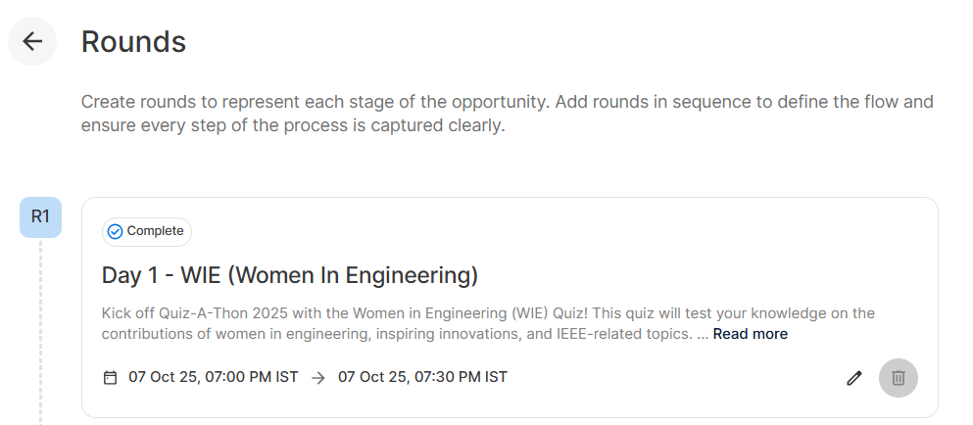  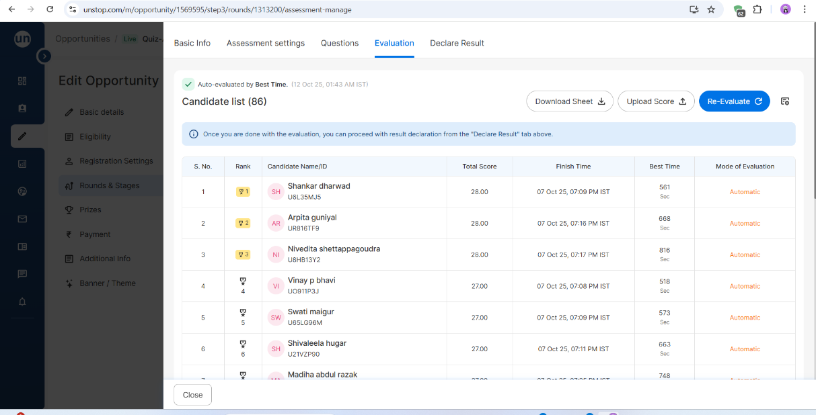  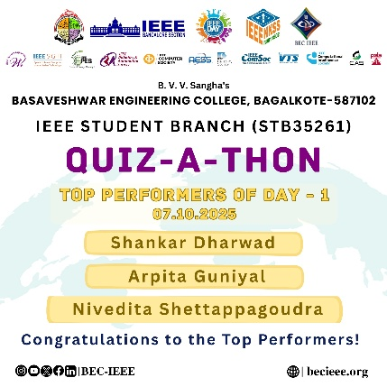
Feedbacks | Participants appreciated the quiz’s theme, the relevance of questions, and the smooth conduct of the event. They found it informative, inspiring, and well-aligned with the objectives of the IEEE WIE Affinity Group. Many expressed eagerness to take part in the upcoming quizzes of the series.

Chair Branch counselor

