

BASAVESHWAR ENGINEERING COLLEGE

BAGALKOTE-587102

IEEE STUDENT BRANCH (Code: STB35261)

\
Event Name | Quiz-A-Thon (Day-5 by BEC-IEEE Computer Society)
Organizer’(s) | BEC-IEEE CS (SBC35261C)  BEC-IEEE (STB35261)
Date | 11.10.2025 | Time | 7:00 PM – 7:30 PM | Platform | Unstop
Brief Report | Introduction:  The BEC-IEEE Computer Society(CS) (SBC35261C) organized the fifth quiz of the Quiz-A-Thon series on 11th October 2025. The Quiz-A-Thon is a 12-day online quiz series conducted by various IEEE societies and affinity groups under the BEC-IEEE Student Branch. Each quiz is designed around the respective society’s domain to promote technical learning and active member engagement.  Objectives:  - To continue the Quiz-A-Thon series with a tech-focused learning event.  - To highlight the core domains like computing, programming and emerging tech.  - To spread awareness about the IEEE Computer Society’s initiatives and resources.  - To encourage healthy compitationand knowledge sharing among IEEE members.  Brief Description:  The Day 5 Quiz-A-Thon was conducted by the BEC IEEE Computer Society on 11th October 2025 from 7:00 PM to 7:30 PM via the Unstop platform. The quiz focused on computer science and technology, featuring multiple-choice questions on programming fundamentals, emerging technologies and IEEE-CS initiatives. The event received enthusiastic participation from students across departments, demonstrating both technical curiosity and a strong interest in computing topics.  Conclusion:  The BEC-IEEE Computer Society successfully carried forward the momentum of the Quiz-A-Thon series with its Day 5 event. The quiz reflected the society’s mission to advance computing knowledge, promote innovation, and strengthen student engagement in IEEE’s technical activities.
Number of participants | 82
Photographs | 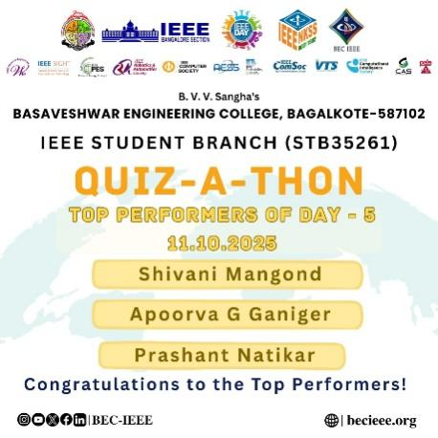  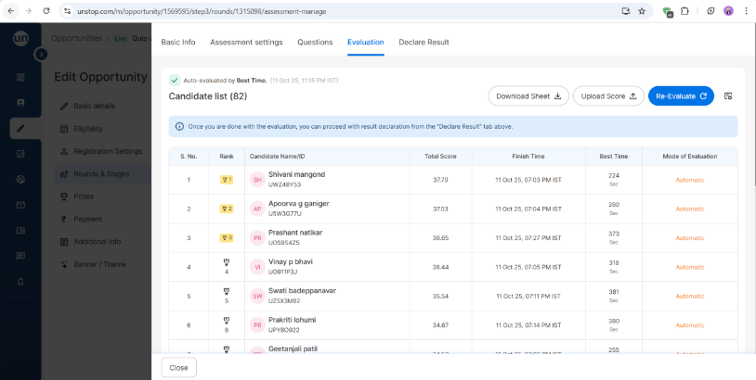  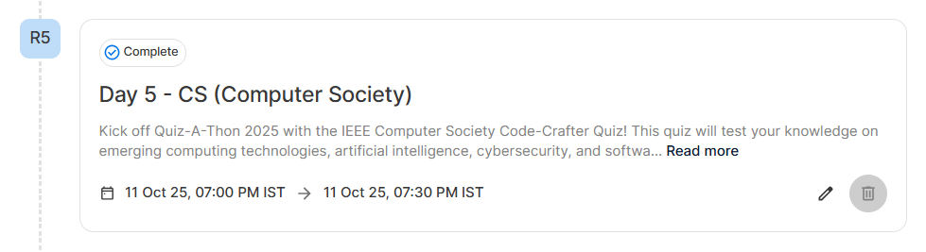
Feedbacks | Participants appreciated the quiz’s focus on computer science topics, the balanced difficulty of questions, and the smooth conduct of the event. They found it insightful, motivating, and aligned with the objectives of the IEEE Computer Society. Many expressed interest in joining upcoming quizzes in the series.

Chair Branch counselor

