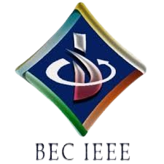

BASAVESHWAR ENGINEERING COLLEGE

BAGALKOTE-587102

IEEE STUDENT BRANCH (Code: STB35261)

\
Event Name | Quiz-A-Thon (Day 3 by BEC-IEEE PES SBC)
Organizer’(s) | BEC-IEEE PES (SBC35261A)  BEC-IEEE (STB35261)
Date | 09.10.2025 | Time | 8:00 PM – 8:30 PM | Platform | Unstop
Brief Report | Introduction:  The BEC-IEEE Power and Energy Society (PES) organized the third quiz of the Quiz-A-Thon series on 9th October 2025. Quiz-A-Thon is a 12-day online quiz series hosted by various IEEE societies and affinity groups under the BEC-IEEE Student Branch. Each day’s quiz focuses on a specific theme related to the respective society, aiming to enhance domain-specific learning and engagement among students.  Objectives:  • To enhance students’ knowledge in the field of Power and Energy systems.  • To promote awareness of IEEE PES and its global initiatives.  • To encourage student participation in technical quizzes related to electrical and energy systems.  • To foster technical curiosity, learning, and collaboration among IEEE members.  Brief Description:  The Day 3 Quiz-A-Thon was conducted by the BEC IEEE Power and Energy Society (PES) on 9th October 2025 from 8:00 PM to 8:30 PM via the Unstop platform. The quiz focused on the theme of power and energy systems, covering topics such as renewable energy, smart grids, and power engineering fundamentals. A total of 116 participants took part in the quiz, competing for the top ranks based on accuracy and completion time. The event received active participation from students across various departments, showcasing their knowledge and enthusiasm for the energy domain  Conclusion:  The IEEE PES Society successfully organized the Day 3 Quiz-A-Thon, contributing to the continued success of the 12-day series. The quiz encouraged students to enhance their technical understanding of power and energy topics, while also strengthening IEEE PES awareness and engagement.
Number of participants | 116
Photographs | 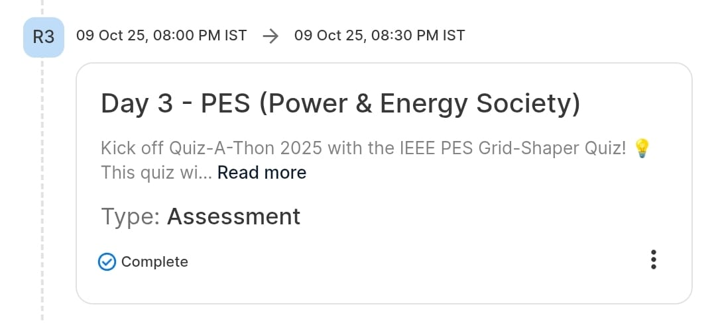  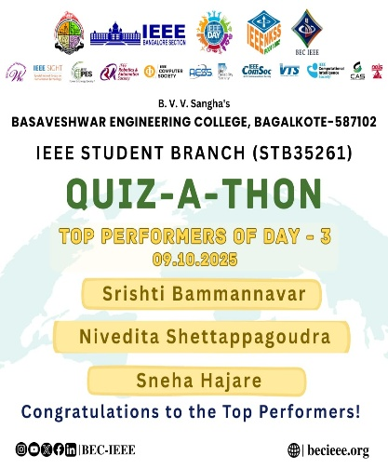  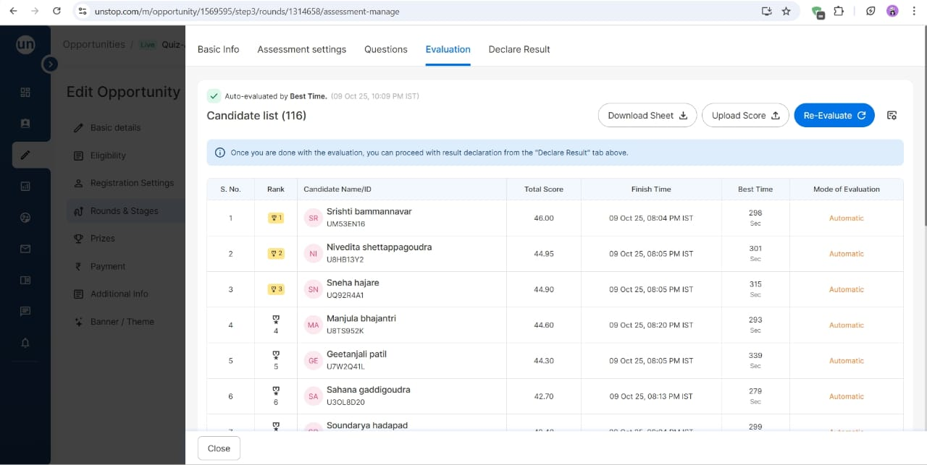
Feedbacks | Participants appreciated the quiz’s relevance to the power and energy domain and praised the smooth organization of the event. They found it informative, challenging, and an excellent opportunity to explore IEEE PES-related knowledge

Chair Branch counselor

