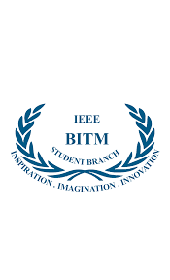




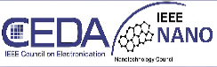

`

BALLARI INSTITUTE OF TECHNOLOGY AND MANAGEMENT
An Autonomous Institute under VTU Belagavi
(Jnana Gangotri Campus, Ballari, Hospete Road Near Allipura, Ballari, Karnataka583104, India)
IEEE STUDENT BRANCH BITM, BALLARI

TITLE: “CADENCE – A Technical Design and Innovation Challenge”
DATE: 16th October, 2025
VENUE: Dept. of ECE, BITM.

ORGANIZED BY: IEEE ITS Society, IEEE BITM Bangalore section

CO-ORDINATOR: Dr. Abdul Lateef Haroon P S, IEEE Branch Counsellor, BITM.
Faculty Coordinator: Mr. Srikanth K.M

About the event :

Introduction:
The IEEE BITM Student Branch successfully organized CADENCE – A Technical Design and Innovation Competition, under the banner of IEEE Society. The event aimed to encourage students to demonstrate their creativity, technical knowledge, and problem-solving skills through innovative design ideas and technical challenges.
Objective:
The primary objective of CADENCE was to provide a platform for students to showcase their innovative abilities in technology and engineering, foster teamwork, and enhance practical understanding of theoretical concepts.
Event Overview:
The competition witnessed active participation from students across various departments. Participants were given a set of problem statements or design challenges. They were required to come up with creative and efficient solutions within the given time.
The event was conducted in multiple rounds, which included:
- Idea Submission
- Design and Implementation Round
- Final Presentation and Evaluation
Faculty coordinators and IEEE volunteers managed the event smoothly, ensuring fair judgment and an engaging experience for all participants.

Judging and Evaluation:
Entries were evaluated based on parameters such as innovation, feasibility, technical depth, teamwork, and presentation skills. The judging panel consisted of faculty co-ordinator Mr.Srikanth K.M.

Winners:
🏆 First Place: Malleshwari– [ECE/4th year]
🥈 Second Place: Nagapoojitha – [ECE/4th year]
🥉 Third Place: Anuja – [ECE/4th year]
All winners were awarded certificates and mementos by the IEEE Counsellor in recognition of their outstanding performance and creativity.

Outcome:
The competition concluded successfully with enthusiastic participation and innovative ideas from the students. The winners were awarded certificates and mementos by the IEEE Counsellor. The event served as an excellent opportunity for students to enhance their technical knowledge, confidence, and collaboration skills.

Conclusion:
The IEEE Society’s Cadence Competition proved to be an inspiring and enriching event that promoted creativity and technical excellence among students. The organizing committee extended its gratitude to the IEEE Counsellor, faculty coordinators, volunteers, and all participants for making the event a grand success.

Competition Duration: 4 hours (9.30 A.M to 1.30 P.M)

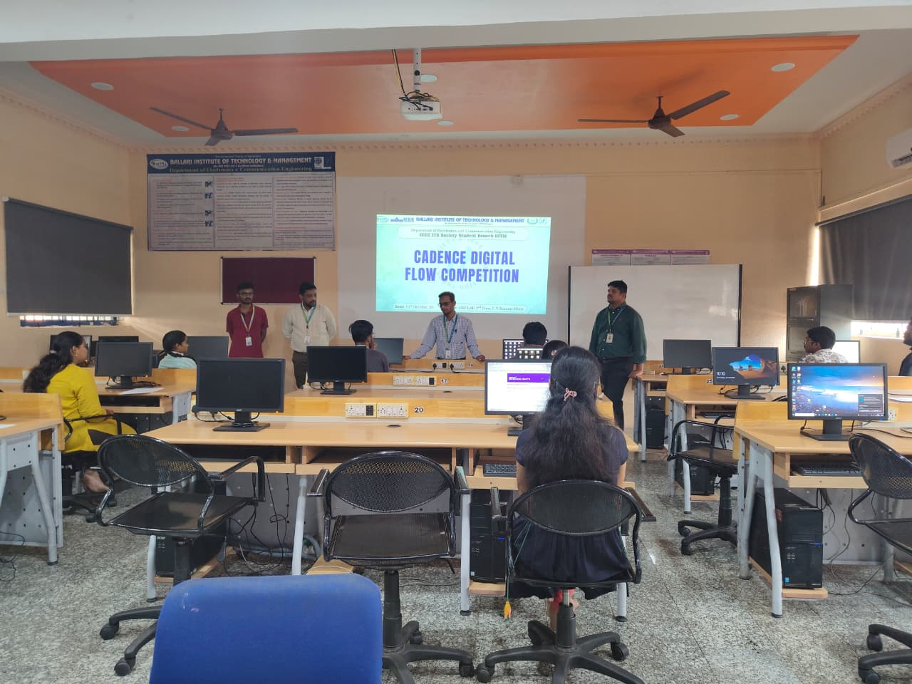

Figure 1“A platform for the next generation of chip designers and engineers”.

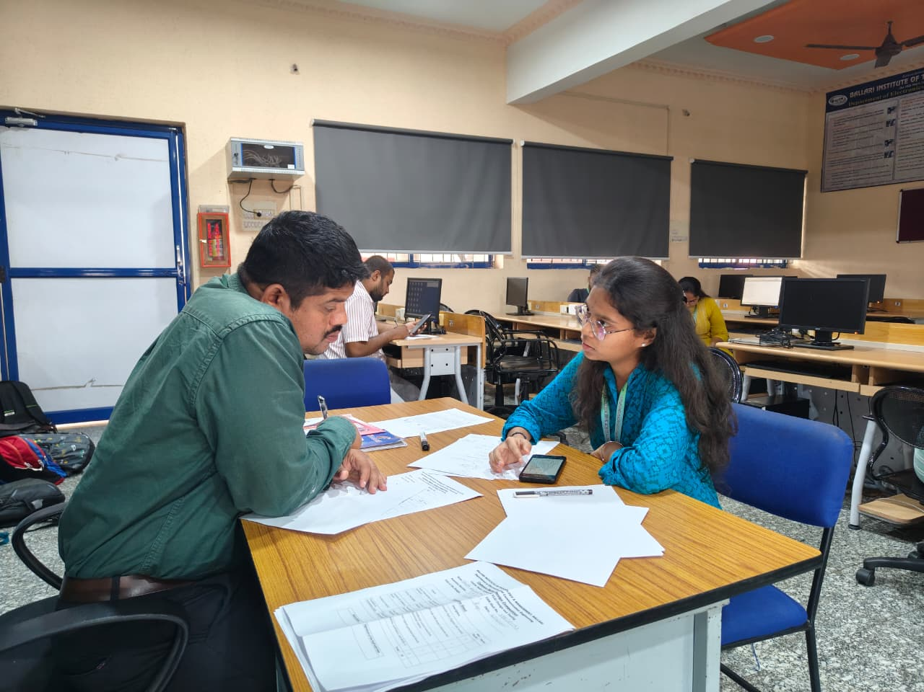
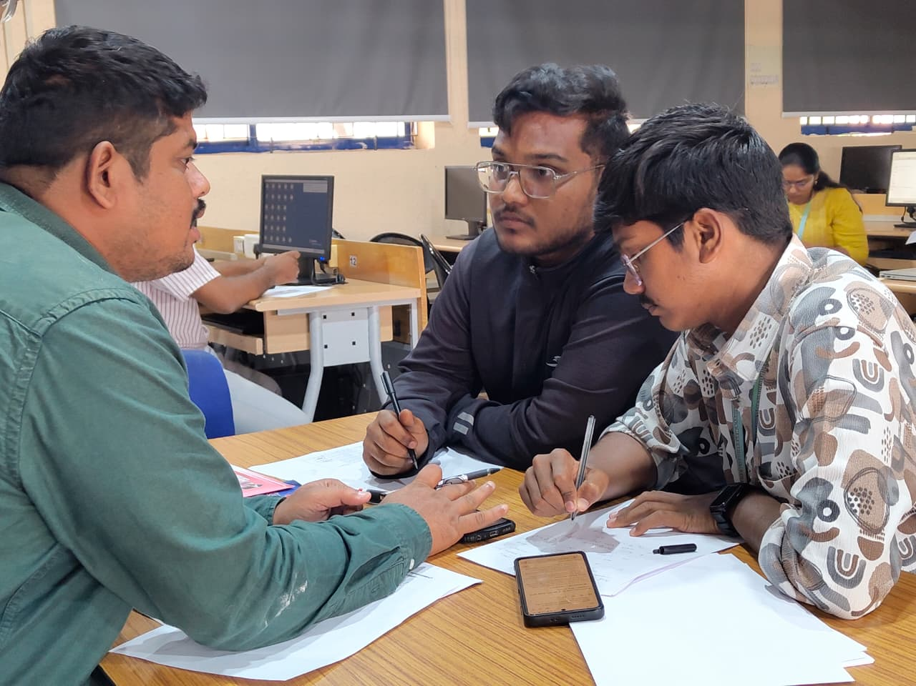
Figure 2:More than a judge, a mentor. Sharing valuable insights during the circuit evaluation.

