Report on our Attending of the 2025 IEEE-HKN SLC Conference in Ann Arbor, MI from Nov 7-9

Dr. Harpreet Singh, Chair of the Life affinity group, participated in IEEE-HKN conference from Nov 7-9. The conference was very successful one and participated by more than 500 students from all over the globe. Jim Riess presented the IEEE Individual Service Award 2025 plaque to Dr. Harpreet Singh on November 7. The award has the following citation,
For commitment towards life member affinity group activities and dedication to keeping IEEE members of the section participate in events of interest to life members.
Dr. Harpreet Singh was accompanied by Ihfaz Islam, webmaster of Life affinity group. In the meeting, the HKN students were familiarized about the life members activities in general and activities of SEM section in particular.

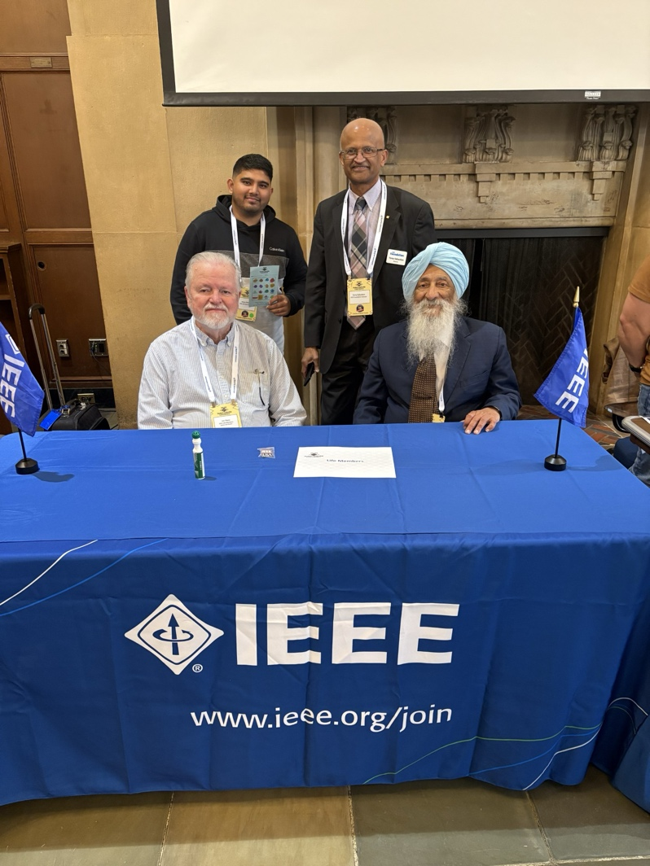
Sitting:
Jim Riess, IEEE Life Members Committee Region 4 Coordinator (left)
Harpreet Singh, Chair life affinity group SEM (right)

Standing:
Ihfaz Islam, Webmaster life affinity group (left)
Tomy Sebastian, IEEE Foundation Director

