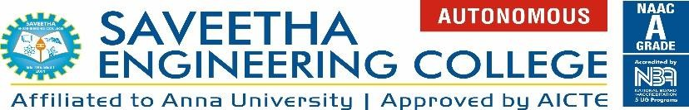
WORKSHOP REPORT
Department of Medical Electronics
Workshop Title | IOT NEXUS
Date & Time | 5/11/25 - 6/11/25 & 9.00 am - 4.00pm
Venue | 5/11/25 - 3411
Coordinator(s) | Student Coordinators: Vaishnavi.S & Barath.S  Faculty Coordinators: Dr.M.Moorthi  Mrs.T.Indumathy
Resource Person(s)  (with Affiliation) | VEI Technologies Pvt.Ltd –  Dr.B.Ezhilavan (Founder & CEO),  Akash D (software developer),  Siva K (Embedded Developer)

About the Workshop:
The two-day hands-on workshop on “Internet of Things (IoT) NEXUS”, organized in collaboration with VEI Technologies Pvt.Ltd, was held on 5th and 6th November 2025 from 9:00 a.m. to 4:00 p.m. The workshop aimed to introduce participants to the fundamentals of IoT, smart connectivity, and automation. This practical-oriented session guided participants in developing innovative IoT projects using Arduino, Raspberry Pi, and cloud platforms, emphasizing hands-on learning and application-driven understanding.
Day 1 focused on the basics of IoT and embedded systems, covering IoT architecture, communication protocols, and Arduino fundamentals — including setup, Embedded C programming, and interfacing sensors such as temperature, humidity, and heart rate with Arduino boards.
Day 2 covered cloud integration and Raspberry Pi applications, where participants created cloud accounts, explored platforms like Thing Speak and Firebase, and learned Raspberry Pi setup, Linux basics, Python programming, and GPIO control.
The workshop witnessed enthusiastic participation from students from different departments, who gained valuable insights into how IoT can be integrated with medical devices and diagnostic systems. Through expert talks, live demonstrations, interactive sessions, and hands-on exercises, the event effectively bridged the gap between academic learning and industrial practice.We signed MOU with VEI Technologies Pvt.Ltd on 06.11.25
Guest Profile
The workshop was graced by the presence of distinguished guests from VEI Technologies Pvt. Ltd., Chennai, a leading IT solutions and consulting company founded by Dr. B. Ezhilavan, who also serves as its Chief Executive Officer. VEI Technologies specializes in IoT, Artificial Intelligence, Web Application Development, and Digital Transformation, providing innovative solutions that bridge the gap between industry and academia. The invited guests included Dr. B. Ezhilavan, Founder and CEO, renowned for his contributions to IT consulting and technology-enabled education; Akash D (software developer) recognized for his engaging and impactful training sessions on IoT and automation; Siva K (Embedded Developer) known for his expertise in developing and integrating smart systems using Arduino, Raspberry Pi, and cloud platforms. Their presence and expertise added immense value to the workshop, offering participants practical insights into IoT implementation, embedded systems, and real-world applications automation.
Event Objectives
- Introduce the core concepts and architecture of IoT.
- Familiarize students with embedded systems and sensor interfacing.
- Develop practical skills in Arduino and Raspberry Pi programming.
- Demonstrate cloud integration and data visualization using platforms like Thing Speak and Firebase.
- Encourage participants to design and implement innovative IoT-based projects.

Outcomes / Key Takeaways
Summarize the outcomes of the workshop in terms of learning, participation, and skill development. Mention feedback highlights.
Attendance Summary
Total Participants | 95
Students | 95
Faculty | 2
Internal Participants | 93
External Participants | 2

Event Poster:
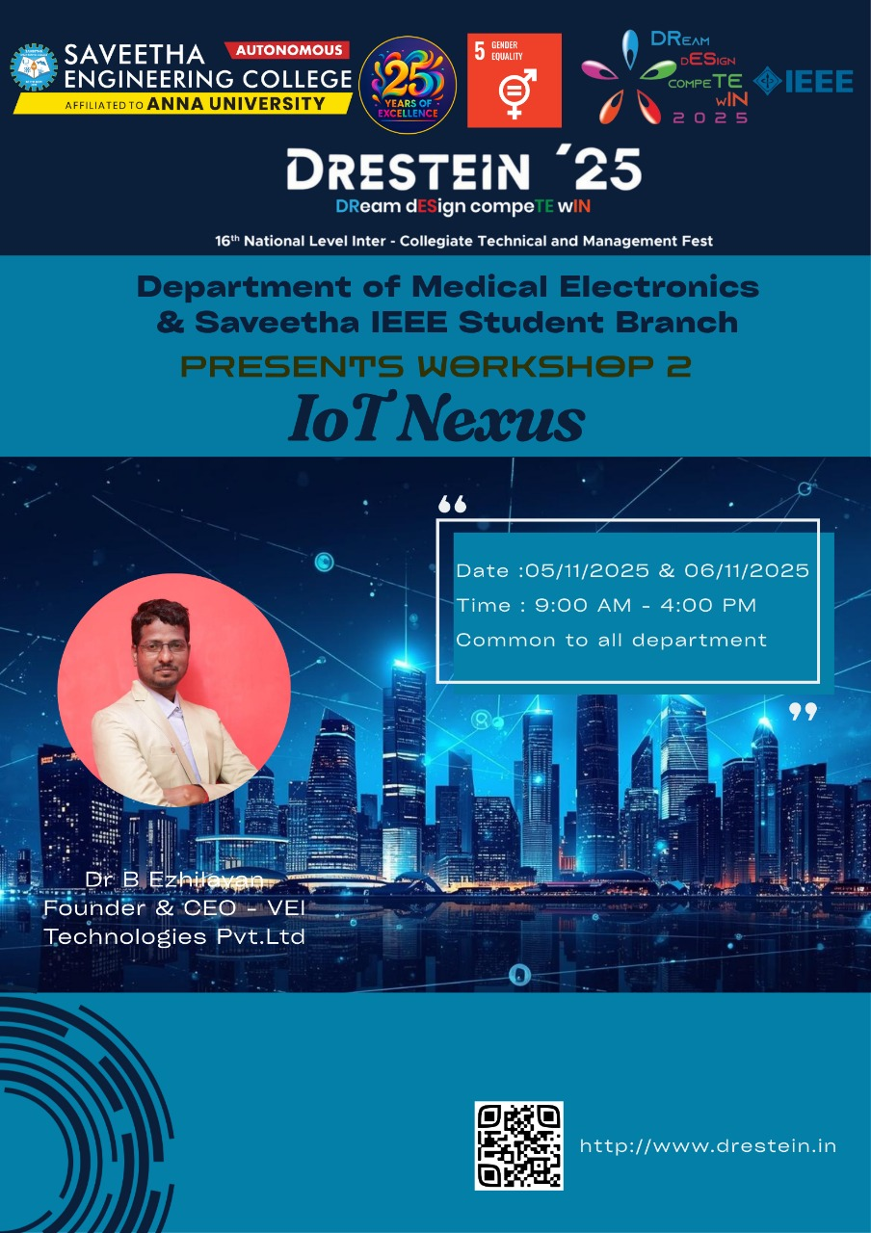
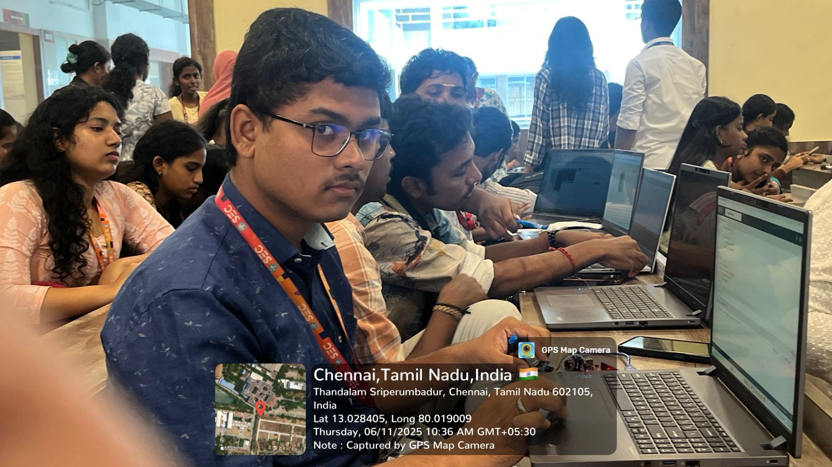
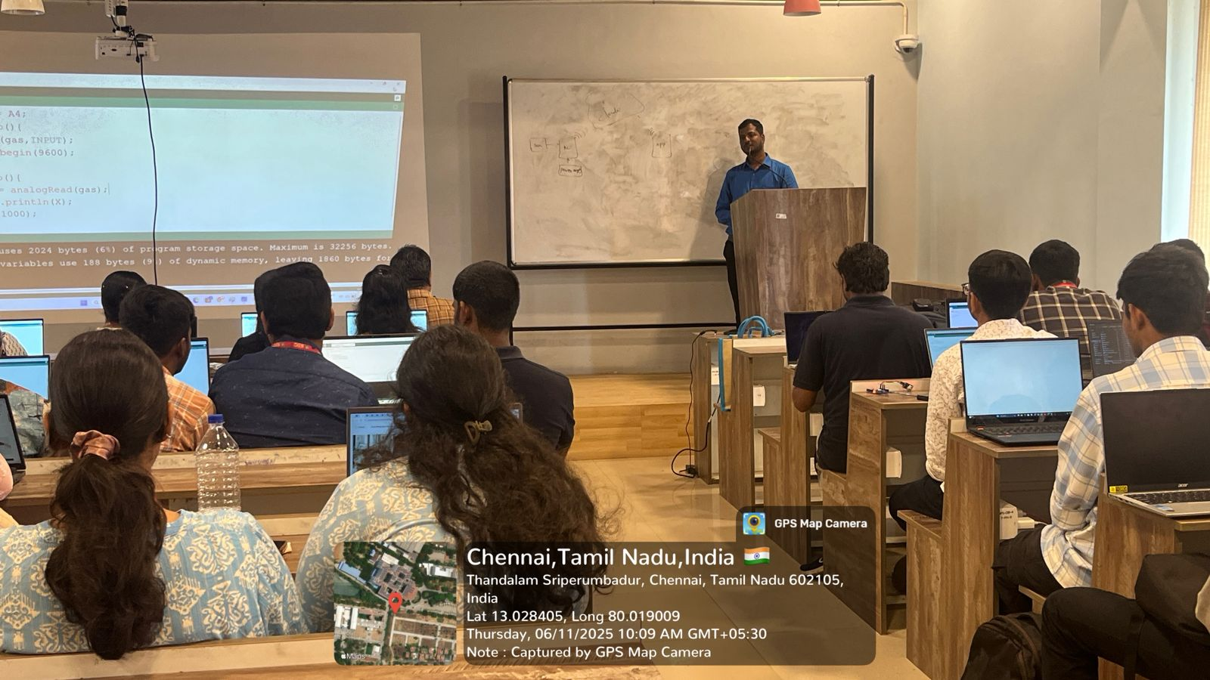
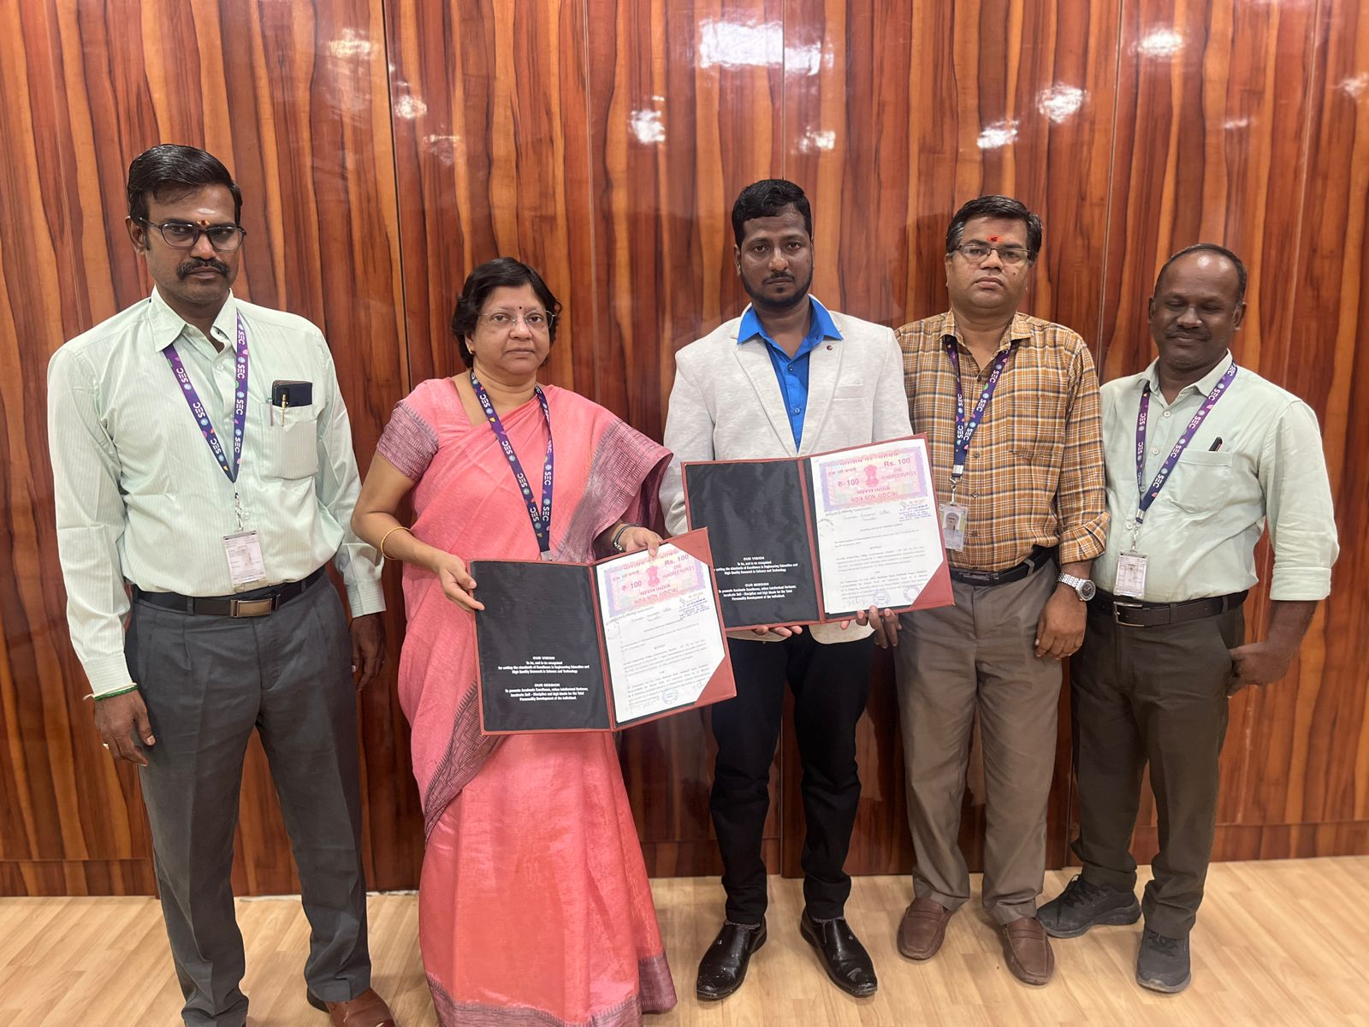

Feedback from Students
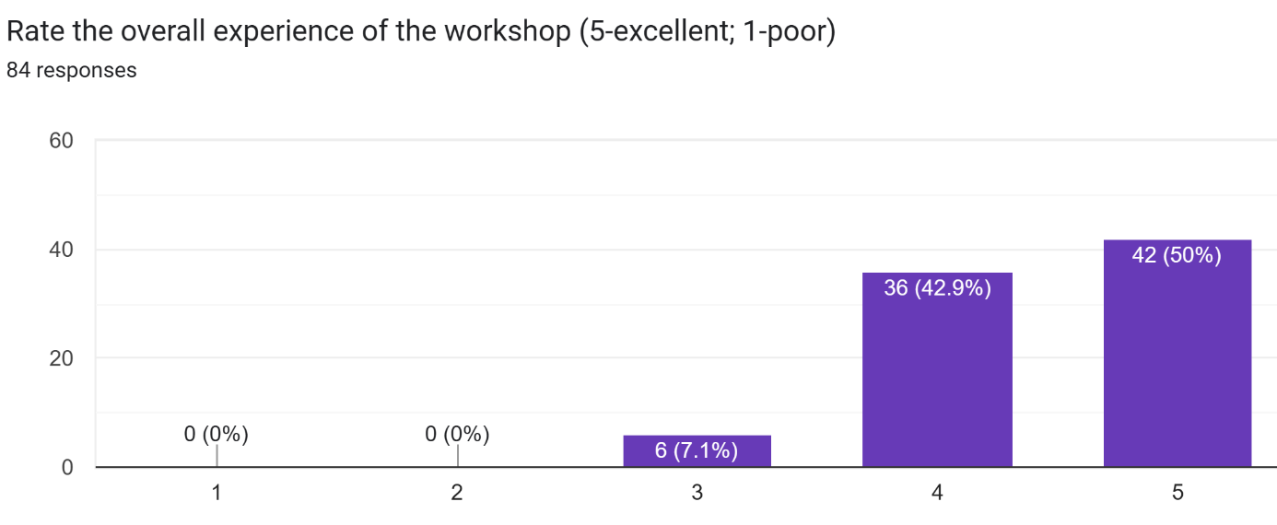
The IoT workshop received overwhelmingly positive responses from participants, who described it as useful, informative, and engaging. Many appreciated the hands-on learning approach, gaining practical experience with components such as Arduino, Proteus, ESP modules, LEDs, sensors, and ThingSpeak cloud.

Students highlighted that the sessions helped them understand IoT concepts, automation, and controller mechanisms, while improving their coding, circuit design, and simulation skills. The interactive teaching style and real-time demonstrations made complex topics easy to grasp.
Participants felt the workshop was beneficial for their mini-projects and future projects, especially for beginners with little prior experience. They valued the instructor’s clear explanations, patience, and guidance.
Google Form Link (if any): https://docs.google.com/forms/d/e/1FAIpQLSfiFGaV0lbaMpc5h8NVdMz4vxTh89AmRiNfK9lzmCRsaO1Nag/viewform?usp=header
Reflections
The IoT workshop was a successful and engaging learning experience, offering valuable hands-on exposure to Arduino, sensors, and IoT applications. Faculty suggested adding more time for advanced demonstrations, team-based mini projects, and improving classroom facilities. Organizers noted strong student enthusiasm and recommended follow-up or advanced workshops for deeper learning. The coordinator appreciated the active participation and practical approach, highlighting plans to enhance future sessions with better infrastructure and more interactive activities.
Event Coordinator(s) | Head of Department | Drestein Coordinator(s)
Faculty Coordinators:  Dr.M.Moorthi  Mrs.T.Indumathy  Student Coordinators:  Vaishnavi S  Barath S | Dr. M.Moorthi | Faculty Coordinators:  Dr.M.Mary Adline Priya  Mrs.T.Indumathy  Student Coordinators:  Selva Lakshmi T.K  Kaushek B.A

