A report on “Inauguration of IEEE Communications Society, Aerospace Society & Nanotechnology Council”

EVENT DETAILS
Field | Nanotechnology
Type of Activity | Inauguration Function
Name of the Event | Inauguration of IEEE Communications Society, Aerospace Society & Nanotechnology Council
Dates / Duration | 28-10-2025
Organized by | IEEE-NTC
Host Organization | CBIT
Sponsored by | IEEE-Hyderabad Section
Organizer / Contact Person | Name: Mrs. N Sujata Gupta  Designation: Assistant Professor  Email: sujatagupta@ieee.org  Phone: 9963028231
Flyer / Banner
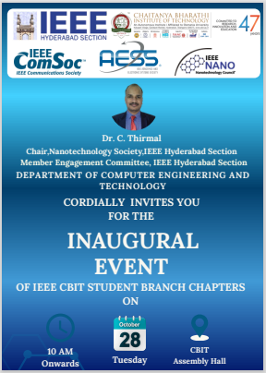

GROUP PHOTO
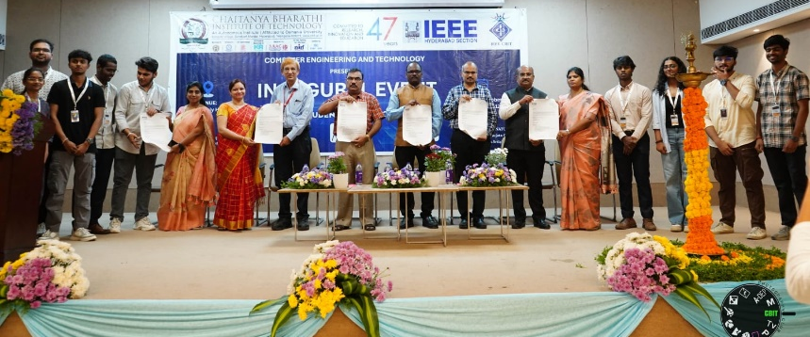
Inauguration of Nanotechnology council
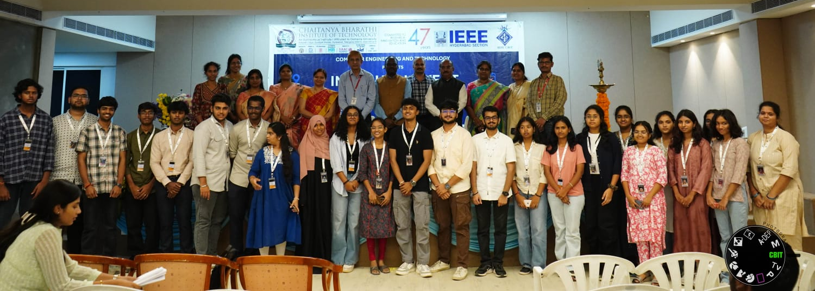
Inaugural speech by the Chair, IEEE-NTC-Hyderabad and volunteer group photo with expert

EVENT HIGHLIGHTS
- The nanotechnology council was inaugurated and the chair, Dr. C. Thirmal gave the inaugural speech
- The Dr. C. Thirmal emphasized the importance of the multidisciplinary nature of nanotechnology and its possible applications in various fields.
- The upcoming events were discussed with the newly formed executive committee of the CBIT, NTC chapter.
- The networking opportunities for the students and faculty were discussed.
Attended Members: 50

