
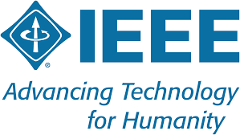



IEEE Mysore Subsection – R0011903
Home - IEEE Mysore Subsection
Navkis College of Engineering,Hassan IEEE STUDENT BRANCH-STB98724
Date:28-11-2025
Technical Talk on
“Introduction to IOT and its Applications”
A Technical Talk was organized by the Department of Electronics and Communication Engineering under the IEEE Student Branch on the topic “Introduction to Internet of Things and its Applications” on 28th November 2025 at 2:30 PM in the Edusat Room.
The target audience for the session comprised 3rd Semester students (A and B Sections) of the ECE Department, with a total participation of around 60 students.

i. Objective of the Talk
The main objective of this technical talk was to provide students with an in-depth understanding of the Internet of Things (IoT), its architecture, and its wide range of applications in various domains. The session aimed to familiarize students with emerging technologies and motivate them to explore IoT-based projects and research areas.

ii. Speaker
The resource person for the session was Dr. Wilfred J. Vaz, Professor & Head, Department of IoT, who delivered an insightful lecture on IoT fundamentals, its real-time applications, and its role in transforming industries and smart systems.

iii. Session Highlights
Dr. Wilfred Vaz began the session by explaining the concept and evolution of IoT, emphasizing how the integration of sensors, connectivity, and data analytics enables smarter systems. He discussed:
- The architecture and components of IoT systems.
- The importance of data collection, cloud connectivity, and decision-making in IoT networks.
- Applications of IoT in healthcare, agriculture, transportation, smart cities, and home automation.
- Challenges and future trends in IoT, including security, interoperability, and scalability.
The session was highly interactive, and students from both A and B sections actively participated by asking questions related to IoT-based design and career opportunities in this field. The talk helped them gain better insight into the practical aspects of IoT and its role in shaping future technologies.

iv. Outcome of the Talk
The technical talk significantly enhanced the students’ knowledge of IoT concepts and inspired them to consider IoT as a promising domain for innovation, mini-projects, and research. It also helped bridge the gap between theoretical learning and practical implementation of IoT technologies. Overall, the event was well-received by the 3rd-semester students, who expressed enthusiasm for exploring IoT-based applications in their upcoming coursework and projects.

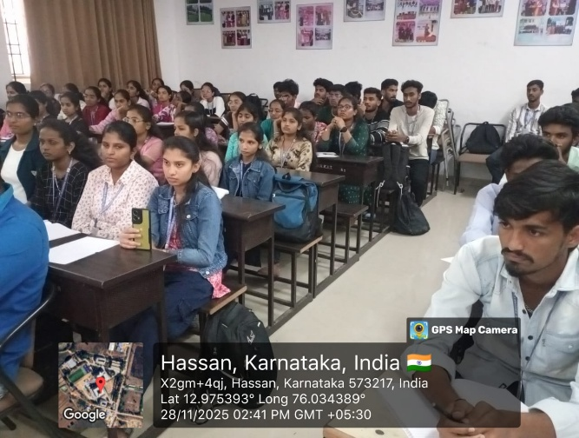
.vi. GPS Tagged photos
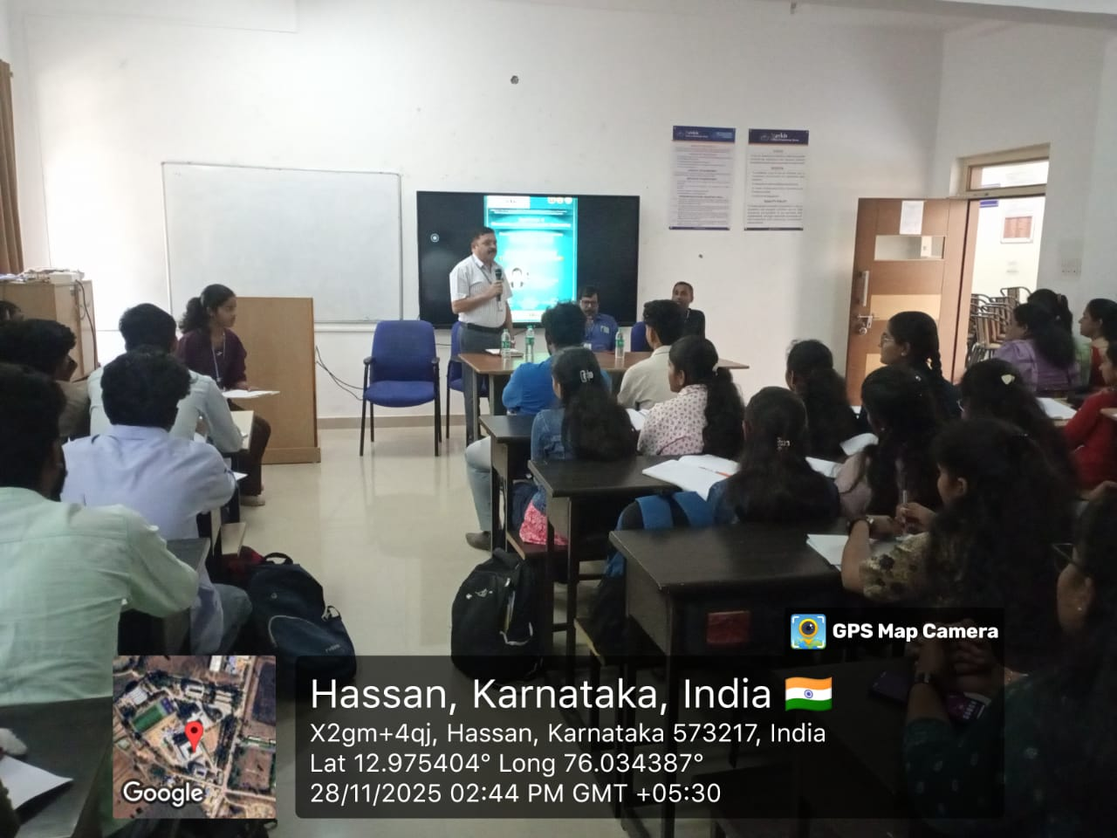

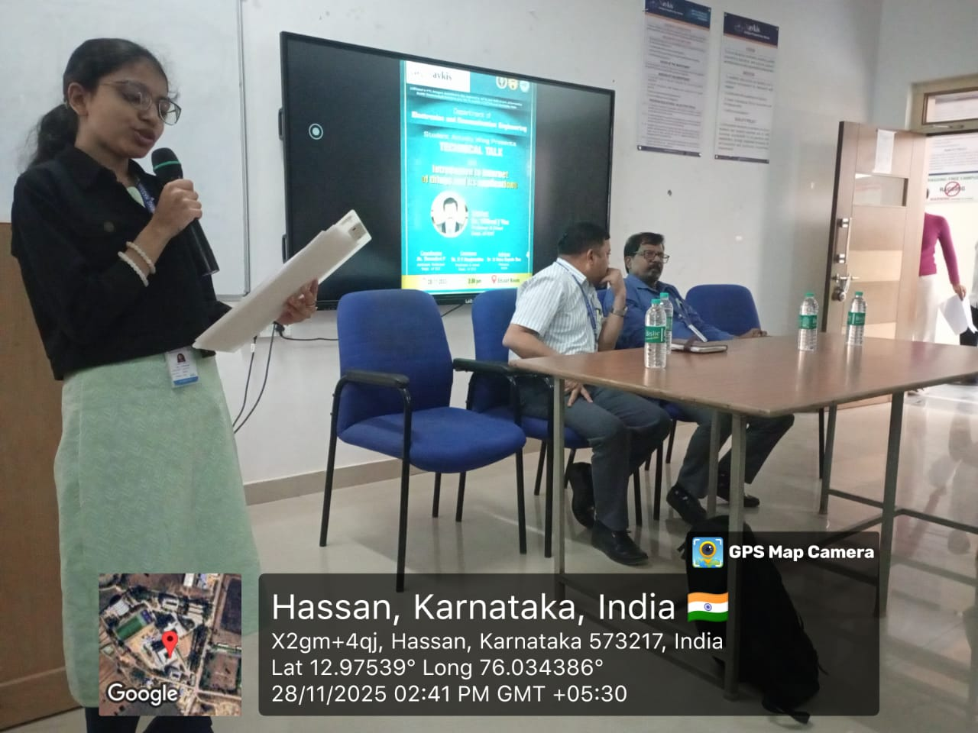
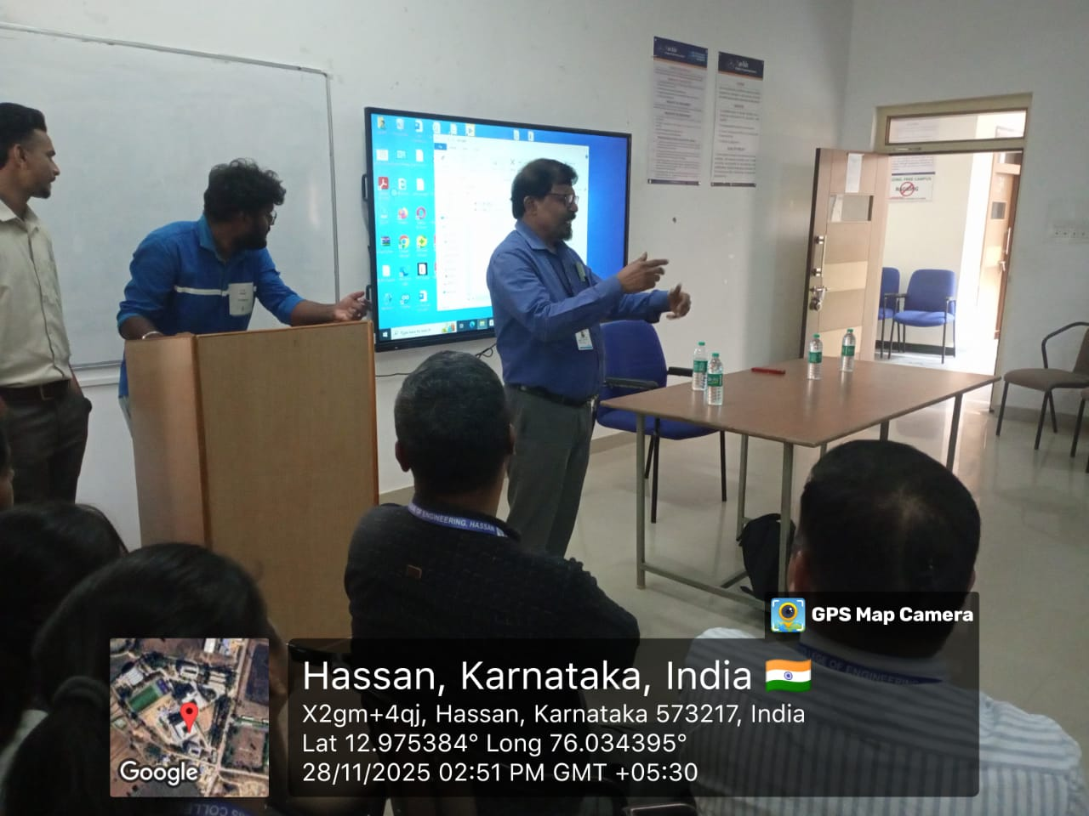

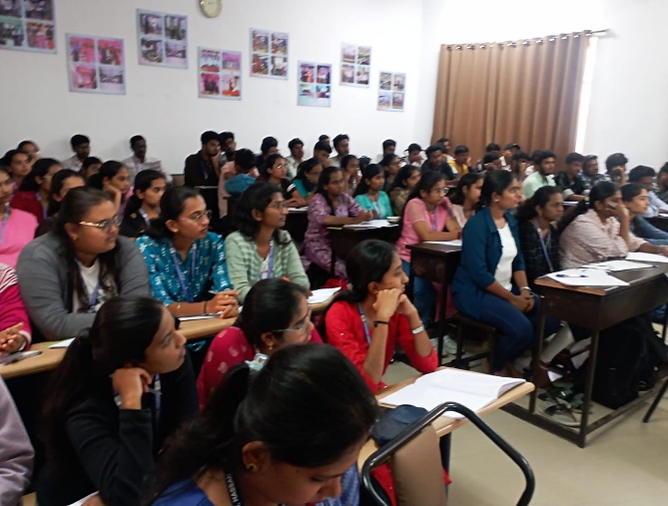
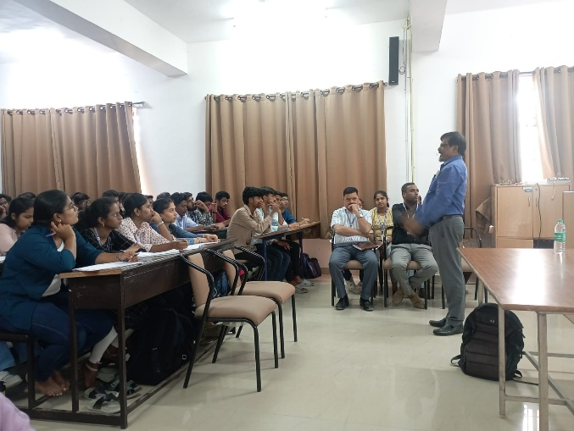
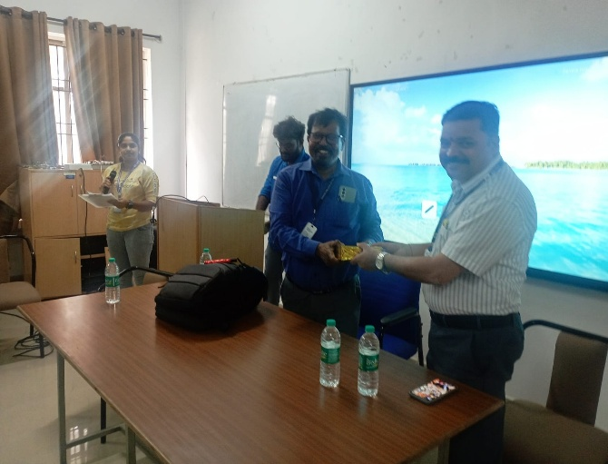
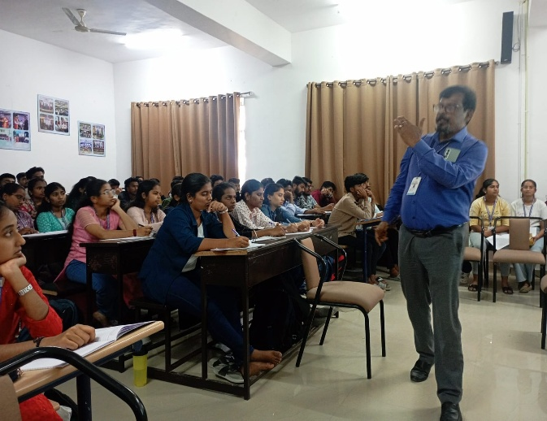

Dr.Deepak H A
IEEE Branch Counselor
Execom 2025

