The Student Activities Committee (SAC), IEEE Hyderabad Section, in collaboration with GyanNidhi Innovations, UTS and the IEEE VNRVJIET IES & SPS Chapters, is organizing a Unified Technical Hybrid Workshop at VNRVJIET on 12th Feb.2026 from 10 AM to 1PM

o 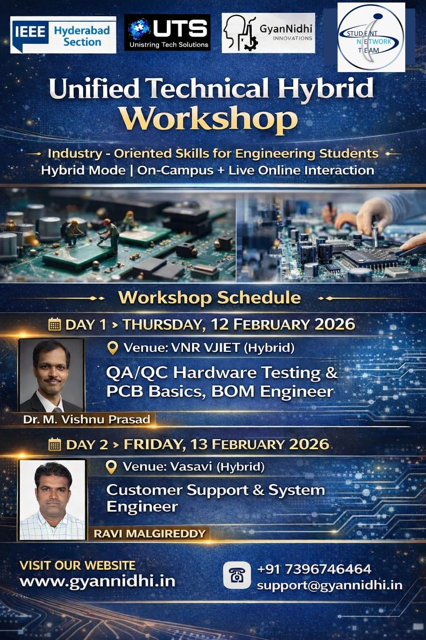

Date :Thursday, 12 February 2026
Venue: VNR Vignana Jyothi Institute of Engineering & Technology B214 (Hybrid Mode)
Participants :Physical :37, Online:100
Topic: QA/QC Hardware Testing, PCB Basics & BOM Engineering
Speaker: Dr. M. Vishnu Prasad
Dr. M. Vishnu Prasad is the Strategic HR Division Head at Unistring Tech Solutions, where he leads initiatives to align talent acquisition, capability building, and training with organizational growth and long-term strategic priorities. He holds a Doctor of Philosophy (Ph.D.) in Electrical Engineering from National Institute of Technology Warangal.
An accomplished academician and industry professional, Dr. Vishnu brings over 14 years of combined experience, including 10 years in research and academia and 4 years in industrial practice. As a keynote speaker, he offers a balanced perspective that bridges theory and practice, sharing insights on how strong research foundations, disciplined engineering methodologies, and real-world industry exposure together enable the development of robust, scalable, and application-ready engineering solutions.
Day 1 of the Unified Technical Hybrid Workshop focuses on industry-oriented hardware engineering skills, providing participants with practical insights into quality assurance, quality control, PCB fundamentals, and bill of materials (BOM) engineering. The session is designed to bridge the gap between academic knowledge and real-world industry practices, enabling students to understand testing methodologies, design considerations, and production-level workflows.
This interactive hybrid session offers hands-on learning, expert guidance, and real-time industry exposure, making it highly beneficial for students aspiring to build careers in hardware design, testing, and manufacturing domains.

Introduction
To bridge the gap between academic learning and industry requirements, a Unified Technical Hybrid Workshop followed by the Core Electrical & Electronics Job Mela 2026 was organized to provide engineering students with industry-oriented technical exposure and direct hiring opportunities in the core Electrical and Electronics sectors. The initiative aimed to equip students with practical knowledge, familiarize them with real-world job roles, and create a platform connecting students with recruiters offering core engineering opportunities.
The workshop sessions were conducted in hybrid mode, enabling both on-campus participation and live online interaction, ensuring wider student engagement.

Technical Sessions and Modules Covered
During the workshop, participants were introduced to several industry-relevant hardware testing, debugging, and product validation modules, providing both conceptual understanding and practical insights into electronic product development and quality assurance workflows. The major modules covered during the sessions included:
- Module 1: QC vs Testing vs Integration
Understanding the differences between quality control, product testing, and system integration and their roles in ensuring product reliability.
- Module 3: Assembled PCB (PCBA) QC – Common Component Defects
Identification of PCB assembly defects such as missing components, incorrect placement, polarity errors, and damaged components, along with inspection techniques.
- Module 4: Power Rail and Current Checks
Verification of voltage rails, current consumption, and electrical performance using standard measurement instruments.
- Module 4: Clock, Reset, and Boot Verification
Testing of clock signals, reset circuits, and system boot processes to ensure proper hardware initialization.
- Module 5: RF Functional Testing (Intro Level)
Introduction to RF testing concepts, measurement setups, and validation of RF hardware performance.
- Module 6: Mechanical Fitment and Alignment
Ensuring correct mechanical placement, structural alignment, and enclosure compatibility of electronic boards and modules.
- Module 7: End-to-End Functional Verification
Performing complete system-level functional testing to confirm proper operation after assembly and integration.
- Module 8: Isolation of Faulty Boards or Modules
Techniques for diagnosing faults by isolating defective modules through systematic testing and troubleshooting procedures.
These modules collectively provided students with a comprehensive understanding of hardware validation workflows followed in electronics manufacturing, testing laboratories, and product engineering environments, helping them gain exposure to real-time debugging and troubleshooting practices used in industry.

Core Electrical & Electronics Job Mela 2026
Following the workshop, the Core Electrical & Electronics Job Mela was conducted on 16th February 2026, offering 100+ job openings across various core industry roles. The event provided students with an opportunity to participate in career-oriented sessions, interact with recruiters, and explore direct hiring opportunities in the electrical and electronics domain.
The Job Mela served as a platform connecting industry organizations with aspiring engineering graduates, encouraging students to pursue careers in core engineering sectors while strengthening industry-academia collaboration.

Conclusion
The Unified Technical Hybrid Workshop and the Core Electrical & Electronics Job Mela 2026 successfully provided students with valuable technical exposure, industry insights, and employment opportunities. The initiative helped participants understand real-world engineering practices, develop job-relevant technical skills, and prepare effectively for core industry careers. The organizers were appreciated for conducting a well-structured program that significantly benefited engineering students by combining technical learning with direct placement opportunities.

Photographs
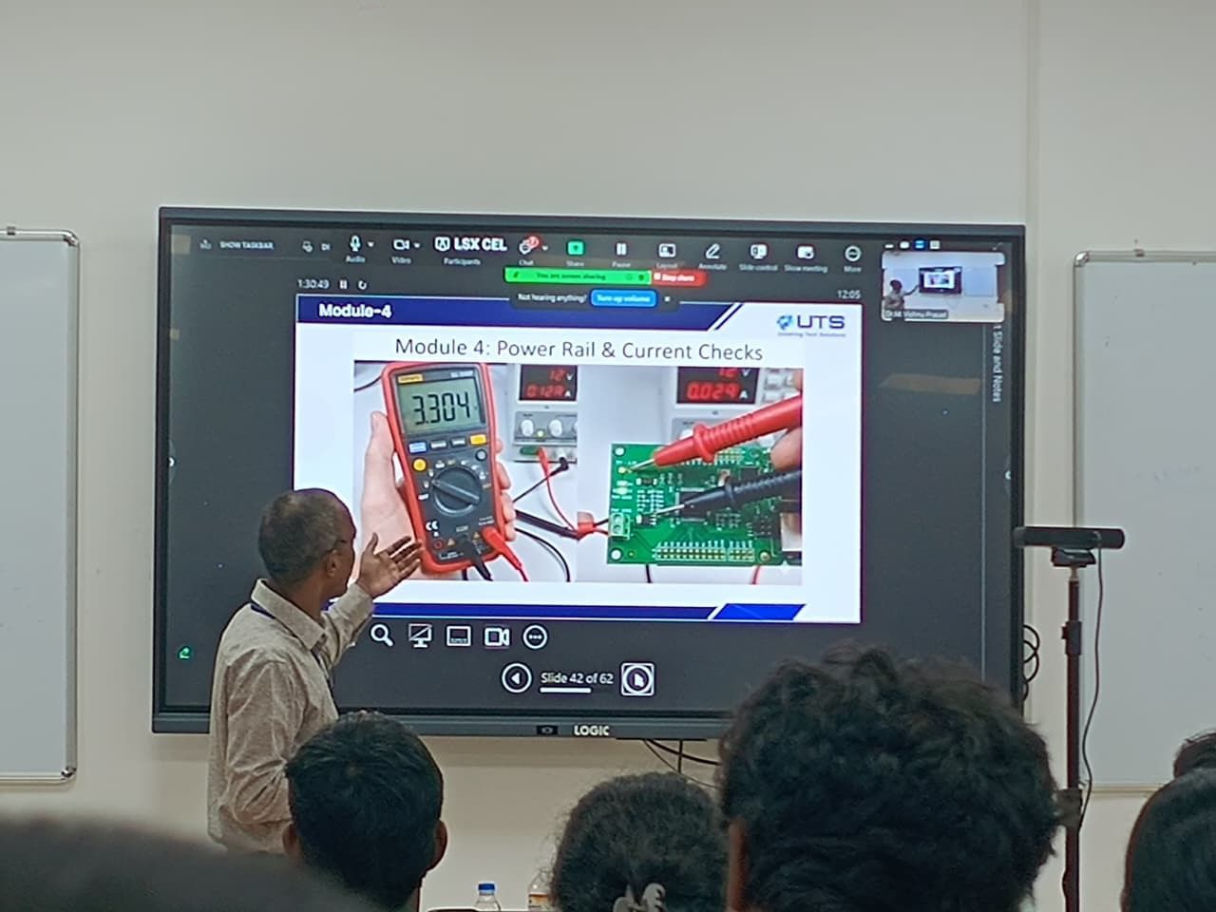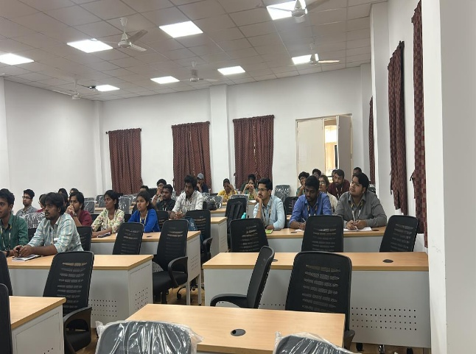
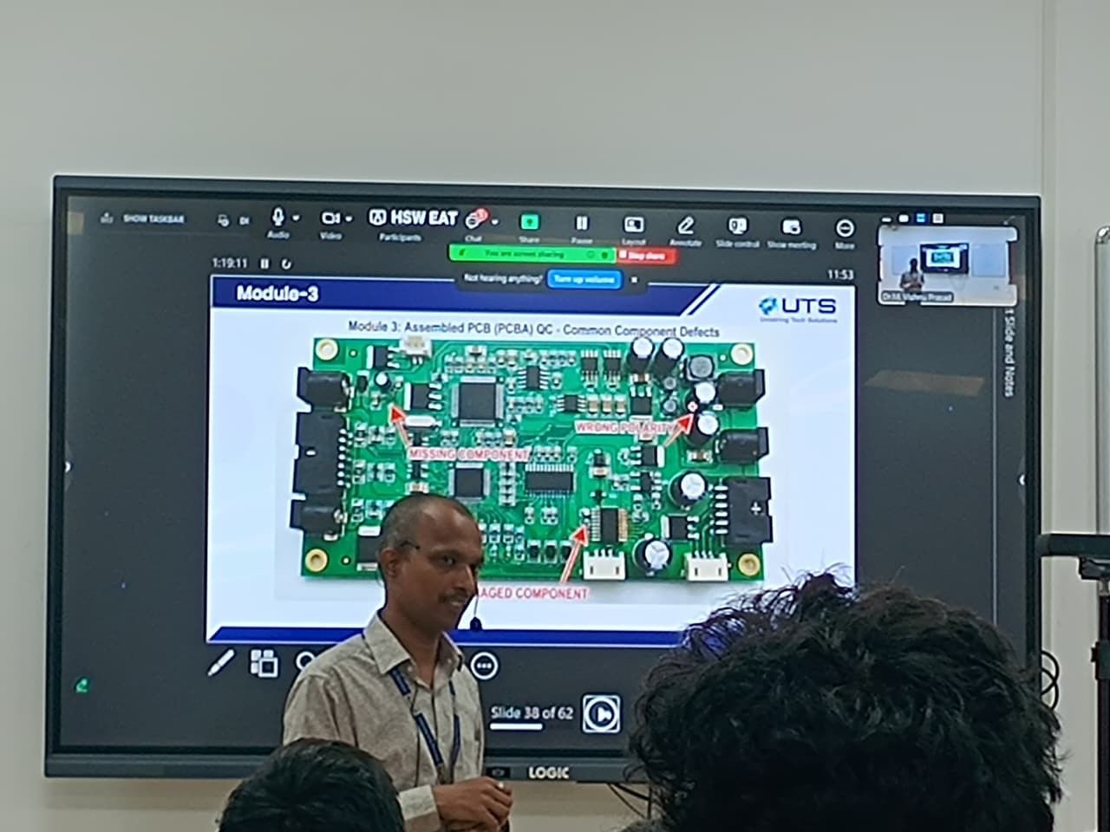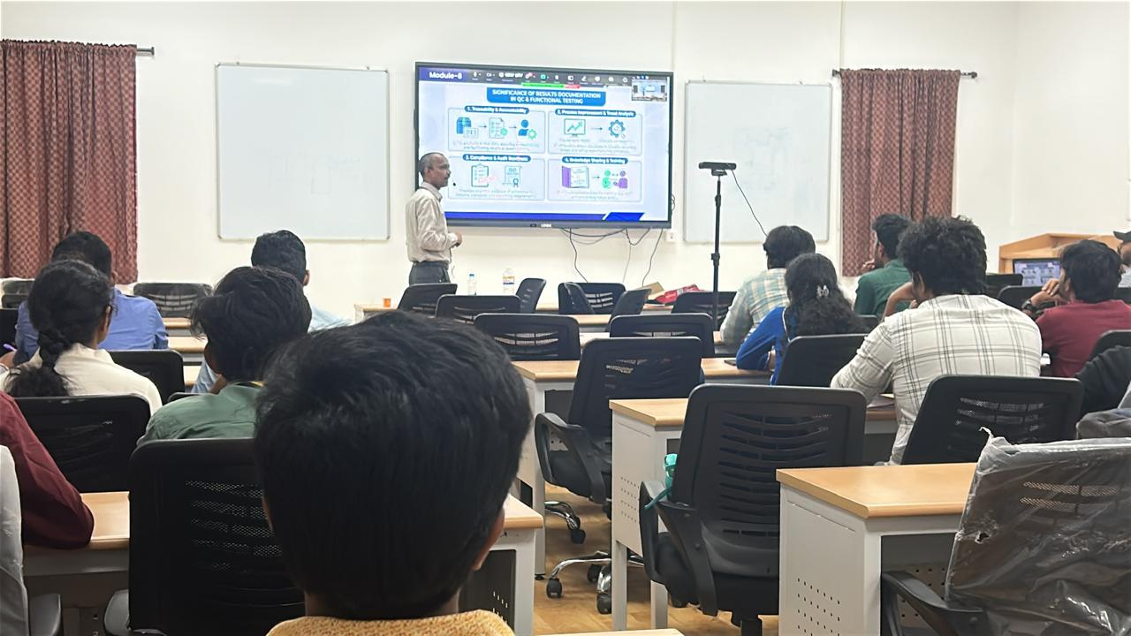

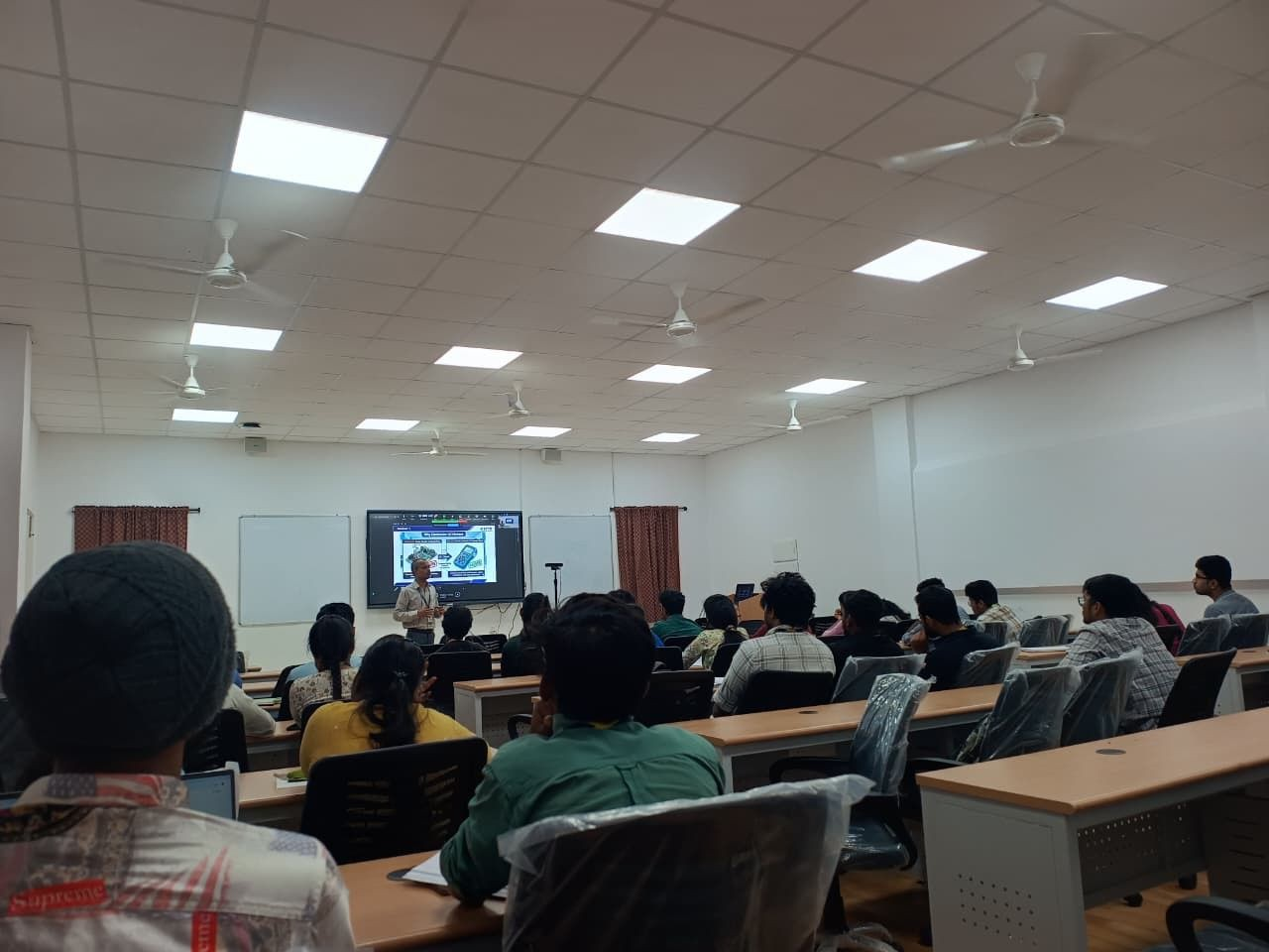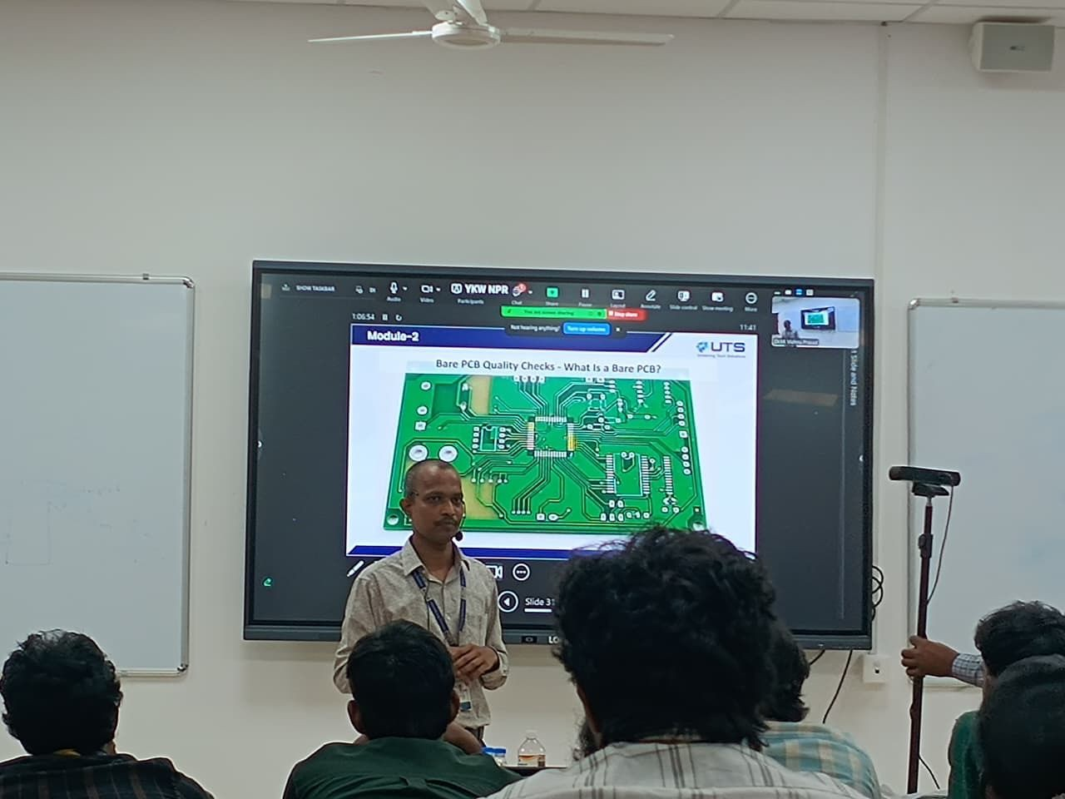

Attendance:
