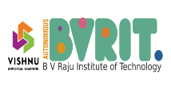 B V RAJU INSTITUTE OF TECHNOLOGY 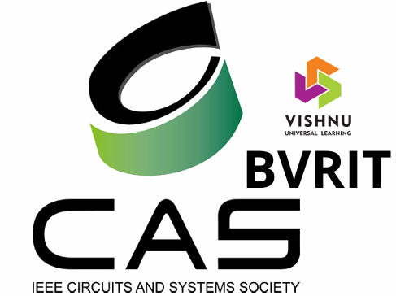
(UGC- Autonomous) with NAAC A+ Grade Narsapur, Medak, Telangana-
502313

Report on
Q-ehackathon

Date Of Conduction: 13 March 2026
Time: 10:00am to 3:30pm
Venue: ECE Seminar Hall
Organized by: IEEE CASS Student Branch
Faculty Guidance: Dr.M.C Chinnaiah, Dr. Anirudh Reddy

Introduction:

The IEEE Circuits and Systems Society (CASS) BVRIT Student Chapter, in collaboration with the Department of Electronics and Communication Engineering (ECE) at BVRIT, actively supported and participated in the Q-eHack – Institute Level Hackathon, organized as part of the QNX Everywhere initiative. The event aimed to provide students with an opportunity to apply Real-Time Operating System (RTOS) concepts to practical, real-world engineering challenges.

The initiative was designed to bridge the gap between theoretical knowledge and practical implementation, enabling students to explore advanced embedded and real-time system technologies. The IEEE CASS BVRIT Student Chapter supported this initiative as part of its mission to promote research, innovation, and technical excellence among students in the areas of circuits, embedded systems, and intelligent technologies

The primary objective of the event was to foster innovation, strengthen practical understanding of RTOS concepts, and encourage students to develop impactful solutions that can contribute to real-world technological advancements.

Panelists:

- Dr Kishore Pinninti – Secretary of IEEE CAS, Hyderabad Chapter
- Dr B R Sanjeev Reddy- HOD, Dept of ECE, B V Raju Institute of Technology.
- Dr M C Chinnaiah- Advisor, IEEE SB CAS BVRIT
- Dr. R Anirudh Reddy – Assistant Professor, Dept. of ECE, BVRIT
- Mr. T P Kausalya Nandan – IEEE CAS Member, Assistant Professor, Dept. of ECE, BVRIT
Participation:

The event witnessed active participation from students of BVRIT who were trained on QNXRTOS have enthusiastically showcased their innovative projects and technical solutions. Students from the Department of Electronics and Communication Engineering presented their work, demonstrating their understanding of emerging technologies and practical applications in engineering.
The presence of faculty members and guests further encouraged the participants and motivated them to continue exploring innovative ideas and real-world technological solutions.

Key Highlights from the session:

The Head of the Department of Electronics and Communication Engineering, Dr. B. R. Sanjeev Reddy, highlighted the importance of students actively participating in technical activities such as workshops, hackathons, and project exhibitions. He emphasized that these initiatives provide practical exposure, enhance problem-solving abilities, and strengthen technical knowledge beyond the regular curriculum.

Following this, Dr. M. C. Chinnaiah, Faculty Advisor of the IEEE CASS Student Chapter, spoke about the significance of professional technical societies like IEEE. He encouraged students to become active members of IEEE CASS to take advantage of its learning opportunities, networking platforms, and exposure to emerging technologies.

The chief guest, Dr. Kishore Pinninti, shared his insights on the importance of joining IEEE and engaging with its technical communities. He explained how IEEE provides students with opportunities to stay updated with global technological developments, participate in research initiatives, and grow professionally, inspiring students to actively explore innovation and emerging technologies.

Project Showcase and Interaction:

After the session, the guest, along with faculty members, visited the student teams to observe and interact with them as they showcased their projects. The students explained the objectives, design approach, and working of their projects, providing an opportunity for the guests to gain a closer understanding of the innovative ideas and technical skills applied by the participants.

The interaction allowed the students to receive feedback, clarify doubts, and discuss potential improvements, creating an engaging and collaborative environment. The project exhibition highlighted the creativity, technical knowledge, and problem-solving abilities of the students, while also motivating them to further explore emerging technologies and innovative solutions.

Conclusion:

The event provided an excellent platform for students to showcase their projects, interact with faculty and experts, and gain insights into emerging technologies. It encouraged active participation in technical activities and highlighted the benefits of joining professional societies like IEEE. Overall, the session was motivating and informative, inspiring students to further develop their technical skills, explore innovative ideas, and engage in research and professional growth opportunities.

Photos:

