IEEE SPERT 2025: A Technically Sponsored Platform Advancing Smart Power and Energy Innovation

The 2025 IEEE International Conference on Smart Power, Energy, Renewables, and Transportation (IEEE SPERT 2025) was successfully held from 22–24 December 2025 at Sardar Vallabhbhai National Institute of Technology (SVNIT), Surat, India. The conference brought together researchers, academicians, industry professionals, and policy stakeholders from across the globe to deliberate on emerging technologies shaping the future of energy systems and electrified transportation.
IEEE SPERT 2025 was organized by the Department of Electrical Engineering, SVNIT Surat, with financial support from the IEEE Gujarat Section and the IEEE IAS/IES/PELS Joint Chapter. The conference also received technical sponsorship from the IEEE Power Electronics Society (PELS) and the IEEE Industry Applications Society (IAS), reflecting its strong technical rigor and international relevance.
The technical program comprised multiple regular tracks covering power converters, renewable energy integration, energy management systems, electric vehicle (EV) charging infrastructure, grid resiliency, automation, and AI driven energy systems. In addition, 15 specialized sessions addressed contemporary topics such as wide bandgap devices, solar based mobility, cybersecurity for renewable rich grids, predictive maintenance, and intelligent transportation systems.
The conference received 524 paper submissions, of which 139 high-quality papers were selected through a rigorous peer-review process and presented across 8 technical tracks and 15 special sessions. Contributions were received from premier institutes including IITs and NITs, along with international submissions from the USA, Italy, Oman, and Japan. Active industry participation from organizations such as Power Grid, KPIT, and CPRI further strengthened academia–industry interactions.
Hosted at SVNIT Surat, the conference provided an engaging platform for young researchers and doctoral scholars to interact with international experts, keynote speakers, and industry leaders. The event fostered interdisciplinary collaboration and enabled meaningful discussions on real world challenges and sustainable solutions in the energy and transportation sectors.
With its strong IEEE technical sponsorship, comprehensive thematic coverage, and robust scholarly contributions, IEEE SPERT 2025 successfully advanced discussions on next generation energy and transportation technologies. The conference reaffirmed the region’s growing leadership in power electronics, renewable energy, and electrified transportation research, while reinforcing IEEE’s global commitment to sustainable and socially impactful technological development.
The detailed report is available here: Report SPERT 2025
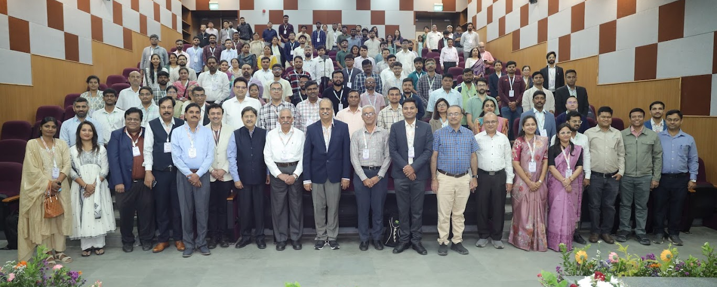Group photo of IEEE SPERT 2025

