2-Day Workshop & Off-Campus Job Drive on System Engineer (Wireless & Embedded)
Poster:
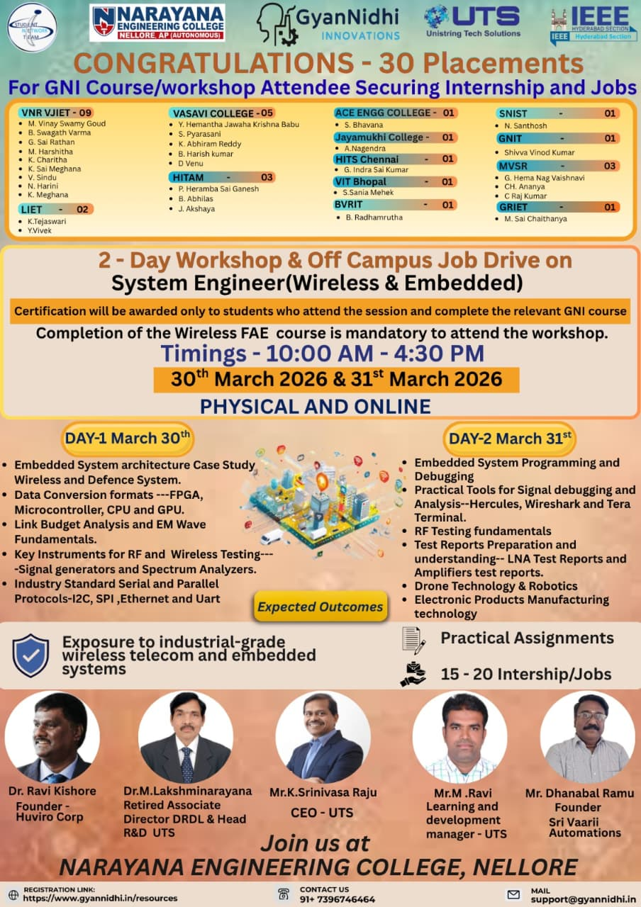

2-Day Workshop & Off-Campus Job Drive on System Engineer (Wireless & Embedded) was successfully organized by the Department of Electronics and Communication Engineering (ECE), VNR Vignana Jyothi Institute of Engineering and Technology (VNRVJIET), Narayana Engineering College (Physical) in association with GyanNidhi Innovations (GNI), Unistring Tech Solutions (UTS), and IEEE Hyderabad Section on 30th & 31st March 2026 from 10:00 AM to 4:30 PM in hybrid mode at VNRVJIET. The event witnessed participation from 8 colleges across Telangana and Andhra Pradesh, with 296 participants on Day 1 and 422 participants on Day 2, reaching over 400+ students in total, including 19 students from VNRVJIET (included in the overall count). The primary objective of the workshop was to provide hands-on exposure to industry-relevant wireless communication and embedded systems while also offering placement opportunities through an off-campus job drive.
The first day focused on foundational and analytical aspects of embedded and wireless systems, covering topics such as embedded system architecture through case studies, overview of wireless and defence communication systems, data conversion techniques using FPGA, microcontrollers, CPUs, and GPUs, link budget analysis and electromagnetic wave fundamentals, demonstration of RF and wireless testing instruments including signal generators and spectrum analyzers, and understanding of industrial communication protocols such as I2C, SPI, Ethernet, and UART. The second day emphasized practical implementation and industry applications, including embedded system programming and debugging techniques, hands-on exposure to tools like Hercules, Wireshark, and Tera Term, fundamentals of RF testing and analysis, preparation and interpretation of technical test reports (LNA and amplifier testing), and insights into applications such as drone technology, robotics, and electronic product manufacturing.
The workshop delivered significant outcomes by providing practical exposure to real-time wireless telecom and embedded systems, enhancing students’ understanding of industry tools and testing methodologies, improving their technical, analytical, and problem-solving skills, and increasing awareness of career opportunities in wireless and embedded domains. As part of the off-campus job drive, 30 students secured internships and job opportunities, demonstrating strong employability impact and successful industry-academia collaboration. A total of 77 skill certificates and 314 participation certificates were distributed, amounting to 391 certificates, where skill certificates were awarded based on performance in hands-on evaluation and participation certificates were issued to eligible attendees.
The event ensured strong multi-college participation and high engagement, particularly during Day 2 hands-on sessions, and effectively bridged the gap between academic learning and industry requirements. The program was conducted following IEEE standards, with event creation and reporting completed through vTools, proper attendance documentation maintained, and necessary institutional and IEEE approvals obtained. Overall, the workshop proved to be highly impactful in delivering technical knowledge, industry exposure, and placement outcomes, thereby strengthening IEEE student engagement and contributing to skill development and professional growth. Attachments include attendance sheets, event photographs, and event poster.

Attendance Sheet:
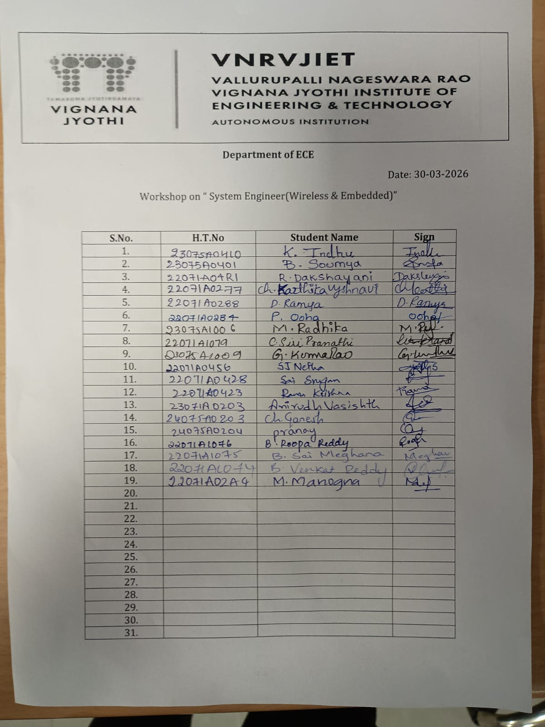

Photographs:
