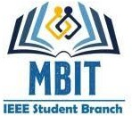
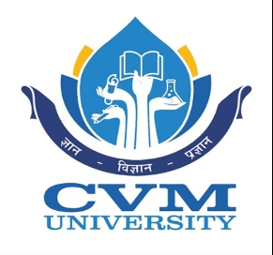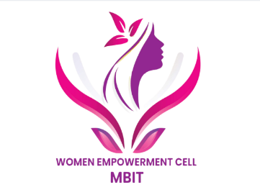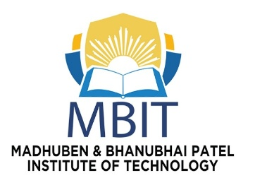

IEEE WIE MBIT: THE ENGINEERING UPGRADE

Event Details
- Event Name: The Engineering Upgrade
- Date and Day: 7th July 2026 (Tuesday)
- Time: 10:00am – 11:00am IST
- Duration: 1 Hour
- Event Type: Offline Event
- Event Level: Collage Level
- Organizer: IEEE WIE MBIT
- Total Participants: 13

Objective of the Event

Introduce students to IEEE and IEEE Women in Engineering (WIE).Encourage students to develop technical, leadership, networking, and innovation skills.Motivate participants to engage in workshops, hackathons, competitions, and IEEE volunteer activities.Promote continuous learning, professional growth, and collaboration.Create awareness about the benefits of joining IEEE and participating in student branch activities.

Summary of the Event

On the occasion of IEEE WIE Day 2026, the IEEE Women in Engineering Student Branch at MBIT successfully organized 'The Engineering Upgrade', an interactive orientation and skill-development program designed to encourage students to begin their engineering journey with the right mindset. The event commenced with a warm welcome to all participants and an introduction to the significance of IEEE WIE Day and the mission of IEEE Women in Engineering. Students were informed about the importance of technical excellence, innovation, leadership, inclusiveness, and lifelong learning in today's rapidly changing engineering profession.
The session featured an engaging introduction to IEEE, explaining how membership provides access to global technical resources, professional networking opportunities, international conferences, research publications, workshops, certifications, competitions, scholarships, and career development programs. Students gained a clear understanding of how active participation in IEEE activities can strengthen their academic profile and improve employability.
To ensure active participation rather than passive listening, the event incorporated interactive activities and discussions. Students explored four major growth pillars represented during the program: Technical Skills, Leadership, Networking, and Innovation. Each pillar highlighted practical opportunities such as hackathons, coding competitions, project development, event management, collaborative teamwork, and real-world problem solving. Participants were encouraged to identify areas for personal growth and understand how these experiences complement classroom education.
A dedicated Skill Unlock Challenge further increased student engagement by promoting teamwork, communication, creativity, and critical thinking. Participants enthusiastically completed activities, interacted with volunteers, and earned upgrade cards and rewards based on their involvement. These activities transformed the session into an enjoyable learning experience while reinforcing the importance of collaboration and continuous improvement.
The event concluded with a motivational message encouraging students to remain curious, embrace innovation, and actively participate in future IEEE initiatives. Overall, 'The Engineering Upgrade' successfully achieved its objectives by creating awareness about IEEE, inspiring students to pursue technical and professional excellence, and motivating them to become confident, skilled, and responsible future engineers. The positive response and enthusiastic participation demonstrated the effectiveness of the program in promoting learning beyond the classroom and fostering a culture of innovation, leadership, and community engagement.

Attendance Record
The following Execom Members attended the event on 7th July 2026:
Sr. No. | Participant Name
1 | Tithi Bhatt
2 | Yashvi Dave
3 | Vruti Patel
4 | Yasmin Seikh
5 | Manas Choksi
6 | Tejas Patel
7 | Shyam Patel
8 | Ronak Das
9 | Krutagna Thesiya
10 | Yash Patel
11 | Akshar Chauhan
12 | Darshil
13 | Aditya

