Dr Sri Niwas Singh
FIEEE (USA), FNAE, FIET (UK), IE(I), IETE(I), FAvH
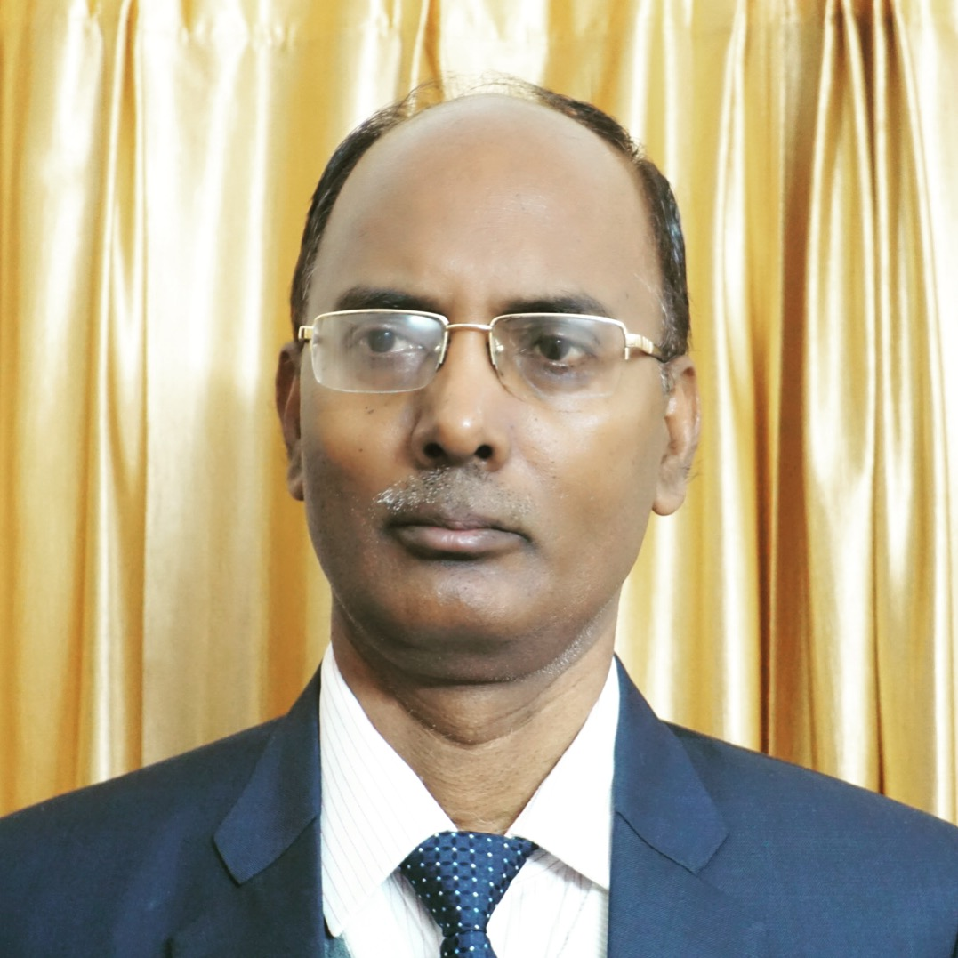

Prof S. N. Singh obtained his M. Tech. and Ph. D. in Electrical Engineering from Indian Institute of Technology Kanpur, in 1989 and 1995. Presently, he is Professor (HAG), Department of Electrical Engineering, Indian Institute of Technology Kanpur, India. Before joining IIT Kanpur as Associate Professor, Dr Singh worked with UP State Electricity Board as Assistant Engineer from 1988 to 1996, with Roorkee University (now IIT Roorkee) as Assistant Professor from 1996 to 2000 and with Asian Institute of Technology, Bangkok, Thailand as Assistant Professor from 2001 to 2002. He was Vice-Chancellor of Madan Mohan Malviya University of Technology Gorakhpur during April 2017 to July 2020. Dr Singh received several awards including Young Engineer Award 2000 of Indian National Academy of Engineering (INAE), Khosla Research Award of IIT Roorkee, and Young Engineer Award of CBIP New Delhi (India), 1996. Prof Singh is receipt of Humboldt Fellowship of Germany (2005, 2007) and Otto-monsted Fellowship of Denmark (2009-10). Prof Singh became first Asian to receive 2013 IEEE Educational Activity Board Meritorious Achievement Award in Continuing Education. He is also recipients of INAE Outstanding Teacher Award 2016 and IEEE R10 region (Asia-Pacific) Outstanding Volunteer Award 2016. Dr Singh is appointed as IEEE Distinguish Lecturer of Power & Energy Society from 2019 and Industry application Society for 2019-2021. He is also recipient of NPSC 2020 Academic Excellence Award.

His research interests include power system restructuring, FACTS, power system optimization & control, security analysis, wind power, etc. Prof Singh has published more than 500 papers in International/national journals/conferences and supervised 31 PhD (12 PhD under progress). He has also written 23 book chapters, 6 Edited books and 2 text-books one on Electric Power Generation, Transmission and Distribution and second is Basic Electrical Engineering, published by PHI, India. Prof Singh has completed three dozen of technical projects in India and abroad. His two NPTEL (YouTube) video lectures on HVDC Transmission and Power System Operation & Control are very popular.

Prof Singh was Chairman, IEEE UP Section for 2013 & 2014, IEEE R10 (Asia-Pacific) Conference & Technical Seminar Coordinator 2015-18 and R10 Vice-Chair, Technical Activities (2019-2020). Presently Prof Singh is Immediate Past Chairman of IEEE, India Council. Dr Singh is Fellows of, IEEE (USA), FIET (UK), FNAE, FIE(I), FIETE, AvH.

