SAGAR INSTITUTE OF SCIENCE AND TECHNOLOGY – EXCELLENCE (SISTec-E), BHOPAL
Department of Electrical Engineering | SISTec-E Bhopal

INDUSTRIAL VISIT REPORT
Indian Institute of Drone Technology (IIDT)
Dodi, Sohagpur, Madhya Pradesh, India
Date of Visit: April 25, 2026
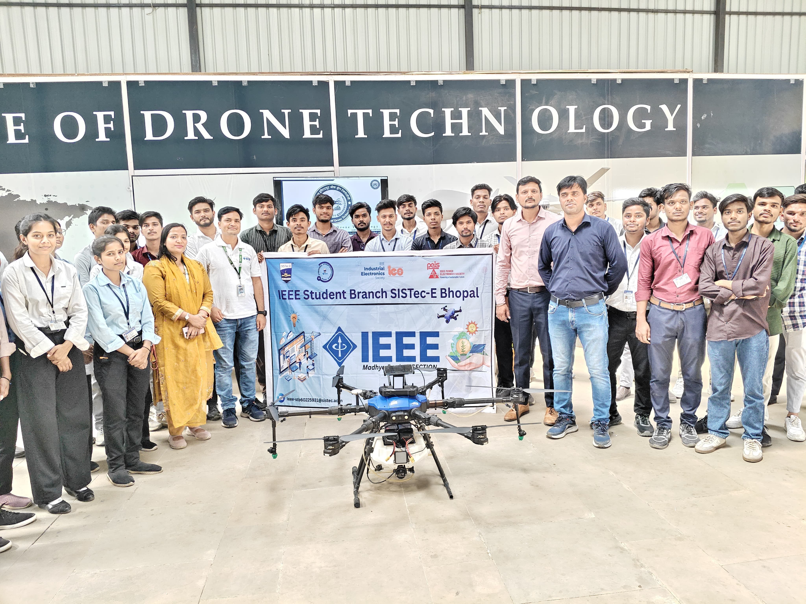
Fig. 1 – IEEE Student Branch SISTec-E Bhopal with the IEEE banner & agriculture hexacopter at IIDT

1. Introduction
On April 25, 2026, students of the Electrical Engineering Department, SISTec-E Bhopal, under the auspices of the IEEE Student Branch SISTec-E, undertook a full-day industrial visit to the Indian Institute of Drone Technology (IIDT), situated at Dodi, Sohagpur, Madhya Pradesh. The visit was organized to provide students with first-hand exposure to the rapidly evolving domain of Unmanned Aerial Vehicle (UAV) technology, commonly known as drone technology.
IIDT is one of India's premier institutions dedicated exclusively to research, development, training, and promotion of drone technology for diverse civilian and defence applications. The institute operates in alignment with the Government of India's vision of making India the 'Drone Capital of the World', supported by the 2021 Drone Rules and the PLI scheme for UAVs. The visit served as a vital bridge between classroom theory and real-world engineering practice.

2. Objectives of the Visit
- To gain an understanding of the fundamental working principles and aerodynamics of drones.
- To study the different types and classifications of UAVs — multi-rotor, fixed-wing, VTOL hybrid.
- To witness live demonstrations of drone hardware including multi-rotor copters and fixed-wing aircraft.
- To understand the role of drone technology in the Indian defence and military ecosystem.
- To explore career and research opportunities in the UAV domain for engineering graduates.
- To enhance practical knowledge of electrical systems integrated within modern drone hardware.
- To understand India's DGCA drone regulatory framework and operational compliance requirements.

3. About the Indian Institute of Drone Technology (IIDT)
The Indian Institute of Drone Technology (IIDT), located at Dodi, Sohagpur, Madhya Pradesh, is a pioneering institution established with the mission to democratize drone education and foster innovation in India's UAV sector. The institute offers a full-fledged infrastructure encompassing drone assembly workshops, flying arenas, simulation labs, and testing facilities for a wide variety of UAV platforms ranging from micro-drones to large industrial hexacopters.
IIDT operates in close collaboration with industry partners, government bodies, and academic institutions to develop a highly skilled workforce for India's booming drone ecosystem. The institute offers training programs in drone piloting, drone manufacturing, flight controller software, and regulatory compliance as per DGCA guidelines. A prominent signboard inside the facility proudly reads 'DODI – DRONE CAPITAL OF THE WORLD', reflecting India's global ambitions in the UAV space.

4. Technical Session – Lecture Hall Briefing
Upon arrival, the entire student group was seated inside IIDT's spacious lecture hall. Two separate sessions were conducted by experienced faculty members and industry experts. The sessions were highly interactive, covering theoretical and applied aspects of drone technology.
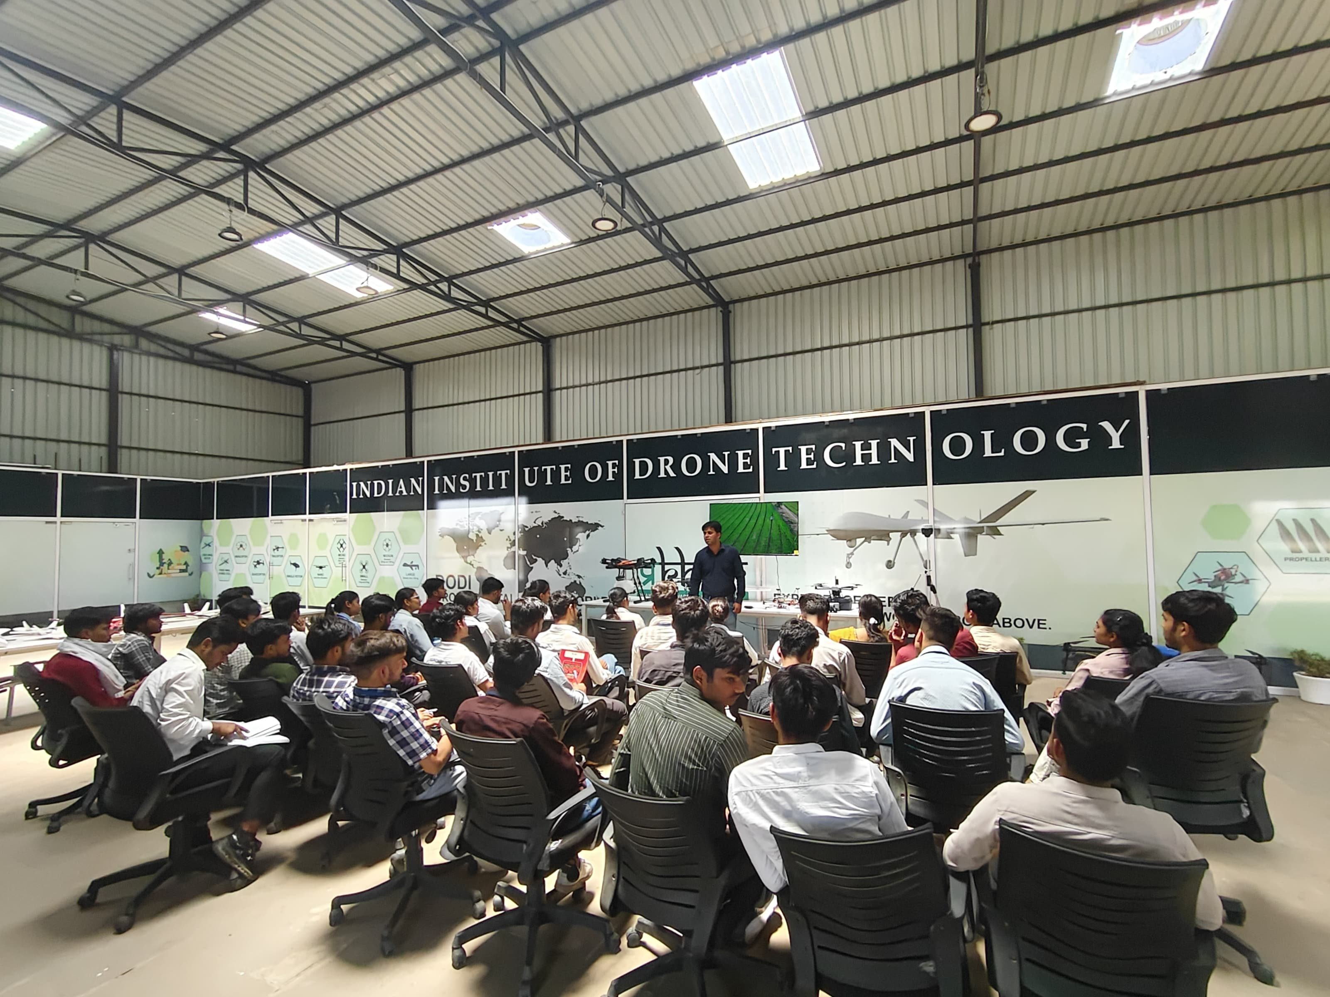
Fig. 2 – Students attending the opening lecture session inside IIDT's main hall
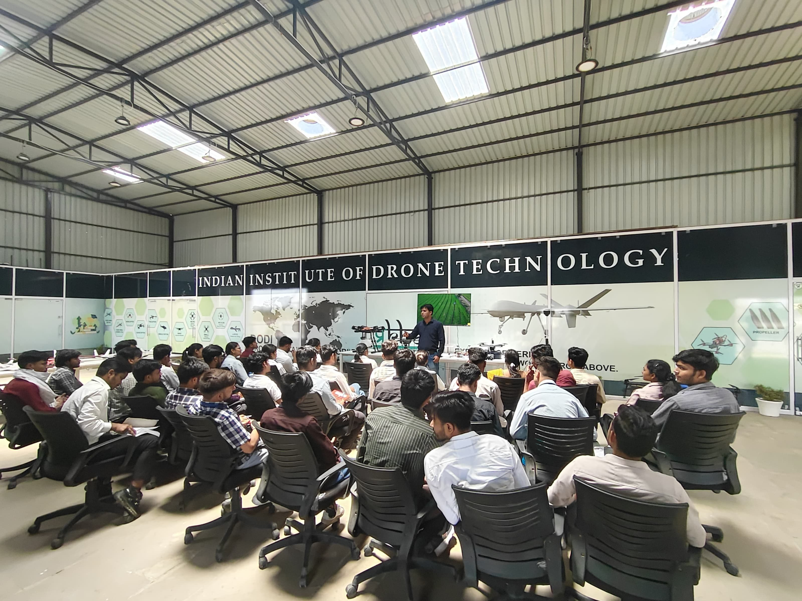
Fig. 3 – Full student batch seated at IIDT during the technical briefing session
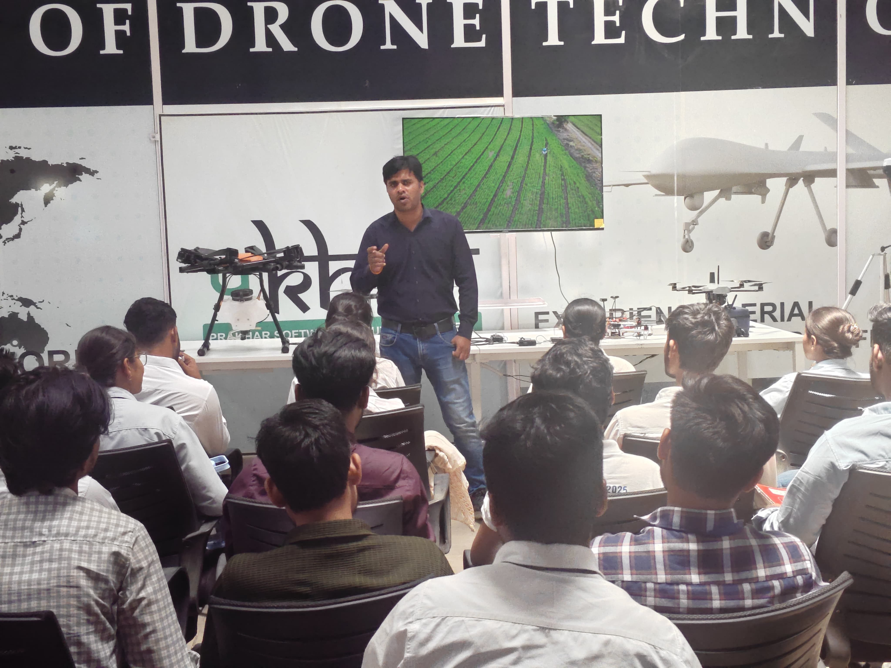
Fig. 4 – IIDT expert delivering lecture with agricultural drone aerial footage on screen

4.1 Topics Covered in the Lecture Sessions
- Introduction to UAVs – History, evolution, and India's position in the global drone market.
- Working Principle – Lift, thrust, drag, torque, yaw; Newton's laws applied to multi-rotor flight.
- Types of Drones – Multi-rotor (quad/hexa/octocopter), fixed-wing, VTOL hybrid, tilt-rotor.
- Applications – Photography & Videography, Precision Agriculture, Surveillance & Security, Infrastructure Inspection, Delivery Services, Disaster Management, Anti-Drone Systems.
- Drone Components – BLDC Motors, ESC, Flight Controller (Pixhawk/ArduPilot), LiPo Battery, GPS Module, Telemetry, FPV Camera, Radio Transmitter/Receiver.
- Drone Flying Zones – Red Zone (No-fly), Yellow Zone (permission required), Green Zone (free fly).
- DGCA Regulations – Digital Sky Platform, NPNT (No Permission No Takeoff), UAS Rules 2021.
- Defence Applications – Surveillance UAVs, loitering munitions, anti-drone tech, swarm drones.

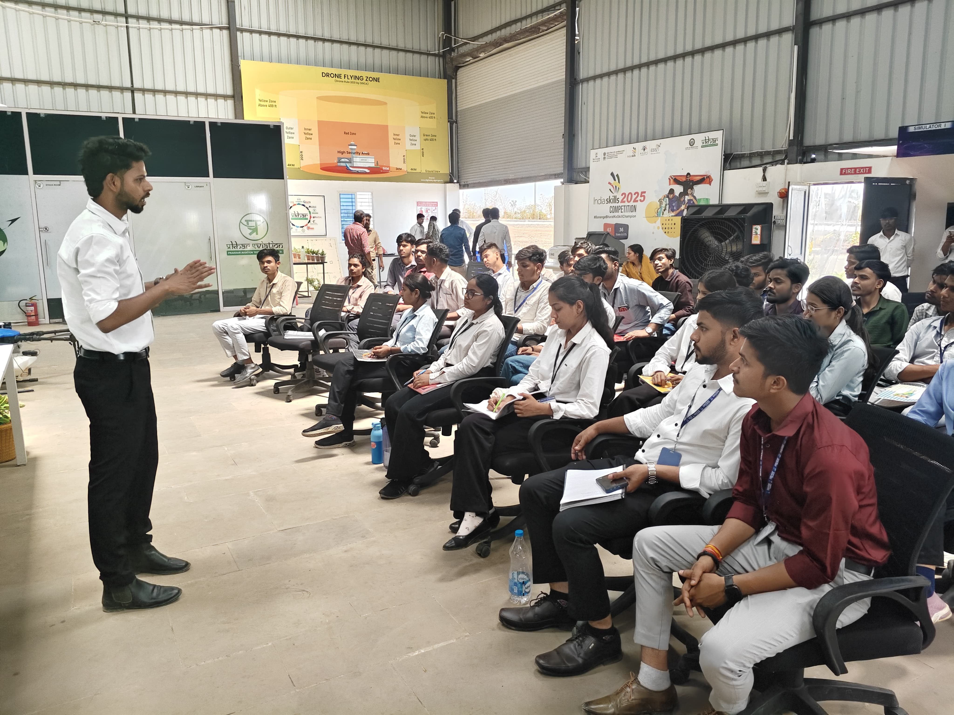
Fig. 5 – Session on Drone Flying Zones (Red/Yellow/Green) and DGCA regulations for airspace compliance
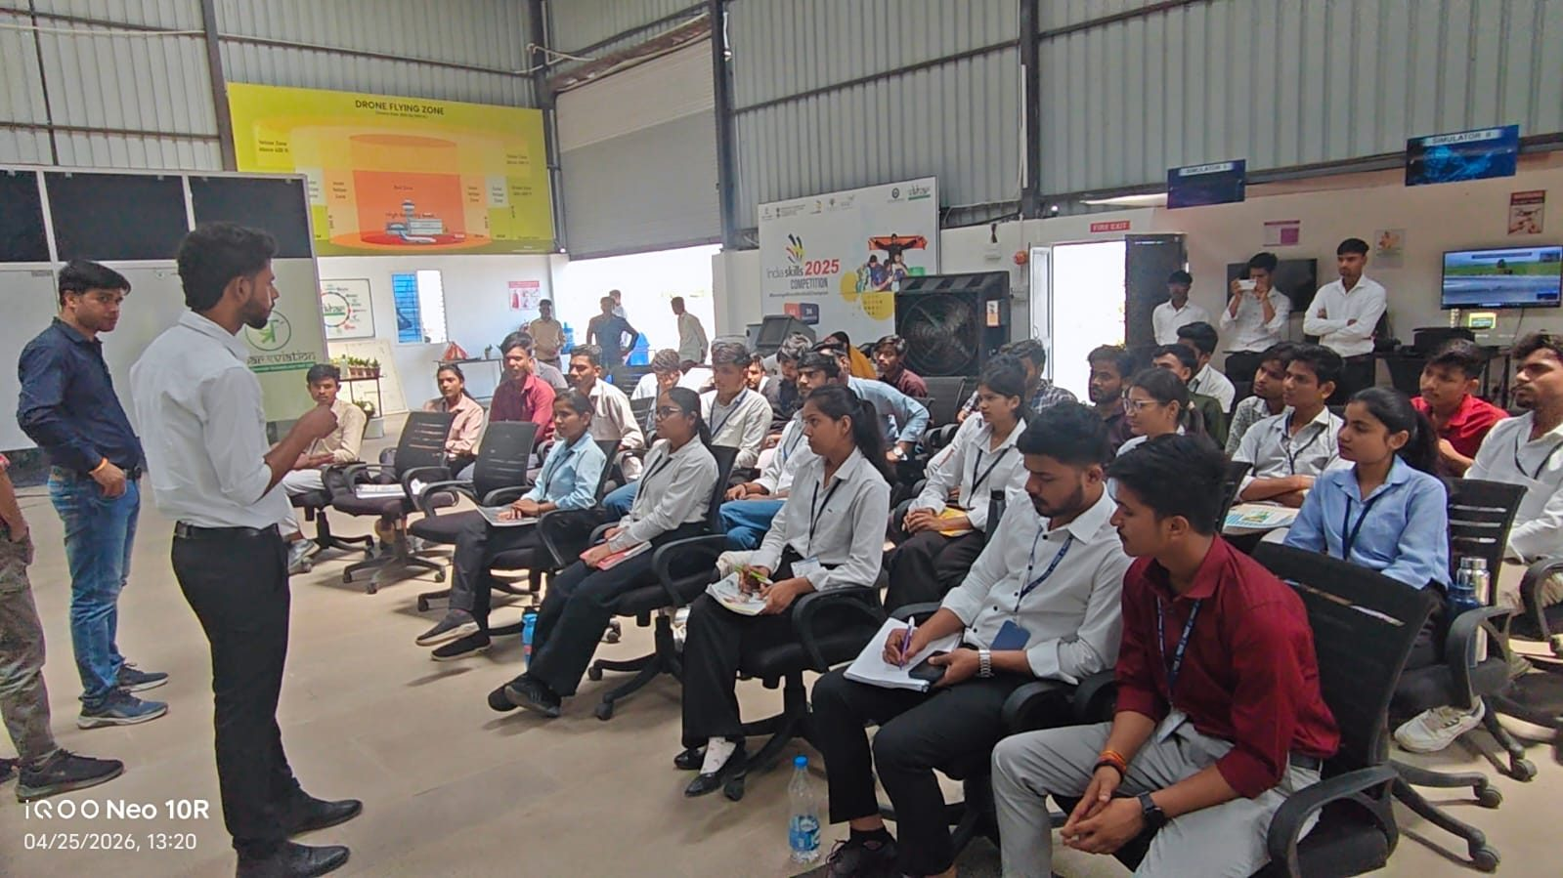
Fig. 6 – IIDT representative explaining airspace zoning and career pathways in drone technology

5. Practical Exposure – Hardware Tour and Drone Models
Following the lecture sessions, the students were guided through IIDT's drone hardware display area and indoor workshop zone. IIDT's technical staff demonstrated a wide variety of UAV platforms physically, explaining the function of each component and system. This hands-on exposure was one of the most impactful parts of the visit.

5.1 Drone Models Observed
Drone Type | Configuration | Primary Application
Agriculture Hexacopter | 6-rotor, GPS, spray nozzles, 10 L tank | Precision crop spraying
Surveillance Quadcopter | 4-rotor, FPV, 4K camera, thermal option | Security, perimeter patrol
Fixed-Wing Military UAV | High-aspect wing, BLDC pusher motor | ISR, border monitoring
Mini FPV Racer | 4-rotor, carbon frame, 200+ km/h | Pilot training, sports
Foam Fixed-Wing Trainer | Foam body, servos, brushless motor | Aerodynamics study, training
VTOL Hybrid | Fixed-wing + multi-rotor combined | Mapping, delivery, defence ISR
Swarm Drone (demo unit) | Compact quad, mesh RF link | Coordinated multi-UAV ops

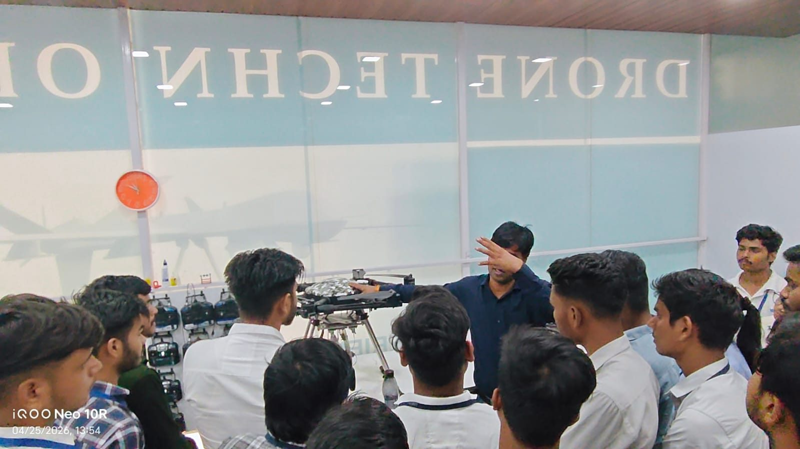
Fig. 7 – IIDT technician demonstrating drone hardware and components to students up close
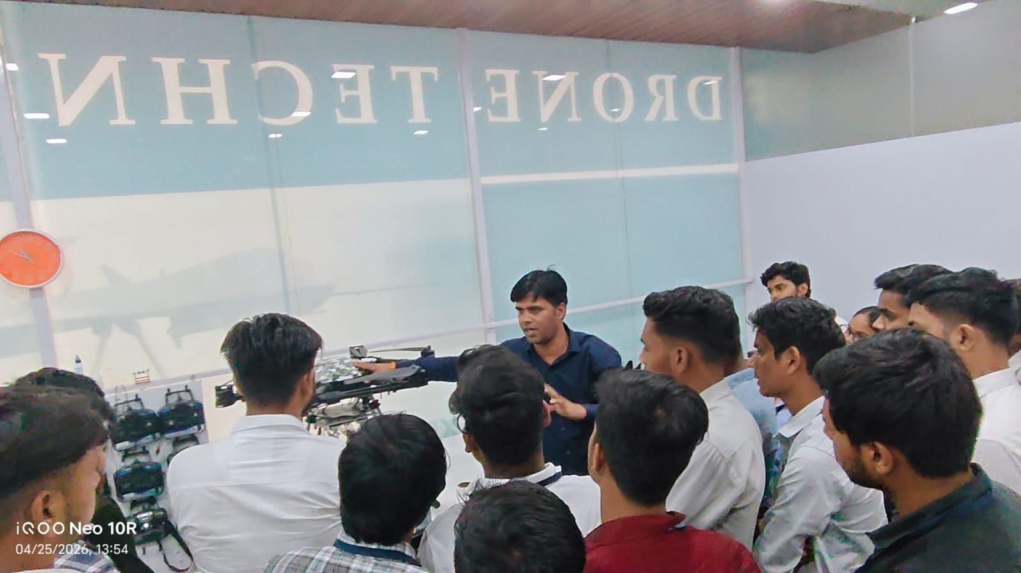
Fig. 8 – Detailed explanation of drone frame, motors, and flight controller system
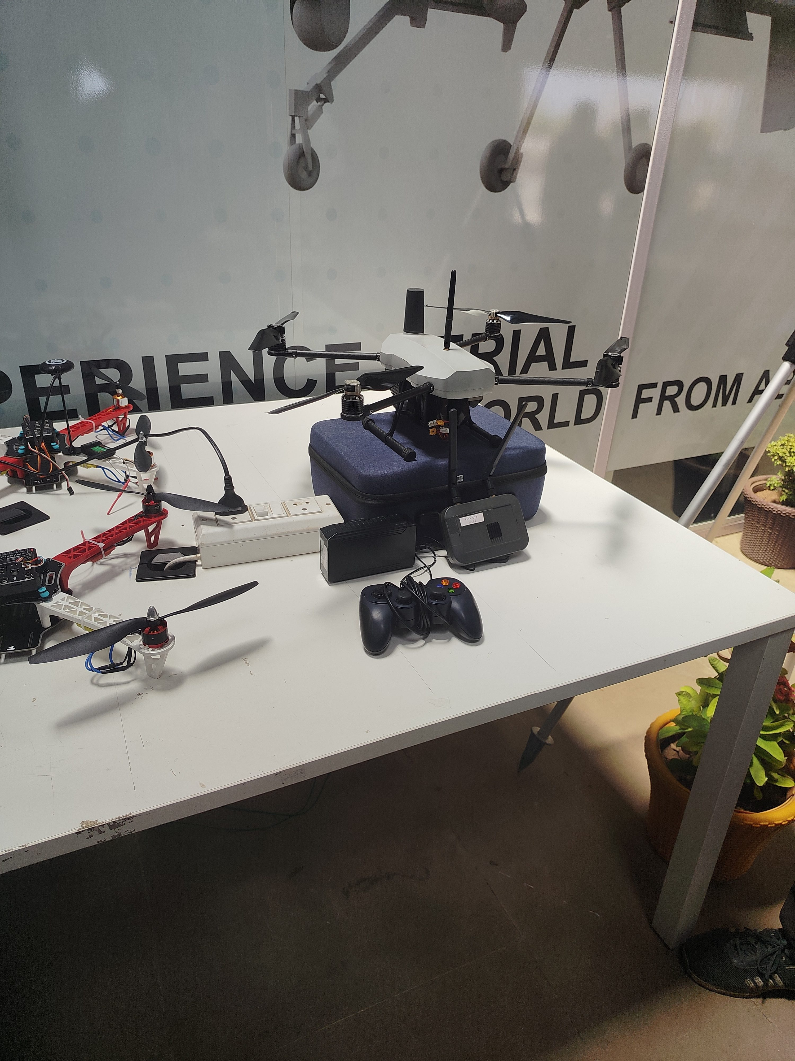
Fig. 10 – Workshop desk: quadcopter, FPV racer, flight controller, gamepad controller, and LiPo packs

6. Defence and Military Drone Systems
A highly impactful segment of the visit was the dedicated section on defence and military-grade UAV systems. IIDT showcased physical models and delivered an expert explanation on how drones are transforming modern warfare and border security in India and globally.
- Surveillance UAVs – Long-endurance platforms with thermal imaging used for reconnaissance along sensitive border regions; demonstrated via a full-scale fixed-wing model on display.
- Loitering Munition Drones – Kamikaze-type drones that hover over a target zone and strike with precision payload delivery, significantly reducing soldier risk.
- Anti-Drone Systems – RF jamming units, laser-based intercept systems, and net-capture mechanisms designed to detect and neutralize hostile UAVs in sensitive airspace.
- Swarm Drone Technology – Coordinated autonomous multi-drone formations used in electronic warfare and saturation attack strategies in modern military operations.
- HALE UAVs (High Altitude Long Endurance) – Fixed-wing military drones used for persistent ISR (Intelligence, Surveillance & Reconnaissance) covering vast geographic areas.
- DRDO & Make in India UAVs – Students were informed about indigenous programmes like Rustom, Tapas-BH, and CATS Warrior under India's self-reliant defence manufacturing push.

7. Key Learnings
The visit was highly enriching and provided actionable insights that strongly complement the Electrical Engineering curriculum at SISTec-E. Key takeaways include:
- Brushless DC (BLDC) motors, ESC, and power electronics — directly applicable to EE Power Electronics and Drives coursework.
- LiPo battery technology, C-ratings, energy density, and embedded power management systems.
- Flight controllers (ArduPilot, Pixhawk) as real-world embedded microcontroller applications.
- GPS-based autonomous navigation, telemetry, and wireless communication system integration.
- DGCA regulatory framework — Digital Sky Platform, NPNT, drone categories (Nano to Large).
- Drone Flying Zones (Red/Yellow/Green) and airspace safety protocols.
- Defence-grade UAV systems and India's growing indigenous drone manufacturing ecosystem.
- Career pathways: drone pilot, drone engineer, GCS software developer, regulatory consultant.
- India Skills 2025 Competition — IIDT is a registered centre, opening competition opportunities.

8. Conclusion
The industrial visit to the Indian Institute of Drone Technology (IIDT), Dodi, Madhya Pradesh, on April 25, 2026, was an outstanding and highly productive experience for the students and faculty of SISTec-E Bhopal. The exposure to a wide range of UAV systems — from hobby-grade drones to sophisticated military-grade platforms — gave students a comprehensive perspective on real-world applications of Electrical and Electronic Engineering principles.
The visit reinforced the importance of bridging theoretical knowledge with practical exposure. Students left with a deeper appreciation of the interdisciplinary nature of drone technology, encompassing aerodynamics, embedded systems, power electronics, communication systems, and regulatory frameworks. Interactions with IIDT's faculty and industry experts further motivated students to explore research, innovation, and careers in this rapidly growing domain. The India Skills 2025 Competition banners visible during the visit further highlighted that IIDT provides nationally recognized skill certification in UAV operations.

