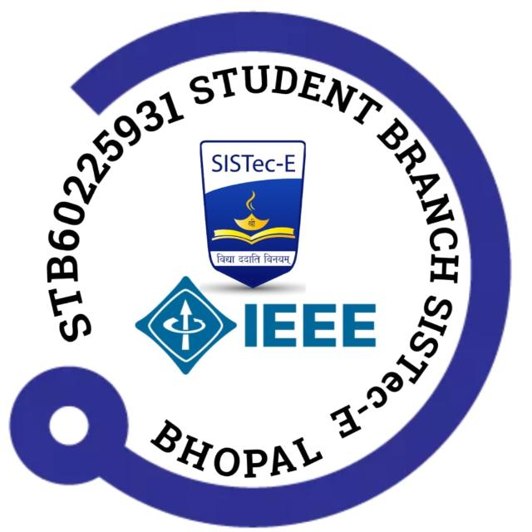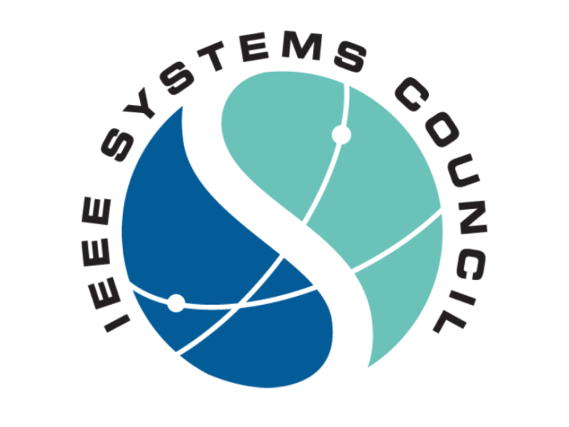
Report on Workshop: "First Step into IoT"
Organized By: Department of Electrical Engineering, SISTec Ratibad, Bhopal

Workshop Details

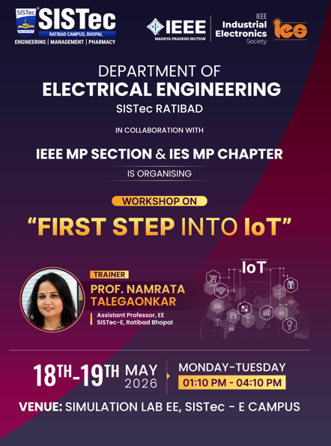

Introduction

The Department of Electrical Engineering, SISTec Ratibad, in collaboration with IEEE MP Section and IEEE Industrial Electronics Society (IES) MP Chapter, successfully organized a two-day hands-on workshop titled 'First Step into IoT' on 18–19 May 2026. The workshop aimed to introduce students to the fundamentals of the Internet of Things (IoT) and provide practical exposure to IoT-based system development.

Objectives

- Introduce participants to the concept and applications of IoT.
- Familiarize students with IoT hardware and software platforms.
- Provide hands-on experience in sensor interfacing and device connectivity.
- Demonstrate real-world IoT applications in smart homes, healthcare, industry, and automation.
- Encourage students to develop innovative IoT-based solutions.

Workshop Proceedings

The workshop commenced with an overview of IoT concepts, architecture, sensors, controllers, communication protocols, cloud platforms, and data analytics. Participants gained practical exposure through hands-on activities involving sensor interfacing, device programming, connectivity, and real-time monitoring.

Learning Outcomes

- Understand IoT fundamentals.
- Interface sensors with embedded hardware platforms.
- Establish communication between devices and cloud platforms.
- Develop basic IoT prototypes.
- Explore engineering applications of IoT.

Participant Response

The workshop received enthusiastic participation from students. Interactive discussions and practical demonstrations helped participants gain a clear understanding of IoT concepts and applications.
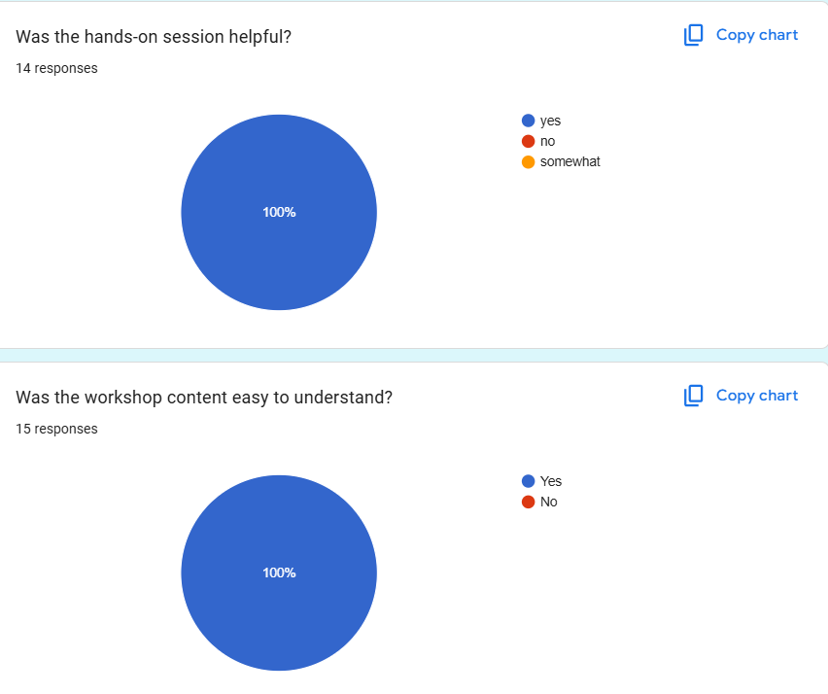
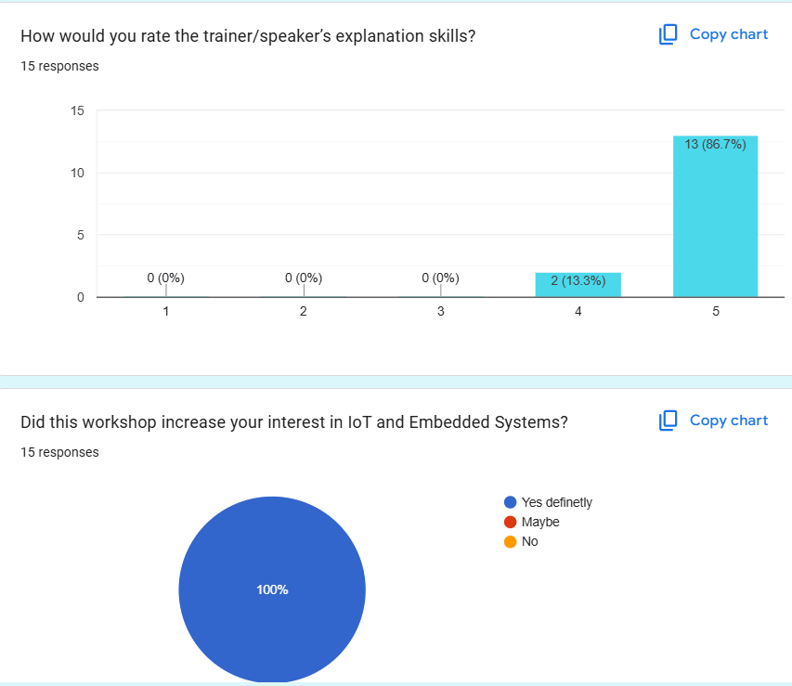

Conclusion

The workshop successfully achieved its objectives by providing participants with both theoretical knowledge and practical exposure to IoT technologies. It served as an excellent platform for students to explore emerging technologies and enhance their technical skills.
Some glimpses of workshop are as follow
