IEEE Region 10 ACEI – Delhi Section Ambassador Team 2026
Consolidated Event Report

One-Week Workshop on Intellectual Property, Innovation and Entrepreneurship (IPIE 2026)
Date: 13–17 July 2026
Mode: Online
Organized by: IEEE Region 10 AdHoc Committee on Entrepreneurship and Innovation (ACEI) – Delhi Section Ambassador Team 2026

Innovation and entrepreneurship thrive when creators and organizations understand how to identify, protect, and commercialize their intellectual assets. For students and emerging professionals, developing a strong foundation in Intellectual Property Rights (IPR) is essential to translate original ideas into legally protected and economically valuable outcomes. As part of the One-Week Workshop on Intellectual Property, Innovation and Entrepreneurship (IPIE 2026), the IEEE Region 10 ACEI Delhi Section Ambassador Team organized a comprehensive five-day online workshop from 13–17 July 2026. The programme brought together renowned academicians, patent professionals, government officials, industry experts, and innovation leaders to provide participants with a holistic understanding of intellectual property, innovation management, entrepreneurship, organizational resilience, startup funding, and emerging technologies.

The workshop successfully created an interactive learning environment where participants gained both theoretical knowledge and practical insights into protecting innovations, commercializing research, building resilient organizations, and developing entrepreneurial skills. A total of 162 participants attended the workshop.

Objectives of the Workshop : The workshop was organized with the following objectives:
- To enhance awareness about Intellectual Property Rights and innovation protection.
- To familiarize participants with patents, trademarks, copyrights, and Intellectual Property strategies.
- To strengthen understanding of organizational resilience and business continuity.
- To introduce best practices in governance, risk management, and crisis preparedness.
- To encourage innovation while promoting responsible and sustainable organizational practices.
- To expose participants to startup ecosystems, commercialization strategies, and funding opportunities.
- To create awareness regarding Artificial Intelligence and emerging technologies in entrepreneurship.
- To provide opportunities for interaction with experienced professionals from academia, industry, and government.

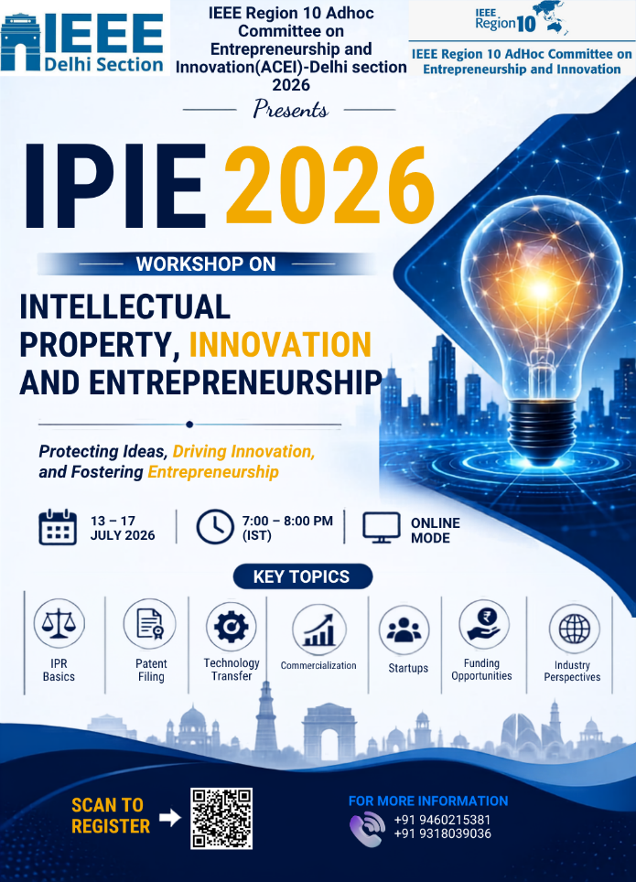

Workshop Overview : The workshop consisted of ten expert sessions delivered over five days. Each day focused on a specific theme related to innovation and entrepreneurship.
Day | Theme | Expert Speakers
Day 1 | Intellectual Property & Research Innovation | Dr. Vinod Karar, Dr. Muthu Venkatesh S
Day 2 | Patent Protection & Intellectual Property Rights | Ms. Nekita Kumari, Ms. Bharti Jain
Day 3 | Patent Strategies & Geographical Indications | Mr. Maulesh Parikh, Prof. Shruti Jain
Day 4 | Intellectual Property & Organizational Resilience | Ms. Monika, Mr. Daman Sood
Day 5 | Funding Opportunities & Industry Perspectives | Prof. Parul Malik, Mr. Tarun Kumar

Distinguished Speakers
- Dr. Vinod Karar, Scientist G & Head, PME, CSIR–Central Road Research Institute (CSIR-CRRI), New Delhi : Dr. Vinod Karar is a senior scientist and innovation leader with extensive experience in research management, technology transfer, and commercialization of research outcomes. His session emphasized translating research into deployable innovations and strengthening industry–academia collaborations.

- Dr. Muthu Venkatesh S, Managing Associate (Patents); Indian Patent Agent & Patent Attorney, Bengaluru

- Ms. Nekita Kumari, Assistant Controller of Patents & Designs, CGPDTM, DPIIT, Government of India : Ms. Nekita Kumari provided participants with valuable insights into India's Intellectual Property framework, patent examination process, and the National Intellectual Property Awareness Mission (NIPAM).

- Ms. Bharti Jain, Advocate & Registered Patent Agent : Ms. Bharti Jain explained the patent drafting process, patentability criteria, prosecution procedures, and practical aspects of Intellectual Property protection for innovators and entrepreneurs.

- Mr. Maulesh Parikh, Registered Patent Agent | Technology Transfer Officer | IPR Expert : Mr. Parikh discussed patent filing strategies, technology transfer, innovation management, and commercialization of research, helping participants understand the practical dimensions of Intellectual Property.

- Prof. Shruti Jain, Dean Academics, Jaypee University of Information Technology : Prof. Shruti Jain delivered an engaging session on Geographical Indications (GI), Intellectual Property awareness, research commercialization, and innovation ecosystems, highlighting the role of GI in preserving traditional knowledge and regional identity.

- Ms. Monika, IP Consultant, Aksh IP Associates : Ms. Monika focused on patent searches, patent analytics, Intellectual Property strategy, and practical methods for protecting innovative ideas through patents and trademarks.

- Mr. Daman Sood Head – Head - Governance, Business Reviews, and Consultative Sale - ITS Technology Solution Pvt Ltd. – IP Strategy for Startups : Mr. Daman Sood emphasized organizational resilience, governance, business continuity, cybersecurity, leadership, and strategic decision-making for sustainable organizations.

- Prof. Parul Malik, Professor, New Delhi Institute of Management (NDIM) : Prof. Malik explained startup funding ecosystems, government grants, investor readiness, financial planning, business model development, and entrepreneurship support mechanisms available in India.

- Mr. Tarun Kumar, AI/ML & Generative AI Expert : Mr. Tarun Kumar shared industry perspectives on Artificial Intelligence, startup execution, AI-driven innovation, leadership, and product development while encouraging participants to embrace emerging technologies.

Interactive Activities : To reinforce learning, an online quiz covering all technical sessions conducted during the five-day workshop was organized. The activity served as a knowledge assessment and revision exercise and encouraged participants to revisit important concepts discussed throughout the programme. No winners were declared, as the objective was purely educational.

Outcomes and Impact : The IPIE 2026 workshop made a significant impact by strengthening participants' knowledge, professional competencies, and innovative mindset. Throughout the five-day programme, participants developed a comprehensive understanding of Intellectual Property Rights, patents, trademarks, innovation protection strategies, organizational resilience, business continuity, governance, risk management, startup funding ecosystems, Artificial Intelligence, research commercialization, and entrepreneurship. The expert-led sessions enhanced awareness of industry best practices, leadership, strategic thinking, and responsible governance while providing practical insights into Intellectual Property management, investor expectations, funding mechanisms, and commercialization pathways. The workshop also encouraged participants to think strategically, embrace innovation with ethical responsibility, and continuously upgrade their professional and technical skills. By integrating academic concepts with real-world applications, the programme strengthened participants' confidence in protecting intellectual assets, developing entrepreneurial ventures, cultivating resilience, and contributing effectively to research, innovation, and technology-driven growth. Overall, the workshop successfully equipped attendees with the knowledge, skills, and motivation required to pursue innovation and entrepreneurship with confidence and responsibility.

Key Takeaways : The workshop emphasized the importance of Intellectual Property protection, innovation, entrepreneurship, and commercialization in building sustainable ventures. Participants learned the value of patents, strategic planning, business continuity, startup funding, Artificial Intelligence, and organizational resilience. Continuous learning, adaptability, and ethical leadership emerged as essential drivers of long-term professional and entrepreneurial success.

The One-Week Workshop on Intellectual Property, Innovation and Entrepreneurship (IPIE 2026) successfully provided participants with a comprehensive understanding of Intellectual Property Rights, innovation management, entrepreneurship, startup funding, organizational resilience, Artificial Intelligence, and commercialization strategies. Through expert-led sessions delivered by distinguished academicians, government officials, patent professionals, and industry leaders, participants gained valuable theoretical knowledge and practical insights into protecting intellectual assets, transforming innovative ideas into commercially viable ventures, and developing resilient organizations. The interactive nature of the workshop encouraged participants to think beyond technical knowledge and appreciate the significance of strategic planning, ethical innovation, leadership, and continuous professional development. Overall, the programme proved to be highly informative and impactful, equipping participants with the knowledge, confidence, and professional perspectives necessary to contribute effectively to research, innovation, entrepreneurship, and technology-driven development.

Workshop resources including:
- Presentation Slides
- Workshop Recording
- Event Snapshots
- Additional Learning Resources
https://drive.google.com/drive/u/3/folders/1ULGoMjtiHhj9gjsVGqd1SEzsdFOT_08I
vtools link : https://events.vtools.ieee.org/m/566276

