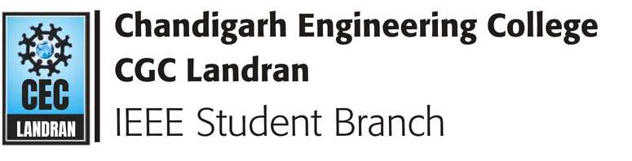


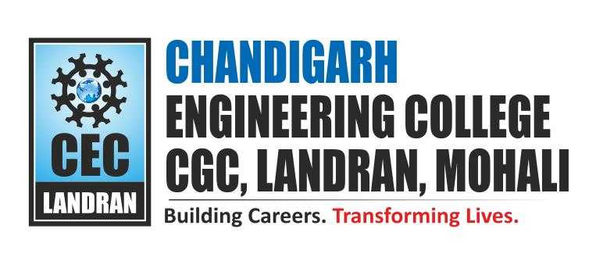
CHANDIGARH ENGINEERING COLLEGE – CGC

IDEATHON 2026
Two-Day Innovation & Ideation Event Report

Date: 6–7 August 2026
Organized by: IEEE Student Branch, Chandigarh Engineering College
Event Start Time: 9:30 AM on both days
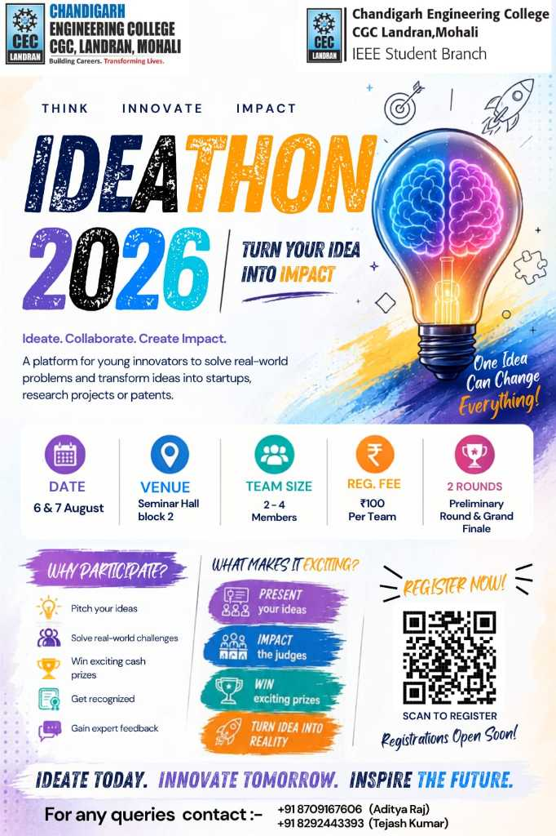

1. Event Overview
IDEATHON 2026 was a two-day innovation and ideation event organized by the IEEE Student Branch, Chandigarh Engineering College, on 6th and 7th August 2026. The event was designed to provide students with a platform to identify and address real-world problems through innovative, feasible, and impactful solutions.
The event encouraged participants to think beyond conventional approaches and develop ideas that could potentially address challenges faced in society, industry, technology, and everyday life. Participants presented their ideas before expert panels, underwent evaluation, and competed for recognition and cash prizes.
A total of 84 teams participated in the event, with each team registering at a fee of ₹100. The first day served as the initial selection/pitching round, following which 20 teams were shortlisted for the final round conducted on the second day.
The second day involved detailed presentations by the shortlisted teams, with several teams additionally presenting prototypes to demonstrate the practical implementation of their proposed solutions.

2. Objectives of IDEATHON 2026
- To provide students with a platform to identify and address real-world problems.
- To encourage innovation, creativity, and problem-solving among students.
- To develop students' ability to convert an idea into a practical and feasible solution.
- To provide exposure to idea pitching and professional presentation.
- To encourage students to explore technological solutions to societal and contemporary challenges.
- To promote teamwork, communication, critical thinking, and collaborative learning.
- To provide students with an opportunity to interact with faculty members and expert judges.
- To recognize and reward promising ideas and innovative solutions.
- To encourage students to move beyond theoretical concepts towards practical implementation and prototyping.

3. Event Statistics
Particular | Details
Event | IDEATHON 2026
Duration | 2 Days
Dates | 6–7 August 2026
Total Teams Participated | 84 Teams
Registration Fee | ₹100 per Team
Total Registration Collection | ₹8,400
Teams Shortlisted for Final Round | 20 Teams
Presentation Duration | Approximately 10 minutes/team
1st Position Prize | ₹2,500
1st Runner-Up Prize | ₹1,500
2nd Runner-Up Prize | ₹1,000
Total Cash Prize | ₹5,000
Emerging Idea Recognitions | 2
Volunteer Certificates | 12
Event Start Time | 9:30 AM

4. Chief Guest and Dignitaries
Mr. Deepak Garg, Chief Guest, was present on both days of the event.
The inauguration was graced by the presence of:
- Mr. Deepak Garg — Chief Guest
- Dr. Sukhpreet Kaur — Director/Principal
- Dr. Vinay Bhatia — HOD, Electronics & Communication Engineering Department and Branch Counsellor
- Dr. Ashima Kalra —Branch Counsellor
- Ms. Ritu Sharma — Faculty Coordinator
Their presence provided encouragement and motivation to the participating students and organizing team.

5. Panel and Judging Committee
The event was conducted through four judging panels to facilitate systematic evaluation of the participating teams.

Panel 1 — IDEA LAB
Panelist | Affiliation
Dr. Amaresh Kr. Panjla | RISE Department
Ms. Sonia Jindal | RISE Department

Panel 2 — IDEA LAB
Panelist | Affiliation
Dr. Dinesh Arora | IPR Department
Dr. Varsha Sood | ECE Department, CEC-CGC

Panel 3 — Seminar Hall, Block 3, CSE Block
Panelist | Affiliation
Ms. Dapinty | CSE Department, CEC-CGC
Dr. Sachin Mohal | ME Department, CEC-CGC

Panel 4 — Seminar Hall, Block 3, CSE Block
Panelist | Affiliation
Ms. Vanmala | ET Department, CEC-CGC
Ms. Nikita Bansal | IT Department, CEC-CGC

Panel Allocation
Panel | Venue
Panel 1 | IDEA LAB
Panel 2 | IDEA LAB
Panel 3 | Seminar Hall, Block 3, CSE Block
Panel 4 | Seminar Hall, Block 3, CSE Block

6. Day 1 – Selection/Pitching Round
Date: 6 August 2026
The first day of IDEATHON 2026 was conducted as the initial selection and idea-pitching round. The event commenced at 9:30 AM.
A total of 84 teams participated in the first round. Each participating team was required to present its proposed solution through a PowerPoint presentation.
The first round focused on understanding the problem identified by each team, the proposed solution, its innovative aspects, and its practical feasibility. Each team was given approximately 10 minutes to present its idea before the respective judging panel.
The four judging panels evaluated the participating teams simultaneously across the two designated venues: Panels 1 and 2 at the IDEA LAB, and Panels 3 and 4 at the Seminar Hall, Block 3, CSE Block.
The judges assessed the participating teams based on:
- Presentation
- Problem Solving
- Innovation
- Feasibility
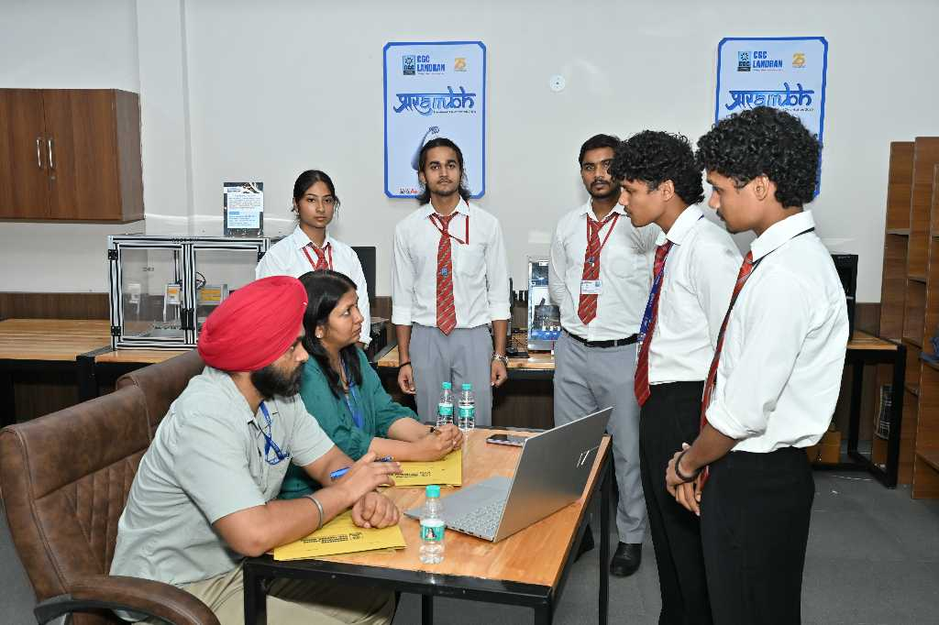
Following the evaluation of all participating teams, 20 teams were shortlisted for the final round.

S. No. | Team Name | Team Leader
1 | Trace Matrix | Charu Bansal
2 | VisionX | Aditi
3 | ARISE | Vikash Prasad
4 | Skydio | Ranjan
5 | Alert X | Samar Singh
6 | ATM Astra | Anchal Malhotra
7 | UNINAV | Aarush
8 | Electronerds | Ritesh
9 | Debug Dynasty | Navseerat Kaur
10 | GridX | Rishit Verma
11 | INNOVATEX | Saurav
12 | Deep Vision | Jashandeep Singh
13 | Tech Rakshak | Ipsa
14 | Ctl Freaks | Prisha Jain
15 | Vision Bridge | Maulik Aneja
16 | Etanglix Labs | Jaideep Taak
17 | Qubit Titans | Chaitanya Arora
18 | Vexora | Aditya Mall
19 | Majstors | Uddha
20 | Kingmaker | Raj Ronak

7. Evaluation Criteria

7.1 Presentation
The clarity, structure, confidence, and effectiveness with which the team communicated its idea.

7.2 Problem Solving
The extent to which the proposed solution addressed the identified real-world problem effectively.

7.3 Innovation
The originality and creativity of the proposed concept and the extent to which it introduced a new or improved approach.

7.4 Feasibility
The practicality of implementing the proposed solution considering technical, operational, and real-world constraints.

8. Shortlisting of Finalists
After the completion of the first-round presentations and evaluation, 20 teams were shortlisted for the final round. The selected finalists were given the opportunity to further develop and present their ideas before the final judging process.

9. Day 2 – Final Round
Date: 7 August 2026
The second day of IDEATHON 2026 commenced at 9:30 AM and featured the final round of the competition.
The 20 shortlisted teams presented their ideas before the judging panels. The teams continued to use PowerPoint presentations to explain their proposed solutions, while some teams went a step further by developing and demonstrating working prototypes.
Each team was given approximately 10 minutes for its presentation. The final round provided an opportunity to assess not only the conceptual strength of the solutions but also their potential for practical application.
The judges evaluated the finalists based on presentation, problem solving, innovation, and feasibility. The final evaluation resulted in the selection of the top three positions along with two special recognitions for Emerging Ideas.
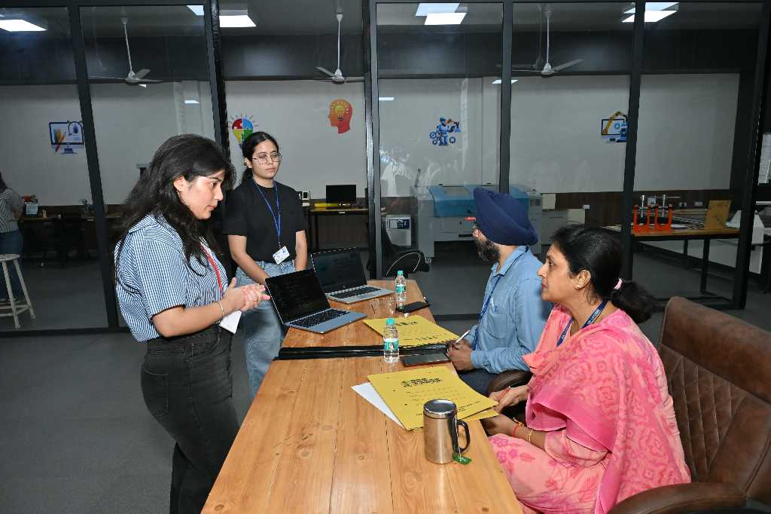

10. Winners and Recognitions
Position | Student/Team Leader | Team Name | Cash Prize
1st Position | IPSA | Tech Rakshak | ₹2,500
1st Runner-Up | Vikash Prasad | ARISE | ₹1,500
2nd Runner-Up | Jaideep Taak | ETanglix Labs | ₹1,000

The three principal winning teams were recognized for their innovative solutions, problem-solving capability, presentation, and feasibility.

11. Emerging Idea Recognitions
Recognition | Student | Team | Award
Emerging Idea | Navseerat Kaur | Debug Dynasty | Cash Prize + Certificate
Emerging Idea | Jashandeep Singh | Deep Vision | Cash Prize + Certificate

The Emerging Idea recognitions were intended to encourage promising concepts that demonstrated innovation and potential for further development.

12. Prize Distribution and Certification
The concluding ceremony included the recognition of the winning teams and participants. The teams securing the 1st Position, 1st Runner-Up, and 2nd Runner-Up were awarded cash prizes and certificates of achievement.
The two teams recognized under the Emerging Idea category were also presented with cash prizes and certificates.
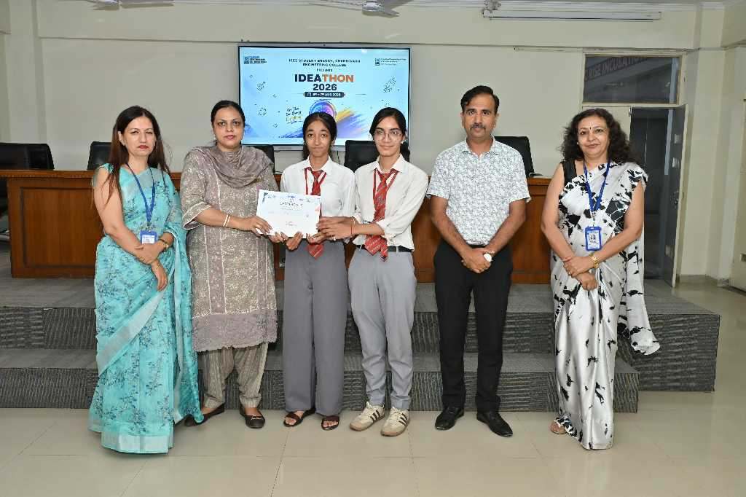

13. Volunteer Recognition
A total of 12 volunteers were awarded Certificates of Appreciation in recognition of their contribution towards the successful organization and execution of IDEATHON 2026.
Their contribution supported areas such as event coordination, participant management, venue management, technical assistance, communication, and other organizational responsibilities.
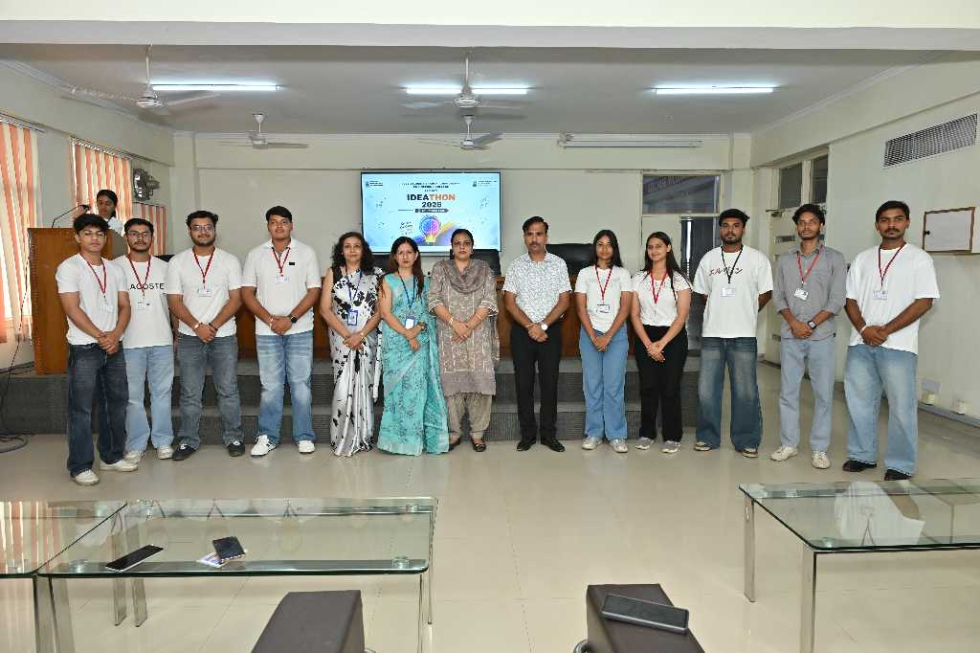

14. Recognition of IEEE Student Branch Council Members
The IEEE Student Branch Council members involved in the planning and execution of IDEATHON 2026 were also recognized with Certificates of Appreciation for their contribution towards event planning, coordination, participant management, panel coordination, venue management, technical arrangements, communication, documentation, and overall execution.
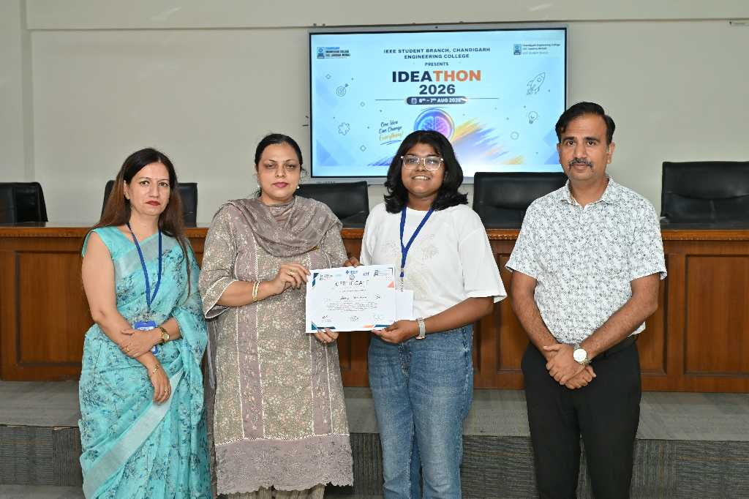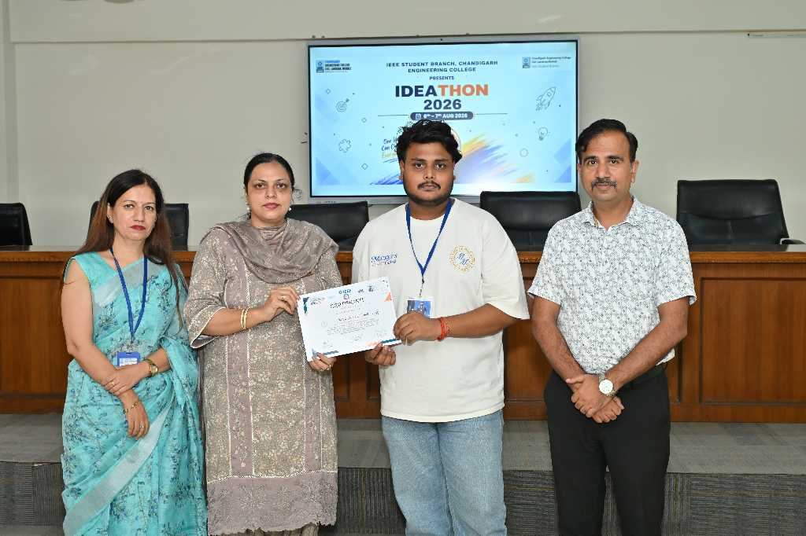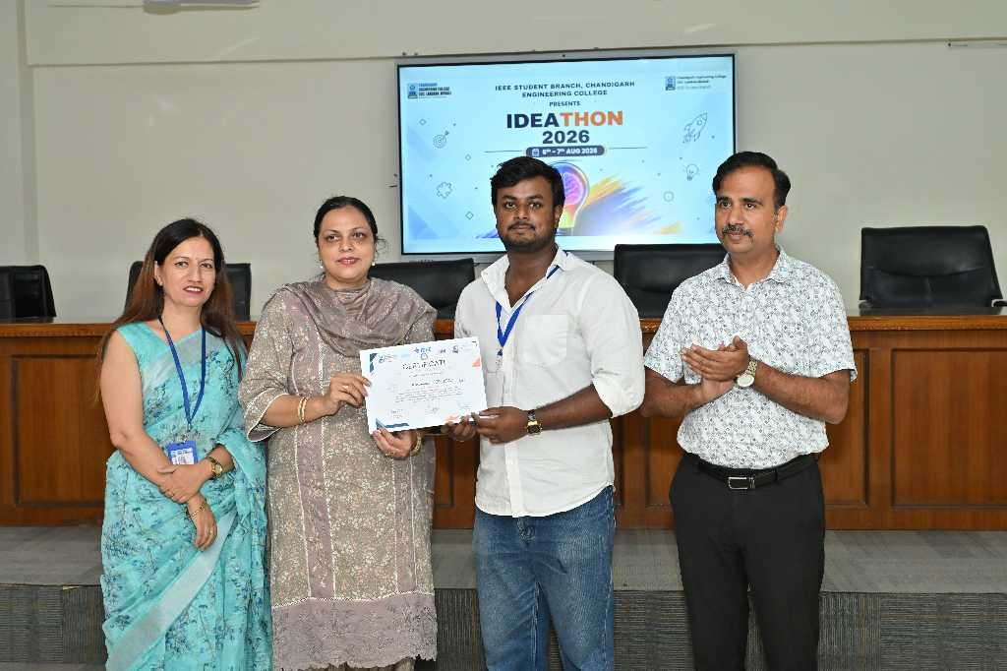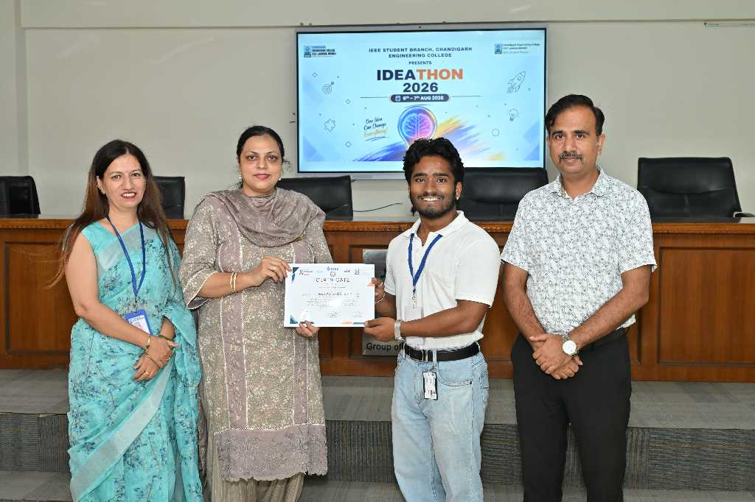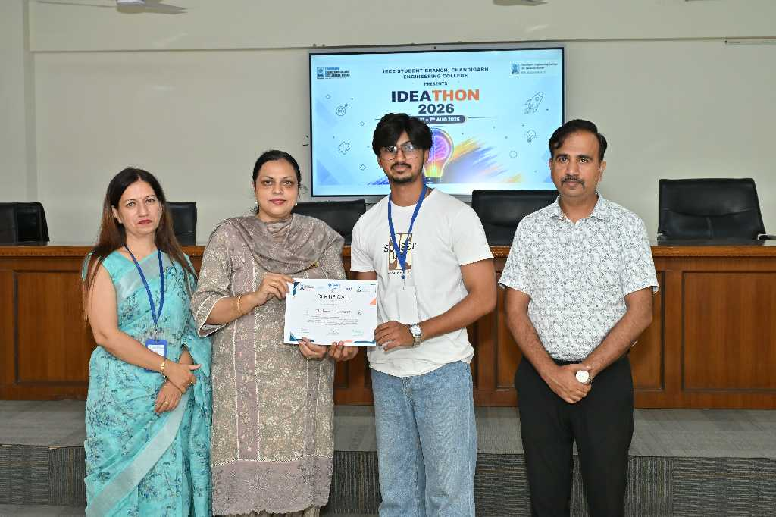

15. Event Highlights
- Participation of 84 teams in the initial round.
- A structured four-panel evaluation system.
- Conduct of the selection round across IDEA LAB and Seminar Hall, Block 3.
- Shortlisting of 20 teams for the final round.
- Approximately 10-minute presentations by participating teams.
- Presentation of innovative solutions to real-world problems.
- Development and demonstration of prototypes by some finalist teams.
- Evaluation by faculty and experts from different academic departments.
- Recognition of the top three positions.
- Recognition of two Emerging Ideas.
- Distribution of cash prizes and certificates.
- Recognition of 12 student volunteers.
- Recognition of IEEE Student Branch Council members.
- Presence of the Chief Guest and senior institutional dignitaries.

16. Learning Outcomes

Innovation and Creativity
Students were encouraged to approach real-world challenges creatively and develop original solutions.

Problem Identification
Participants were encouraged to understand existing problems and identify areas where technological or innovative intervention could create meaningful impact.

Presentation Skills
The requirement to present ideas before judges helped students improve communication, confidence, and professional presentation skills.

Teamwork
Working on an idea as a team encouraged collaboration, division of responsibilities, and collective decision-making.

Technical Implementation
Teams that developed prototypes were able to bridge the gap between conceptual ideas and practical implementation.

Feasibility Analysis
Participants were required to think about whether proposed solutions could realistically be implemented, developing an understanding of practical constraints.

Exposure to Expert Evaluation
Interaction with panelists from different departments provided students with perspectives and feedback on their ideas.

17. Overall Impact
IDEATHON 2026 successfully created a platform where students could transform their observations of real-world problems into innovative solution-oriented concepts.
The participation of 84 teams demonstrated strong student interest in innovation and problem-solving. The progression of 20 teams to the final round further highlighted the competitive and developmental nature of the event.
The inclusion of prototype demonstrations during the final round added a practical dimension to the competition and encouraged students to move beyond theoretical presentations towards tangible implementation.
The event also promoted interdisciplinary interaction, with judges representing RISE, IPR, ECE, CSE, Mechanical Engineering, ET, and IT. Through presentations, evaluations, recognition, and awards, IDEATHON 2026 contributed to an environment that encourages students to explore innovative solutions to real-world challenges.

18. Acknowledgement
The IEEE Student Branch, Chandigarh Engineering College, expresses its sincere gratitude to Mr. Deepak Garg, Chief Guest, for his valuable presence and encouragement throughout IDEATHON 2026.
The organizing team also extends its sincere appreciation to Dr. Sukhpreet Kaur, Director/Principal; Dr. Vinay Bhatia, HOD ECE and Branch Counsellor; Dr. Ashima Kalra; and Ms. Ritu Sharma, for their guidance, support, and encouragement.
Special appreciation is extended to all the panelists for dedicating their time and expertise to evaluate the participating teams.
The organizing team also acknowledges the contribution of the 12 student volunteers and the IEEE Student Branch Council members, whose coordination and efforts played an important role in the successful execution of the event.
Finally, sincere appreciation is extended to all 84 participating teams for their enthusiasm, creativity, and commitment towards presenting innovative solutions to real-world problems.

19. Conclusion
IDEATHON 2026, conducted on 6th and 7th August 2026, successfully provided students with a platform to identify real-world challenges and present innovative solutions to address them.
Beginning with 84 participating teams, the event progressed through a structured selection process that resulted in 20 finalist teams. The final round provided participants with an opportunity to further demonstrate their concepts, with several teams showcasing prototypes alongside their presentations.
The recognition of the top three positions and two Emerging Idea teams encouraged students to continue developing their innovative concepts. The event also emphasized teamwork, problem-solving, presentation skills, innovation, and feasibility.
The participation of faculty members and experts from multiple departments, along with the support of the institution, IEEE Student Branch Council, and student volunteers, contributed significantly to the successful execution of the event.
Overall, IDEATHON 2026 served as a meaningful platform for fostering innovation, creativity, technical thinking, entrepreneurship, and real-world problem-solving among students.

Annexure

A. Finalist Team List
To be inserted after confirmation of the 20 finalist team names.
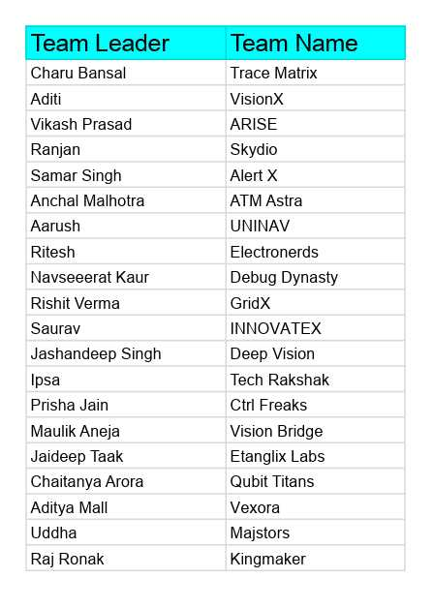

B. Event Schedule
Day | Date | Start Time | Proceedings
Day 1 | 6 August 2026 | 9:30 AM | Selection / Idea Pitching Round
Day 2 | 7 August 2026 | 9:30 AM | Final Round / Finalist Presentations

C. Photograph Documentation



